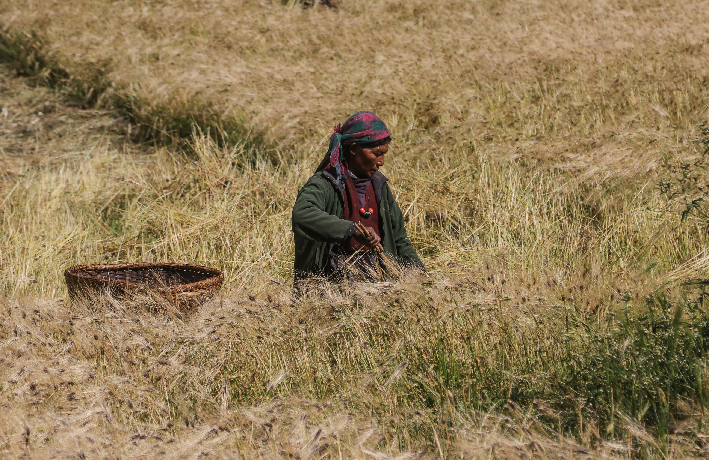

UN COUNTRY TEAM
ANNUAL RESULTS REPORT 2022
NEPAL

Table of Contents
UN Nepal Annual Results Report 2022 0
List of Abbreviations 1
UN COUNTRY TEAM 4
UN DEVELOPMENT SYSTEM IN THE COUNTRY 5
CHAPTER 1 KEY DEVELOPMENTS IN THE COUNTRY AND REGIONAL CONTEXT 6
CHAPTER 2 UN DEVELOPMENT SYSTEM SUPPORT TO NATIONAL DEVELOPMENT PRIORITIES THROUGH THE ASSISTANCE FRAMEWORK 9
2.1. Overview of Assistance Framework Results 9
2.2. Assistance Framework Priorities, Outcomes and Outputs 12
Outcome 1. Sustainable and Inclusive Economic Growth 12
Outcome 2. Social Development 21
Outcome 3: Resilience, Disaster Risk Reduction and Climate Change 33
Outcome 4: Governance, Rule of Law and Human Rights 42
42
Outcome 4: Governance, Rule of Law and Human Rights 43
2.3. Support to Partnerships and Financing the 2030 Agenda 52
2.4. Results of the UN working more and better together: UN coherence, effectiveness and efficiency 56
2.5. Evaluations and Lessons Learned 59
2.6. Financial Overview and Resource Mobilization 60
2.6.1. Financial Overview 60
2.6.2. Resource mobilization and quality of funding 66
CHAPTER 3 UNCT KEY FOCUS FOR NEXT YEAR 68

List of Abbreviations

ADS | Agriculture Development Strategy
AFIC | Adolescent Friendly Information Corners
BIPAD | Building Information Platform Against Disaster
CCF | Climate Change Financing Framework
CEDAW | Convention on the Elimination of All Forms of Discrimination Against Women
CERP | Critical Ecosystem Restoration Plans
CERT | Community Emergency Response Team
CLAC | Central Labour Advisory Committee (CLAC)
CPSW | Community psychosocial workers
CRC | Committee on the Rights of the Children
CRIMS | Child Rights Information and Monitoring System
CR-WSP | Climate Resilient Water Safety Plan
CSE | Comprehensive Sexuality Education
CSO | Civil Society Organisations
CSV | Climate-smart villages
CTEVT | Council for Technical Education and Vocational Training
DG-ECHO | Directorate-General for European Civil Protection and Humanitarian Aid Operations
DIMS | Disaster Information Management System
DRM | Disaster Risk Management
DRR | Disaster Risk Reduction
DRRM | Disaster Risk Reduction and Management
ECD | Early Childhood Development
EU | European Union
FANSEP | Food and Nutrition Security Enhancement Project
FAO | Food and Agriculture Organization of the UN
FCHVs | Female community health volunteers
FEB | Foreign Employment Board
FFS | Farmer Field Schools
GBV | Gender-based violence
GCM | Global Compact on Migration
GCN | Global Compact Nepal
GESI | Gender and Social Inclusion
GEWE | Gender equality and women's empowerment
GIS | Geographic Information Systems
GoN | Government of Nepal
GRB | Gender Responsive Budgeting
GRPFM | Gender responsive public finance management
Ha | Hectar
IAEA | International Atomic Energy Agency
ICPD | International Conference of Population and Development
ICT | Information communication technology
IDPG | International Development Partners Group
IFAD | International Fund for Agricultural Development
ILO | International Labour Organization
IMAM | Integrated Management of Acute Malnutrition
IOM | International Organization for Migration
ITC | International Trade Centre
LDC | Least Developed Country
LDCRPs | Local disaster and climate resilience plans
LGBTIQA+ | Lesbian, Gay, Bisexual, Transgender, Intersex, Asexual
LNOB | Leave No One Behind
MISP | Minimum Initial Service Package
MoALD | Ministry of Agriculture and Livestock Development
MoEST | Ministry of Education, Science and Technology
MoF | Ministry of Finance
MoFAGA | Ministry of Federal Affairs and General Administration
MoFE | Ministry of Forests and Environment
MoHA | Ministry of Home Affairs
MoHP | Ministry of Health and Population
MoLESS | Ministry of Labour, Employment and Social Security
MSMEs | Micro, Small and Medium Enterprises
MSNP | Multi-Sector Nutrition Plan
MTEF | Medium-Term Expenditure Framework
NDC | National Determined Contribution
NDRRMA | National Disaster Risk Reduction and Management Authority
NHRC | National Human Rights Commission
NHRIs | National Human Rights Institutions
NHSP | National HIV and AIDS Strategic Plan
NLC | National Land Commission
NPC | National Planning Commission
NPR | Nepali Rupee
NSO | National Statistics Office
NWC | National Women's Commission
OCMCs | One-stop crisis management centers
OF | Obstetric fistula
OHCHR | Office of the High Commissioner for Human Rights
OMT | Operations Management Team
OPD | Organisation of Persons with Disabilities
PPFP | Post-Partum family planning
PSEA | Prevention of Sexual Exploitation and Abuse
RC | Resident Coordinator
RCCE | Risk Communications and Community Engagement
UN RCO | UN Resident Coordinator's Office
RMNCAH | Reproductive, Maternal, Newborn, Child and Adolescent Health
RWEE | Rural Women’s Economic Empowerment
SAM | Severe acute malnutrition
SAS | Safe abortion services
SBCC | Social and Behavioural Change Communication
SBD | Standard Bidding Documents
SBN | SUN Business Network
SDC | Swiss Agency for Development and Cooperation
SDG | Sustainable Development Goals
SESP | School Education Sector Plan
SPPFM | EU Action on Improving Synergies between Social Protection and Public Finance Management
SRH | Sexual and Reproductive Health
SRHR | Sexual and reproductive health rights
SSDP | School Sector Development Plan
SWAP | Sector Wide Approach
TCV | Typhoid conjugate vaccine
TVC | Typhoid conjugate vaccine
UN | United Nations
UN Habitat | United Nations Human Settlement Programme
UN Women | United Nations Women
UNAIDS | Joint United Nations Programme on HIV/AIDS
UNCDF | United Nations Capital Development Fund
UNCITRAL | United Nations Commission on Trade and Development
UNCT | United Nations Country Team
UNCTAD | United Nations Conference on Trade and Development
UNDAF | United Nations Development Assistance Framework
UNDP | United Nations Development Programme
UNDSS | United Nations Department for Safety and Security
UNEP | United Nations Environment Programme
UNESCO | United Nations Educational, Scientific and Cultural Organization
UNFPA | United Nations Population Fund
UNHCR | United Nations High Commissioner for Refugees
UNICEF | United Nations International Children's Emergency Fund
UNIDO | United Nations Industrial Development Organization
UNOPS | United Nations Office for Project Services
UNSDCF | UN Sustainable Development Cooperation Framework
UNV | United Nations Volunteers
UPR | Universal Periodic Review
VAWG | Violence against women and girls
WASH | Water, sanitation and hygiene
WHO | World Health Organization
WiVC | Women in Value Chain

UN COUNTRY TEAM
RESIDENTIAL AGENCIES
FAO | 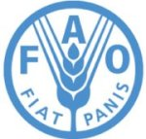 | UNICEF | 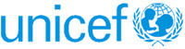
IFAD | 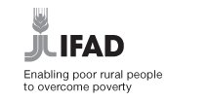 | UNOPS | 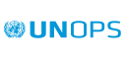
ILO | 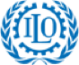 | UNWOMEN | 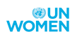
IOM | 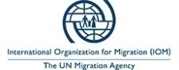 | WFP | 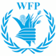
UNAIDS |  | WHO | 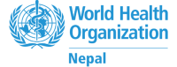
UNCDF | 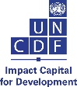 | UNHABITAT
UNDP | 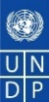 | UNHCR | 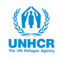
UNESCO | 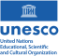 | UNODC | 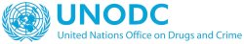
UNFPA | 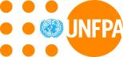 | UNV | 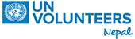

NON-RESIDENT AGENCIES
ESCAP | 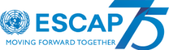 | UNDRR | 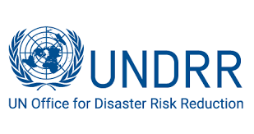
ITC UN | 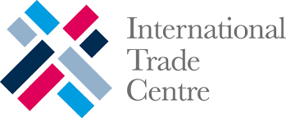 | UNEP | 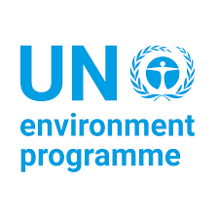
OHCHR | 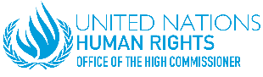 | UNIDO | 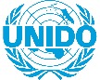

UN DEVELOPMENT SYSTEM IN THE COUNTRY
In 2022, the last year of the implementation of the United Nations Development Assistance Framework (UNDAF) 2018-2022, the UNCT in Nepal has strengthened its partnership with all three tiers of government, development partners, private sector, civil society and academia. Additionally, the UNCT in Nepal has facilitated an extensive process of consultations with a broad range of stakeholders to inform the development of the new United Nations Sustainable Development Cooperation Framework (UNSDCF) 2023-2027. The overall objective of the consultations was to make the UNSDCF formulation process as inclusive and participatory as possible and to ensure that the voices and priorities of diverse communities, provinces and different palikas were captured.
Joint UN initiatives funded by a variety of multi-partner trust funds as for example, the UN Joint SDG Fund, the Global Programme to Accelerate Action to End Child Marriage, the United Nations Partnership on the Rights of Persons with Disabilities or the UN’s Central Emergency Response Fund/Anticipatory Actions are being implemented. The signing of the new European Union (EU) and UN joint programme, “Empowered Women, Prosperous Nepal”, has scaled up the EU-UN partnership in Nepal in 2022 and has reinforced the reinvigorated Resident Coordinator (RC) System at the country level.
In 2022, the UN RC and the UNCT have played a key role in leading a diverse set of development coordination platforms. Since July 2021 the EU Ambassador and the UN RC co-chair the International Development Partners Group (IDPG) and the UN Resident Coordinator’s Office (UN RCO) houses its permanent secretariat. Similarly, UNDP, UNICEF, UN Women, ILO, IFAD, and IOM co-chair different sectorial IDPG working groups as, for example, federalism; climate change; social protection; migration; education; water, sanitation and hygiene (WASH); health; food security; gender and social inclusion (GESI); and integrity and accountability.
Overall, in 2022, the UNCT has deepened its commitment to working with the people of Nepal and its Government in achieving the aspirations set out in the Agenda 2030, the 2015 Constitution as well as the 15th Plan. The implementation of the four UNDAF outcome areas has brought together the Government of Nepal (GoN), the UN family and national, provincial and local stakeholders to continue building a more inclusive, sustainable and resilient Nepal.

CHAPTER 1 KEY DEVELOPMENTS IN THE COUNTRY AND REGIONAL CONTEXT

In 2021 Nepal carried out the National Housing and Population Census and published the preliminary report in 2022. As seen in Figure 1, Nepal’s population is 29 million (49 % male and 51 % female), which is an increase in the overall population by 10.18 per cent when compared to the Census of 2011. As per the 2021 Census, 66.8% of the total population live in the 293 urban municipalities of Nepal. In 2011, the percentage of the population living in urban areas was 63.2 per cent. The rural population has decreased to 33.9 per cent in 2021 in comparison to 36.8 per cent in 2011.
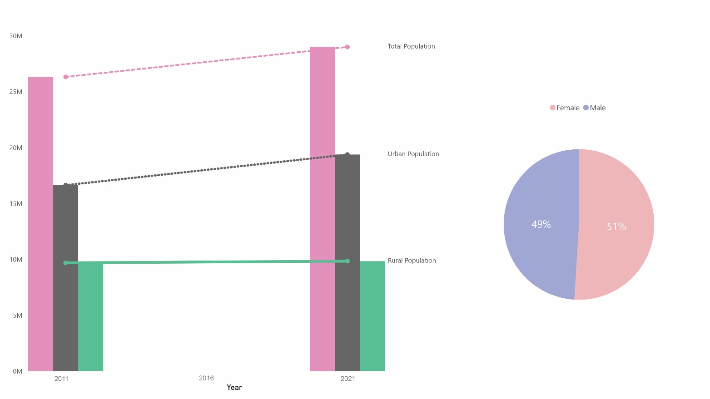
Figure 1 Population trends between 2011 and 2021, by urban-rural population and male-female population.

In 2022, the federal, provincial, and local elections were successfully held; and the new Government was formed of a coalition among the Communist Party of Nepal (Unified-Marxist Leninist), the Communist Party of Nepal (Maoist Centre), Rastriya Swatantra Party and other smaller parties. The overall representation of women in elected position across the three tiers of government is over one third in the 2022 elections (Local Level: 41%; Provincial Level: 36.6%; Federal Parliament: 32%). There has been a significant decrease in women Deputy Mayors/Vice Chairs; only 567 women (75%) won in 2022 compared to 700 (93%) in 2017. This was a result of the low number of women candidates nominated by the party coalitions. The representation of women in first past the post seats in federal level was just 5 (9 women) and 4 per cent (14 women) at provincial level elections.
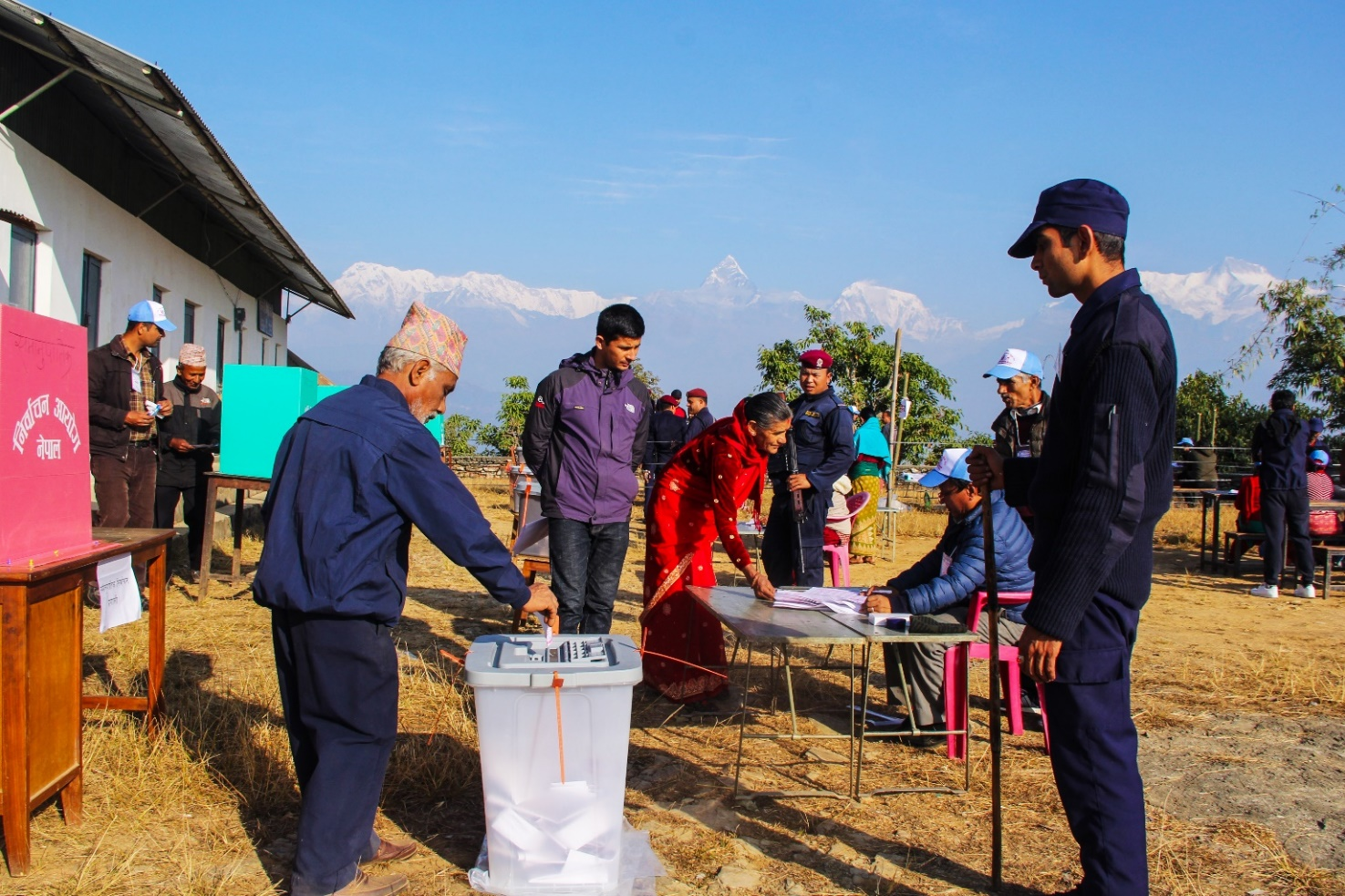
The conclusion of the second round of elections to federal, provincial, and local governments under the Constitution (2015) marks a significant milestone for Nepal’s implementation of federalism. In 2022, the Special Committee formed by the National Assembly of the Federal Parliament carried out a research study on implementation of federalism and prepared a detailed report, identifying progress, challenges, and action points to advance legislative, political, fiscal, and administrative federalism. Efforts to implement the recommendations will be taken forward under the leadership of the newly elected federal, provincial, and local governments. To this end, the newly elected federal government has publicly committed to enact pending bills related to, for example, civil service, public procurement, e-governance, and local administration during the first session of the House of Representatives.

Figure 2: Voters in the process of casting their ballots in the House of Representatives and Provincial Assemblies elections in Pokhara
Photo credit: Krishna Mani Baral / UNDP NEP

In 2022, Nepal witnessed economic uncertainty due to multiple overlapping challenges. The global economic slowdown, the Ukraine war, and rise in fuel price had an impact in Nepal’s economy, leading to increase in balance of payment deficit, drop in the stock of foreign exchange reserves, rise in inflation, and slowdown in economic activities. Nepal’s central bank—Nepal Rastra Bank—responded with tightened monetary policy that had an impact on economic growth and revenue collection.
The country’s economic situation raised concerns with regards to financing Nepal’s development projects, achieving its aspiration to graduate from Least Developed Country (LDC) status in 2026 and achieve the Sustainable Development Goals (SDGs) by 2030. In 2022, the GoN reviewed the SDG indicators and updated them, reducing the indicators from 479 to 304 and selected 90 priority indicators. Similarly, the GoN carried out research studies on the impact of LDC graduation and inter-ministerial consultations to prepare a smooth transition strategy for irreversible and sustainable graduation.
The impacts of climate change are increasingly felt in Nepal, including through observed changes to annual monsoon patterns. This is likely to continue to severely affect the country, in particular the most vulnerable population groups who, to a large extent, rely on agriculture for subsistence. The GoN responds to different climate-led hazards and risks through holistic policies and affirmative mitigation and adaptation actions. Nepal has already started its National Adaptation Plan finalization process keeping in view long, medium, and short-term strategies under leadership by the Ministry of Forests and Environment (MoFE). In the process, UN Nepal has provided support to all levels of government for climate change adaptation and mitigation, which will continue to be critical going forward, including through support to community-based adaptation solutions.
In 2022, Nepal contributed to global progress on climate change action through high-level international processes, including at the COP27 and through commemoration of the International Year of Sustainable Mountain Development. Notably, a new UN resolution on Sustainable Mountain Development was adopted by the UN General Assembly. At COP27, member states also agreed to the establishment of a Loss and Damage Fund, aimed at supporting countries most vulnerable to climate change to adapt and increase resilience. While details, including funding mechanisms, are yet to be worked out, these developments can be significant for Nepal’s ability to access international climate finance in coming years, and for increasing global attention to the particular importance of mountain regions in the face of climate change.
The Global Alliance of National Human Rights Institutions has recommended downgrading the status of the National Human Rights Commission (NHRC) Nepal to “B” status in October 2022 due to lack of conformity of the appointment process with the Paris Principle on National Human Rights Institutions (NHRIs). The petition challenging the appointment process is sub-judice at the Constitutional Bench of the Supreme Court. Various national and human rights communities as well as the Special Procedures have encouraged the GoN to rectify the appointment process, in line with the steps outlined by the Sub-Committee on Accreditation

CHAPTER 2 UN DEVELOPMENT SYSTEM SUPPORT TO NATIONAL DEVELOPMENT PRIORITIES THROUGH THE ASSISTANCE FRAMEWORK

2.1. Overview of Assistance Framework Results

At the heart of UNDAF 2018-2022 lies four strategic priorities guiding the focus of the UN; sustainable and inclusive economic growth; social development; resilience, disaster risk reduction (DRR) and climate change adaptation; and governance, rule of law and human rights. The UNDAF is aligned to the 14th and 15th National plans and is coherent with supporting Nepal’s goals in achieving the SDGs. 2022 marked the final year of the UNDAF. During the last five
years, the framework has steadily guided the work of the UN through a pandemic and the onsetting global economic slowdown. The UNDAF’s outcomes remained relevant in guiding the partnership of the UN wit GoN despite changing circumstances posed by Federalism and COVID-19.

SUMMARY OF UNCT KEY RESULTS IN 2022
OUTCOME 1 : SUSTAINABLE AND INCLUSIVE ECONOMIC GROWTH
 | Increase in the agricultural productivity and income of 113,789 small holder farmers (49% female)
 | The stability of the livelihoods of climate vulnerable and food insecure poor households in three districts of the Karnali mountains were strengthened through improved adaptive capacity and management of livelihood assets and natural resources.
 | Integrated Action Plan for the Formalization of the Informal Economy, providing roadmap to address the unsafe, precarious, unprotected, poorly paid and unsafe jobs adopted by the Central Labour Advisory Committee (CLAC).
 | Social protection extended to 1) workers in the informal sector and 2) wage and self-employed Nepalese migrant workers in destination countries.
 | Extension of contribution-based social security to workers in informal sector and self-employment announced.
 | Construction of 64 small-scale tourism infrastructures created 20,000 person days of temporary employment.
 | Government and UN partnership to deliver Public Employment Services through a delivery structure in all 753 Municipalities established.
 | Bilateral labour migration agreement with the government of United Kingdom signed for protecting the rights of health workers on 22 August 2022.
 | OUTCOME 2: SOCIAL DEVELOPMENT
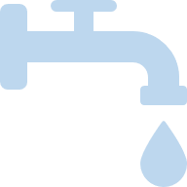 | Water and Sanitation Act enacted, and WASH Regulation and WASH Policy finalized.
 | Three provinces and 125 municipalities developed WASH Acts and 439 municipalities are developing localized climate-sensitive costed WASH plans and digitized WASH information management systems.
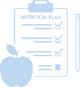 | Integrated Management of Acute Malnutrition (IMAM) interventions for the treatment of 0–59-month children with Severe Acute Malnutrition (SAM) scaled up.  Multi-sector Nutrition plan (MSNP) scaled up in 720 out of 753 local levels, resulting in increased access to and utilization of nutrition services to the most vulnerable populations including children.
 | New School Education Sector Plan (SESP) developed and launched together with a five-year costed education programme.
 | Enrolment rates raised to 88 per cent in early childhood education and 95 per cent in basic education
 | 56,784,630 COVID-19 vaccines administered, covering 89.8 per cent of the population above 12 years of age with the primary second dose. In addition, a targeted 3.76 million children 5 to 11 years of age received 89.9 per cent first and 79.7 per cent second doses of COVID-19 vaccines.
 | Nepal’s routine immunization service improved to pre-pandemic level, with full immunization increased to 91 per cent in 2022
 | Nepal also introduced the Typhoid conjugate vaccine (TCV) in 2022, targeting 7,715,516 children aged between 15 months and 15 years, and achieved 99.7 per cent coverage
 | National HIV and AIDS Strategic Plan (NHSP 2021-26) endorsed. The NHSP’s goal is to end AIDS as a Public Health threat in the country by 2030, and intends to place up to 95 per cent of the estimated 30,000 people living with HIV on life-saving treatment by the end of 2026.
 | OUTCOME 3: RESILLIENCE, DISASTER RISK REDUCTION AND CLIMATE CHANGE
 | The Building Information Platform Against Disaster (BIPAD), and a comprehensive Disaster Information Management System (DIMS) initiated by GoN were further rolled out in 2022, including local and provincial expansion of DIMS supporting timely reporting on disaster events and preparation of provincial disaster resilience frameworks.
 | Nationally Determined Contribution (NDC) Implementation Plan prepared.
 | Mustang Declaration launched and Nepal’s contribution to the adoption of a UN General Assembly Resolution on Sustainable Mountain Development.
 | Climate risks and adaptation integrated into Nepal’s health system through improved health sector planning and implementation, in line with international commitments.
 | Multi-hazard risks were mainstreamed in local government plans.
 | 15 Municipalities developed and updated child-sensitive local disaster and climate resilience plans [LDCRPs] to mainstream multi-hazard risk into local government planning.
 | All seven provinces prepared climate-responsive budgets in 2022, and three provinces finalized their respective Climate Change Financing Framework (CCFF), as a result of UN support to the National Planning Commission (NPC).
 | OUTCOME 4: GOVERNANCE, RULE OF LAW AND HUMAN RIGHTS
 | Elections were carried out at all levels of the federal system which is a cornerstone of the 2015 Constitution of Nepal. The UN has provided long-standing capacity development support to Election Commission Nepal (ECN) since 2008, significantly contributing to its capacity to independently conduct elections.
 | Amendments to the law related to sexual violence has been made, increasing the statute of limitation for reporting of rape from one to two years for adults. For minors, a case can be filed within three years after a child turns 18 years.
 | The Government also endorsed the Children’s Regulation, 2022, paving the way to reduce violence against children by establishing additional minimum criteria for the establishment and operation of childcare facilities.
 | The GoN finalized and adopted the post Universal Periodic Review (UPR) implementation strategy to govern the effective implementation of the recommendations. The UN worked in close partnership with NHRIs and the Office of the Prime Minister and Council of Ministers to conduct dialogue and consultations in the preparation of the strategy.

2.2. Assistance Framework Priorities, Outcomes and Outputs

Outcome 1. Sustainable and Inclusive Economic Growth

Accelerating Progress towards Rural Women’s Economic Empowerment (JP RWEE)
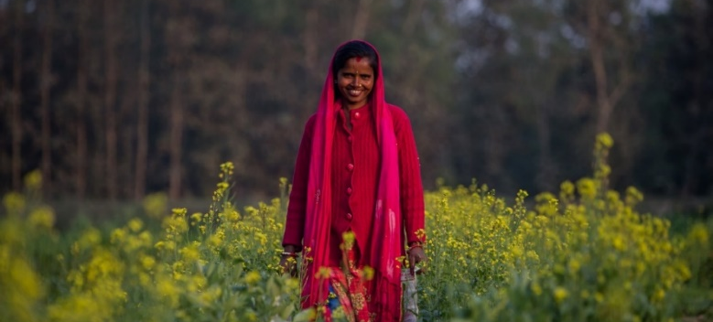
Ramkali Mahato uses climate sensitive, modern farming techniques for better produce. Photo credit: NISHANT GURUNG/UN WOMEN
Ramkali Mahato from Sarlahi was only 12 when she got married. Within the next few years, she was a mother of three.
“With limited income, it was a struggle to ensure all of us
had adequate food to eat. That is when I decided to take matters into my own hands, no matter what the community thought about it.”
In 2016, after learning about agriculture training in her village, she joined with hopes of receiving seeds and equipment for her farm. The training focused on strengthening leadership capacity of rural women farmers at home and communities and included training on climate-sensitive farming. Mahato now grows not only grains but a variety of vegetables using the 14 tunnels she built in her farm. The training was part of the Accelerating Progress towards Rural Women’s Economic Empowerment (JP RWEE) a UN Women-led joint program in collaboration with FAO, WFP and IFAD. The produce from her farm is more than enough for her family and she has a surplus to sell in the market. She saw a sharp increase in her income from a NPR 30,000 a year to NPR 750,000 after she started climate-resilient farming.
Since her commercial farming took off, Mahato has noticed a change in how her neighbours perceive her.
“The same people who once spoke badly of me because I went out
to collect fodder now ask my help to make plastic tunnels for their farms,” she says.

Earlier, Mahato found it difficult to access loans and was also not confident about taking one, but she now comfortably manages her accounts. Her income pays for her children’s tuition, her husband’s medical expenses and the leased farm’s rent. Mahato is also the chair of Laxmi Rural Women Farmer’s Group and Hariyali Women Multipurpose Cooperative, through which, she supports women in her community to generate income from agriculture.

Outcome 1 - By 2022, economically vulnerable, unemployed, and underemployed people have increased access to sustainable livelihoods and safe and decent employment and income opportunities.
In 2022, the UN continued working with the Government on the formulation of national policies and plans. The NPC developed the National Human Resource Plan, Provincial level CCFF, LDC Graduation Strategy, a National Leave No One Behind (LNOB) Framework, and revised the SDG indicators. The efficiency and accuracy of tracking priority SDG indicators was strengthened through the further prioritization of indicators to 90 by the NPC. Provincial, and local governments have enhanced knowledge and capacity to integrate SDGs in their planning, budgeting, and reporting process. Systematic budget forecasting at the provincial level has been improved through the roll-out of the Medium-Term Expenditure Framework (MTEF) software across seven provinces, supported by the UN.
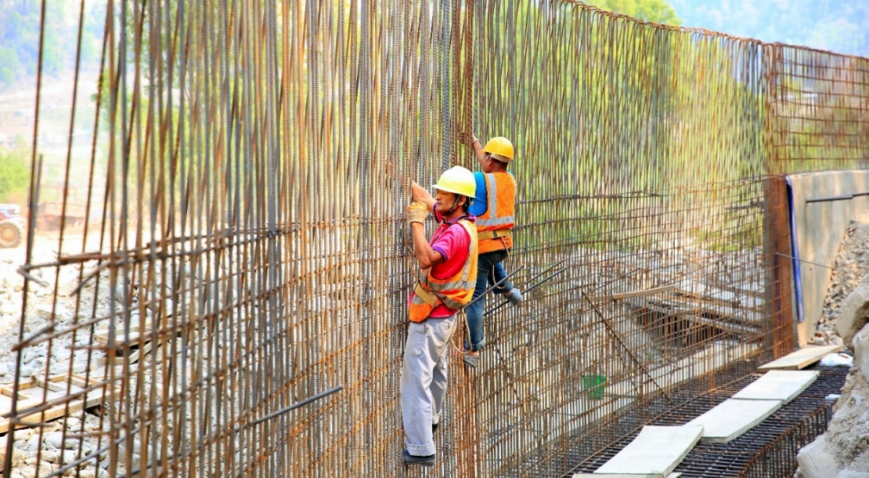
In 2022, small holder farmers’ agricultural production and productivity has been increased, crop failures decreased, and they have received better prices for their produce through the increase in access to agro-advisory services; production technology; irrigation facilities; financial education and services; and market information, contributed to by the UN in partnership with several government counterparts. There was an increase in the agricultural productivity and income of 113,789 small holder farmers (49% female). Household income increased by approximately 60 per cent as compared to baseline statisticsThrough UN programming, the adaptive capacity and management of livelihood assets, and natural resources increased stability of the livelihoods of climate vulnerable and food insecure poor households was observed in three districts of the Karnali mountains. Around 3,162 farmers benefitted from increased knowledge on climate-resilient agricultural practices and 1,538 commercial farmers through improved access to crop insurance.

Figure 3: Workers constructing gabion wall to prevent seasonal flooding. Photo credit: UNDP Nepal
The gradual formalization of the informal economy has progressed as exemplified by Ministry of Labour, Employment, and Social Security (MoLESS) developing an integrated Action Plan for the Formalization of the Informal Economy, that provides a roadmap to address the unsafe, precarious, unprotected, poorly paid and unsafe jobs that characterize the informal economy. The Action Plan has been adopted by the CLAC chaired by the Minister in MoLESS. The GoN has expressed commitment to extend social protection to informal sector employees including self-employed by adopting the work procedures to include workers from informal sector in the contribution-based Social Security Fund. After the implementation of this work procedure, daily wage workers, self-employed or stock market investors will also be able to participate in the social security scheme.
With the support of the UN, 8,308 young people, largely from historically marginalized groups were employed and earning a monthly average income of NPR 11,902. The construction of 76 small-scale tourism infrastructures created 30,456 person days (27 % female) of temporary employment. MoLESS with technical assistance from UN agencies is strengthening Capacities of Municipal Governments to deliver Public Employment Services as a critical element for enhanced employability of job seekers that include vocational /career counselling, and job matching.
Improvements have been seen in ensuring the rights of migrant workers. In 2022, the GoN with the UN effectively advocated through informed participation in bilateral discussions and regional forums on labour migration for fair recruitment; skills recognition and development; protection of migrant workers’ rights; and lowering the cost of remittances.

Output 1.1 - Strengthened capacities of smallholder farmers for increased farm production and marketing.
In 2022, the capacities of smallholder farmers for increased farm production and marketing were strengthened. Small holder farmers saw improvements in crop and livestock production; productivity; food/nutrition security; and household incomes, all through UN technical and financial support (UN Women, UNDP, IFAD, WFP, and FAO). UNDP supported small holder farmers in the project areas earned USD 5.7 million by selling 12,679 metric tons of fruits and vegetables (Evidence Summary of Fruits and Vegetable transaction Data). Women farmers (project participants) increased their average vegetable production fourfold and earned a net profit increment of approximately NPR 25,000 and 1,200 signed up for crop and livestock insurance, thus significantly improving their livelihoods. The financial inclusion of smallholder farmers has increased through the launch of the Kisan Card supported by IFAD implemented Accelerated Private Investment in Agriculture project that improved access to financial services by over 20,000 farmers through 30 branches of the Agriculture Development Bank Limited. The UN (UNDP) also extended services and enabled farmers to address potential climate change impacts in agriculture production through training and technology transfer.
FAO strengthened the capacity of federal, provincial, and local level governments in delivering technical skills, trainings, agricultural inputs (seeds, breeds, small irrigation) and other services to small holder/marginal farmers through the design and implementation of need-based Farmer Field Schools (FFS) (crop and livestock), Farm Business Schools, and Nutrition Field Schools. The capacity of 631 facilitators was augmented to run 80 model schools and 865 field schools. FAO improved the capacity of a total of 38667 farmers (69% women, 62% Youth) through 9 projects, of which 8150 farmers (67% women, 60% youth) were new farmer beneficiaries. A total of 458 government officials from Federal, provincial, and municipal level were provided technical training, refresher courses/orientation in different areas of crop and livestock development.
IFAD implemented “Adaptation for Small Holders in Hilly Areas” project strengthened the framework for climate adaptation at the local level targeting the most climate-vulnerable communities in Nepal. The project focuses on inclusive and scalable climate change adaptation, which supported the construction of community infrastructure (Control/Gabion) for the protection of assets of project beneficiaries from landslides. The project contributed to human and social capital development in the project areas to bolster effective participation of small holder farmer households in local government’s decision-making processes, especially aiming at prioritization of economic activities and public investment in implementing these activities.
Through the CAFS Karnali project, WFP reinforced the capacity of 3162 farmers to adopt climate-resilient agricultural practices, new production technologies, and small rural agricultural machineries for improved agricultural production and income. The project gave 1538 small holder farmers access to agricultural insurance which encouraged commercial farming as climate-related and other risks were managed through the insurance schemes. The project facilitated 138 Agro-based/forest enterprises (87 led by women) by providing trainings and equipment and start-up capital for livelihood diversification. Women in Value Chain (WiVC) project, a joint initiative between WFP and UN Women, enabled 2,465 rural women farmers to increase their production and market access. Through UNDP’s capacity development initiatives, 71 agricultural cooperatives with more than 15,000 members (62% women) gained enhanced capacities and improved access to technology and agricultural inputs, leading to increased production of fruits and vegetables by 16 per cent and 28 per cent respectively, and increased income of the farmers by 15 per cent (Final Evaluation of VCDP, 2022, UNDP). UNDP’s intervention focused on improved business plans, production, collection, branding, and marketing.
UNCDF in partnership with Kheti supported almost 8,000 smallholder farmers (27% women) to gain access to larger markets to sell their products and provided them with access to the digital inventory of high-quality Agri-inputs to support their agricultural production. As a part of this project, Kheti has tied up with NMB bank to facilitate collateral-free agriculture loan processing. Through this project, Kheti was able to facilitate collateral-free loans for 300 farmers (50% women). Further, through assistance from UNCDF, Jeevan Bikash Laghubitta Bittya Sanstha (JBS) was able to sensitize 61,000 (98% women) rural smallholder farmers on Area Yield Index Insurance, which is an agricultural insurance that protects farmers against losses from perils such as windstorm, frost, excessive rainfall, heatwave, hail, flood, drought, pest, and diseases.

Output 1.2 – Increased inclusive employment through support to Micro, Small, and Medium Enterprises (MSME) mainly in major growth sectors, including agriculture and tourism.
In 2022, inclusive employment was strengthened through support to Micro, Small and Medium Enterprises (MSMEs) targeting major growth sectors including agriculture and tourism. UN support contributed to achievement of the 15th National Plan targets of securing productive and decent employment for 49% of the population by 2024, and establishment of 15,000 MSMEs every year.
More than 3,800 MSMEs were onboarded to different e-commerce platforms in 2022, by enhancing their digital financial capabilities. UNCDF, with the assistance of the Swiss Agency for Development and Cooperation (SDC), was able to partner with Thulo and Sastodeal, two e-commerce platforms, the Federation of Nepalese Chambers of Commerce and Industry, and the Federation of Nepal Cottage and Small Industries to achieve this result. UNCDF also partnered with Nabil Bank to bolster merchants’ contactless payment methods and to build capacities for the use of QR codes, as an entry point to open bank accounts. In this way MSMEs led by women and youth without bank accounts can digitize their transactions and start to use loans based on QR cash flows. Till date, more than 5,300 merchants (60% youth and/or women) have been enrolled and 86 merchants benefitted from loan products based on QR code transactions.
The business skills of 1473 persons (589 women) working in the tourism sector were augmented, including in travel and tour, trekking and river-based tourism, all with the support of UNDP. Around 50 per cent of the recipients were self-employed. UNDP further improved services available to people working in the tourism industry by developing training reference books and manuals: 1) “Cookbook”, 2) Restaurant and Bar Management Guidelines”, 3) Reference book for trekking guides, 4) River Guides, and 5) training manual for tour product development, online ticketing and customer services.
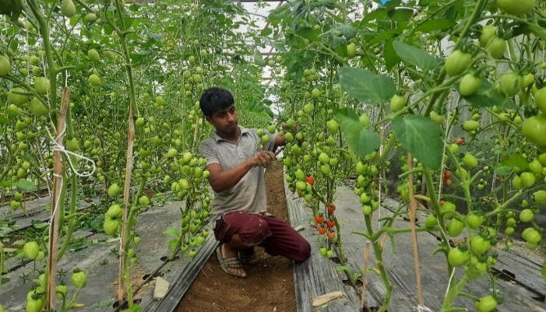
The WFP- UN Women’ WiVC programme helped the enhancement of entrepreneurial and business skills of rural women, which resulted in 325 women farmers starting and/or expanding value-chain-linked businesses in 2022. In same programme, WFP supported 2465 rural women farmers from 100 farmers groups for increasing production and access to market, including linkage with community schools implementing cash-based school meal programme through home grown school feeding approach. A total of 1,186 women farmers learned about climate-smart agricultural technologies and practices through FFS, 80 per cent of whom have initiated grow-to-sell vegetable in more than 30 hectares of land. Women farmers increased their average vegetable production by four times and earned net profit increment of about NPR 25,000 on an average. More than 2,343 women farmers learned about importance and process of crop and livestock insurance, 1,200 of them have insured their livestock and crops. 57 women farmers’ groups established forward contract with community schools who are implementing cash-based school meal programme to supply food commodities for school meal. The capacity development activities of the project also contributed to raised awareness among 2,127 women farmers on gender equality, social inclusion, GBV, and leadership capacity.
FAO provided technical skill and support to farmers in business plan preparation and documentation to access potential grants/resources and 394 groups received matching grants from Food and Nutrition Security Enhancement Project to scale up their farm business in the 8 districts of Madhesh, Bagmati and Gandaki province.
In 2022, UN-Habitat assisted 350 young people and women for the development and promotion of tourism businesses in Bungamati and other historical areas in the Kathmandu Valley. It organized workshops and training programs to help 350 young people and women gain skills and establish enterprises in the handicrafts, hospitality, and food sectors, which are important components of the tourism industry. More With UN-Habitat's assistance, more than 50 enterprises were established, and several events organized that promoted were held to promote heritage tourism, attracting both local and international tourists.
Figure 4: Anil Poudel, Phedikhola 3, lost his job In Qatar and came back to Nepal during COVID 19. He started tomato farming earning nearly 0.5 million rupees a year with support from UNDP’s Value Chain Development of Fruit and Vegetables Project. Photo credit: Ananda Parajuli/UNDP
Output 1.3 People in rural areas have increased access to improved livelihood assets, rural infrastructure, and wage labour opportunities in the process of construction/maintenance of the infrastructures
The access of people in rural areas to improved livelihood assets, rural infrastructure and wage labour opportunities improved. In 2022, 315 producer organisations, involving 8,900 households from 47 municipalities in Karnali Province were engaged in value chains; total of 2,856 households benefited from the completion of 103 sub-projects (427 Ha, total value NPR 91.8 million); and 1,445 households benefited from the completion of 52 community infrastructure schemes (32 irrigation / 20 dipping tanks) through IFAD’s Agriculture Sector Development Programme. Furthermore, increased access to agro-advisory services and market information has helped producers to improve production, productivity, minimize the risks of crop failure, and receive better prices for their produce are instrumental for value chain growth.
Through CAFS Karnali project implementation by WFP, a total of 3,980 vulnerable households (40% female headed) in Kalikot, Jumla, Mugu earned USD 741,626.46 from temporary employment created through 106,095 workdays through Cash for Asset work such as construction of community infrastructure that strengthened community assets (solar powered community service centres, drinking water supplies, water mills, irrigation, water harvesting ponds, soil stabilization). This community infrastructure benefited 32,189 people in rural areas.
Climate resilience of eight villages in Kalikot, Mugu and Jumla districts have been bolstered through a climate-smart villages approach which introduced the use of climate smart technologies and use; improved access to climate information services and insurance; increased farmers’ knowledge on climate resilient technologies, practices; improved access to climate and agriculture development finance; and strengthened capacities of local governments and market intermediaries and public private institutions.
Together with UNDP, WFP piloted approaches that supported inclusive planning and delivery of green, resilient, inclusive and productive local infrastructure through the testing of incentive and co-financing-based mechanism and enabled the local governments for the use of government monitoring and financing instruments. 15 local governments in Karnali province received the technical support. WFP has mobilized the local governments to identify and implementing 94 co-financed schemes mobilizing the resources from the LISP Pilot and Local Governments with improved modality of delivering climate-resilient, productive, and employment-generating local infrastructure services at the local level. Access to services and integration of refugees into host communities were improved through UNHCR’s support to identifying local solutions for the inclusion of refugees in public services, policies and plans as well as supporting capacities and livelihood opportunities for refugees. Cash support was provided to 1,528 (889 women) extremely vulnerable refugee families (young children, elderly people, pregnant and lactating women, individuals with disabilities and chronic illnesses, etc.) to help them meet their basic needs.
To support the Government of Nepal’s commitment to land tenure security as ensured by the Constitution and Land Policy, the 15th National Plan committed to ensure the rights and access to land of unorganized settlers and undertake to bring into state records an estimated 10 million informally operated parcels by about 1.3 million households. Including marginalized groups. UN-Habitat played a vital role in creating the essential guidelines for identifying, verifying, and recording of landless and informal land tenure holders, and in implementing the subsequent steps for granting land titles by the National Land Commission, based on the outcomes of pilot projects carried out in different municipalities. It facilitated the gathering of applications and enumeration of 89,409 landless and informal land tenure households without land ownership documents in 14 municipalities and managed the issuance of temporary cards to 71,413 households and land ownership certificates to 233 households.
Progress was made towards sustainable tourism recovery and improved livelihoods in the tourism sector through construction of 76 small-scale infrastructure, creating 30,456 person days of employment (27% women), and enhanced skills of 1,473 (40% women) tourism sector workers as a result of participation in standardized trainings developed jointly by UNDP and the Nepal Tourism Board. After certification, approximately 50 per cent of them are now self-employed.

Output 1.4 – Fair and decent work promotion for youths and migrant workers through vocational skill enhancement, improved access to employment services, and bilateral, regional, and global dialogues for safe, orderly, and regular migration.
IOM and ILO improved government capacities at all levels for the implementation of Global Compact on Migration (GCM), including funding support from IOM to ensuring informed representation of Nepal in regional discussions on the International Migration Review Forum, Abu Dhabi Dialogue, Bali Process, Colombo Process, and GCM regional level consultations. The national implementation strategy for GCM in a whole of government and society approach was drafted by the Government through IOM support, which is currently under the final review from the government.,
Awareness was raised among key stakeholders in all seven on the skilling, reskilling, recognizing prior learning, private sector partnerships in skilling, and reintegration of returnees by conducting multiple research pieces and disseminating the findings. The capacities and understanding of over 1400 youth, government officials, private recruitment agencies, returnee migrant network members were increased on safe migration, fair/ethnical recruitment, and decent work. Similarly, capacities on M&E tools on return and reintegration were strengthened amongst Migration Resource Centres, civil society organisations (CSOs), rural and urban municipalities, provincial and federal ministries, and Provincial Planning Commissions through the support of IOM.
In support of the Government’s promotion of fair recruitment and reporting against SDG 10.7.1, ILO has augmented the capacity of the National Statistics Office (NSO) to conduct a national survey on recruitment cost borne by migrant workers from Nepal. Survey tools have been designed and memorandum of understanding signed between ILO and NSO to implement the survey. The Nepal Labour Migration Report 2022 was developed through partnership between UN agencies (ILO and IOM) and MoLESS. The report provides insight and analysis of key migration trends, policy responses, gaps in governance and considerations of ways forward for improved migration governance.
The Reintegration Programme (Operation and Management) Directives for Returnee Migrant Workers 2022, including provisions on inclusion in employment programmes with access to skill testing and certification, provision of skills-based training, promotion of entrepreneurship and Guidelines for inclusion of workers in foreign employment and self-employed Nepali workers in contribution-based social security scheme for the drafting of which ILO provided technical assistance, were adopted in 2022.
Through the awareness campaigns of IOM, over six million Nepali migrants living abroad and at home were reached through radio, television and social media messages on safe and dignified migration, skilling and sustainable reintegration.
The skills of 1,612 (64 women, 8 persons with disabilities) returnee migrant workers were increased, through training, skills testing, and post-career counselling, and their opportunities to reintegrate into local markets were increased through technology/tools/equipment support from UNDP.
To promote safe, orderly, and regular migration through gender responsive migration governance, UN Women disseminated a gender responsive migration toolkit to 37 migration resource centres across the country as follow up action to the recommendation from a policy dialogue with four key federal level government stakeholders including the Ministry of Women, Children and Senior Citizens (MoWCSC), Ministry for Foreign Affairs (MoFA), Foreign Employment Board and MoLESS and CSO representatives on gender responsive migration conducted in the previous year.
A reintegration policy was developed through a collaboration between the Municipality of Dhankuta and IOM together with SAMBRIDDHI project support by IFAD and implemented by Ministry of Industry, Commerce and Supplies.
In 2022, through IFAD, 18,238 aspiring and returnee migrants received various services. A total of 148 foreign employment victims were supported to receive compensation totaling NPR 38,176,738. The capacities of 1,015 vulnerable women were trained on gender action learning systems and through social mentoring. Women’s leadership positions increased from 49 per cent in 86 groups to 56 per cent in 378 groups.

Output 1.5 – Strengthened enabling environment for job creation, trade facilitation and sustainable livelihoods.
In 2022, UN agencies’ interventions contributed to enhancing the capacity of the government and key stakeholders including Workers’ and Employers’ organisations to create an enabling environment for job creation, sustainable livelihoods and trade facilitation.
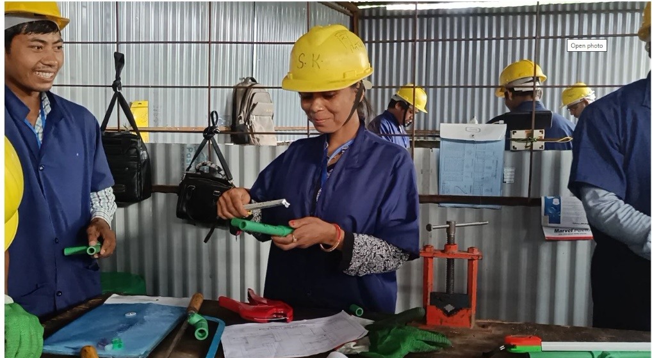
UNDP bolstered the capacity of over 1500 officials (7 % Female) from all 753 local governments on SDG
aligned planning, budgeting, and monitoring including reporting on the National Data Profile utilizing the newly developed resource books for SDG budget coding and MTEF preparation. UNDP developed software on MTEF to help sub-national governments generate digital MTEF plans (systematic budget forecasting) for three years. Under the Economic Development Cooperation Fund-II project, UNDP contributed to institutional strengthening and helped to ensure that the benefits of aid are shared more widely and that local communities can contribute to and shape their own development. UNDP implemented activities that strengthened the availability and effective use of a more diverse range of development finance and aid management capacity of the government at all levels.
UN Women improved the capacity of 1,090 local government officials and representatives (996 male; 94 female) from across the seven provinces on gender responsive budgeting (GRB). UN Women developed a set of recommendations to strengthen planning and budgeting processes from a GESI lens in line with the principle of LNOB, through consultations with 27 representatives from the Badi community, CSOs and with eight former deputy mayors and 42 GESI focal points.
Figure 5: Sarita Pariyar from Nepalgunj is happy to break down barriers for women to work in skilled trades like plumbing. She is among 1612 returnee migrant workers who received skills trainings conducted by UNDP’s SKILLS project with support from the European Union in Nepal and British Council managed Dakchyata Project. Photo Credit: Anand Gurung/ UNDP Nepal.
ILO in partnership with the Government, Workers’ and Employers’ organization through “EU Action on Improving Synergies between Social Protection and Public Finance Management project continued to increase the technical and institutional capacities of the Social Security Fund which was established to manage contribution-based social security to workers. The ILO, in partnership with MoLESS, also designed and mobilized resources for a project to strengthen local government’s capacity to improve and extend basic Employment Services through 753 Municipalities by merging the services of Employment Service Centres in Municipalities and the Migration Resource Centres in 39 districts.
With the support of the UN, several policy documents and resources were developed for a more enabling economic environment in 2022.
In 2022, ILO strengthened the capacity of the CLAC, chaired by the Labour Minister, to convene a tripartite high level task force including Joint Secretaries of federal level Ministries and leaders of Workers and Employers’ Organizations. This led to the development of a National Action Plan for formalization of informal enterprises, including the formalization of MSMEs and their workers. It also improved the coordination capacity of MoLESS with other Ministries for the implementation of planned interventions.
UNDP provided technical assistance to the NPC to develop several key policy documents: National Human Resource Plan; Provincial level CCFF; LDC graduation strategy; LDC graduation policy action matrix; and revision of SDG indicators.
UN Women improved the knowledge base on gender and macroeconomics. This included: (a) feminist economic analysis on the impacts of COVID 19; (b) feasibility analysis of gender responsive basic income (with UN RCO and UNDP); (c) study on gendered impacts of COVID-19 on local and national supply chains and (d) policy brief on gender responsive financial inclusion, with a particular focus on conflict affected single women. Additionally, UN Women, IFAD, WFP and FAO under the joint project for Rural Women’s Economic Empowerment (RWEE) partnered with the Ministry of Agriculture and Livestock Development (MoALD) to develop a policy brief on the revised GESI strategy of the Agriculture Development Strategy (ADS). In addition to the feasibility study, with the Government, UNDP and UN Women continued the experimentation of Temporary Basic Income to support structural transformation towards an inclusive economy, directly reaching 1,000 vulnerable women, and indirectly supporting more than 5,000 family members.
In 2022, UN Women increased the job opportunities and access to sustainable livelihoods for women from excluded and vulnerable groups in Nepal. A total of 592 women from excluded and vulnerable groups accessed income generation opportunities, with UN Women’s support. Of these 183 women have started small businesses. The capacity of the women to scale up their businesses were strengthened through vocational training, entrepreneurship development and financial management training and the provision of material support. Further, UN Women enhanced the skills of 92 women in three districts following which, the women were organized into the groups to advance women’s collective business on seasonal vegetable farming (Kathmandu), poultry farming (Kailali) and cloth and bag stitching (Morang).
Awareness was raised among over six million Nepali migrants living abroad and at home on promoting self-employment, entrepreneurship, available private sector job opportunities, government programmes on livelihoods support, safe and dignified migration, skilling and sustainable reintegration through various media campaigns by IOM.

Outcome 2. Social Development

Voices against child marriage
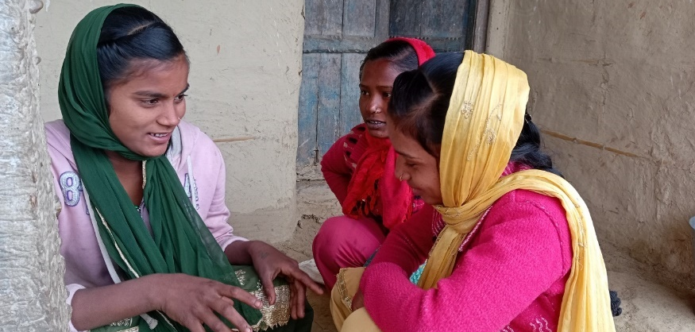
Priyanka Kumari Mahara (far left) chatting with friends outside her home in Rautahat District in southern Nepal.

In Nepal’s south, thanks to learnings from the Rupantaran ("transformation") programme, young girls are finding the confidence to speak out against child marriage and usher in change in their families and communities. Priyanka Kumari Mahara recalls the day her parents approached her with a proposal when she was 13: they wanted her to marry a boy from a nearby village.
This was not entirely unexpected for Priyanka. Child marriage is common in her community, and many of her own friends had married before 18. She understood the strain on her parents due to a meager income as agricultural laborers and five children to raise. Yet, she was still certain that this was not what she desired for herself.
"I told them openly that if I married now, it would be child marriage, which is a crime…and that I wasn't physically or mentally prepared to take that step…I said I wouldn't agree to marriage until I was 20, because I had so many things I wanted to do before that," she says.
Priyanka's statement was so strong that her parents were surprised, but eventually after extended discussions promised to cancel the wedding. Priyanka's mother asked Priyanka how she knew all this information. "I told her I learned everything at Rupantaran," Priyanka says. She had enrolled in the Rupantaran program just a few months before the conversation with her parents. Priyanka was not able to attend school but always had a desire to learn.
Rupantaran comprises a comprehensive training package to provide social and financial skills to adolescents aged 10 to 19 from marginalized communities and challenging circumstances. Developed by UNICEF and UNFPA, in partnership with the Government, the programme is being run across communities in Nepal as part of the UNFPA-UNICEF Global Programme to End Child Marriage.
Mother Reeta Devi says she witnessed her daughter blossom into a confident, intelligent young woman:
“She is so much more responsible, she takes care of herself and others, and her outlook on so many things has changed.

Outcome 2 - By 2022, there is improved, equitable access, availability and utilization of quality basic social services for all, particularly for vulnerable people.
Outcome 2 | Baseline | Target | Reached
2.1 Reproductive, Maternal, Newborn, Child and Adolescent Health (RMNCAH): Birth attended by skilled health personnel (%) | 58 | 73 | 80.1
2.2 RMNCAH: Measles Immunization Coverage (%) | 88 | 90 | 89
2.3 RMNCAH: Proportion of demand for family planning satisfied with modern methods (%) | 56 | 74 | 55
2.4 RMNCAH: Annual incidence of pneumonia among children under five years (per 1,000) | 147 | 138 | 55
2.5 RMNCAH: Prevalence of diarrheal diseases among children under five years (%) | 12 | 6 | 10
2.6 RMNCAH: Adolescent Fertility (per 1000 women of 15-19 age group) | 71 | 51 | 71
2.7 Education: Literacy rate, 15 years and above (%) | 64 | 75 | 71
2.8 Education: Students learning achievements scores in Grade 8 (Math) (%) | 35 | 55 | 32
2.8 Education: Students learning achievements scores in Grade 8 (Nepali) (%) | 48 | 57 | 59
2.8 Education: Students learning achievements scores in Grade 8 (Science) (%) | 41 | 55 | 38
2.9 Education: Survival rate to Grade 8 (%) | 77 | 97 | 84
2.10 Nutrition: Children under five years of age stunted (%) | 32 | 28 | 25
2.11 Nutrition: Children under five years of age wasted (%) | 12 | 7 | 8
2.12 Gender based violence (GBV)/Case Management: Proportion of Women who have ever experienced physical or sexual violence and have ever sought help or services (%) | 23 | 40 | 28%
2.13 GBV/Case Management: Proportion of women aged 20-24 years who were married or in a union before age 18 (%) | 41 | 20 | 34.9%
2.14 WASH: Proportion of the population using basic drinking water service at community level (%) | 84 | 98 | 95
2.15 WASH: Proportion of population having basic toilet (%) | 62 | 82 | 79

Table 1 Overview of Outcome 2 indicators, including baseline, target for 2022 and target reached in 2022.

In 2022, the UN continued its collaborative partnership with all three tiers of government to formulate policy, set standards, build capacity, and provide basic services including health, nutrition, education, WASH, GBV prevention, risk mitigation, and response. A much-awaited Water and Sanitation Act was enacted, and the WASH Regulation and WASH Policy was finalized following a continued advocacy and provincial level consultations on the Bills supported the UN. Through UN assistance, three provinces and 125 municipalities developed WASH Acts and 439 municipalities are developing localized climate-sensitive costed WASH plans and digitized WASH information management systems. The WASH project, under the National Adaptation Plan and worth USD 1 billion, was proposed as a top three priority project for climate financing in the country. Similarly, UNFPA signed the country compact agreement on co-financing of procurement of family planning commodities, demonstrating Nepal’s commitment to meet the goal set at the International Conference of Population and Development Programme of Action by 2030. UN conducted policy review aimed at promoting disability inclusion and ensuring physical and digital accessibility and facilitated the revision of the GESI Operation Guideline 2013 to align it with the SDGs, the New Urban Agenda in the federal context.
Under the framework of an MSNP, UN Nepal provided technical support to the Ministry of Health and Population (MoHP) for the scale-up of malnutrition interventions. IMAM interventions for the treatment of the 0-59 months children with SAM were scaled up, nationwide including piloting of family Mid-Upper Arm Circumference approach as well as treatment of Moderate Acute Malnutrition, all with technical support from the UN. To address different forms of malnutrition, the GoN scaled up the MSNP in 720 out of 753 local levels, with technical support from UN Nepal, resulting in increased access to and utilization of nutrition services to the most vulnerable populations including children.
With technical assistance given by the UN, the government finalized and launched the new long term SESP 2022-2030 together with a five-year costed education programme (2022-2026). SESP aims to continue progress in access and quality in
the education sector as well as improve equity and accelerate progress on recovering the learning loss due to the extended school closures during the COVID-19 pandemic. The UN has helped the government with broad improvements in education including raising enrolment rates to 88 per cent in early childhood education and 95 per cent in basic education.
UN Nepal jointly contributed to the preparedness, response to and recovery from the COVID-19 pandemic and to building a more resilient health system that ensures equitable access to quality RMNCAH services and improves healthy behaviors. With the UN’s direct procurement services, Nepal administered 56,784,630 COVID-19 vaccines, covering 89.8 per cent of the population above 12 years of age with the primary second dose (Figure 2). In addition, a targeted 3.76 million children 5 to 11 years of age received 89.9 per cent first and 79.7 per cent second doses of COVID-19 vaccines. The UN also helped the government with materials and equipment required for COVID-19 preparedness, such as personal protective equipment Sets (3600), Antigen Kits (11,000), infrared thermometers (24) and provided human resources to the ground crossing points to set of health desks. Nepal’s routine immunization service has improved significantly to the pre-pandemic level, with full immunization increased to 91 per cent this year as compared to 78 per cent in 2021. In 2022, measles-rubella II coverage climbed from 81 to 92 per cent, and DPT-HepB-Hib3 coverage rose from 87 to 95
Figure 6 Vaccine coverage in Nepal 2021 and 2022.
per cent. Nepal also introduced the TCV in 2022, targeting 7,715,516 children aged between 15 months and 15 years, and achieved 99.7 per cent coverage.

Output Area 2.1 - Reproductive, Maternal, Newborn, Child and Adolescent Health (RMNCAH)
The UN supported the GoN in the development of plans and policies that contribute to creating an enabling environment for the efficient execution of RMNCAH operations. The UN assisted in the development of the Health Sector Strategic Plan 2022-2030 and the Sector Wide Approach (SWAP), the Social Behaviour Change Communication Strategy (SBCC) 2022-2026, the Nepal New-born Action Plan 2022-2030, the National implementation guideline of Kangaroo Mother Care for Low Birth Weight and preterm babies, and different sets of National Medical Standard for Maternal and New-born Care.
UNFPA, WHO, and UNICEF jointly supported the strengthening of health systems and the capacity of health service providers to deliver quality RMNCAH services. In 2022, WHO assistance included 136 safe abortion service locations, 300 clinicians, and 27 hospitals in the surveillance program for new-born birth defects. UNFPA supported the training of 405 health workers in the Electronic Logistics Information Management System, 86 in Health Logistics forecasting and quantification of Health commodities, 99 in various long-acting FP methods, 76 health managers, service providers and rapid response team members of Lumbini province received Minimum Initial Service Package (MISP) orientation to undertake necessary preparation for the continuation of Minimum initial services on sexual and reproductive health rights (SRHR) during any humanitarian emergency and the training of 15 midwifery educators in the revised midwifery educators training package. During the year, UNICEF helped the improvement of the new-born and paediatric quality of care in 12 hospitals in Madhesh Province, initiated Emergency Triage Assessment and Treatment Plus in 5 hospitals, and provided various Maternal and New-born Health (MNH) related trainings to 968 health workers.
UNICEF contributed to quality improvements in MNH services in Madhesh, Karnali, and Sudhurpaschim provinces by assisting a review of the municipal and health facility quality assurance working team, and Maternal Perinatal Death Surveillance and Response programme in Karnali and Sudhurpaschim provinces. UNICEF conducted master Training of Trainers for 20 medical professionals who further cascaded training to 275 health workers. UNICEF also provided orientation on Child and Adolescent Mental Health and healthy habits to 10,240 students (male: 4,692; female: 5,548), 226 teachers, and 523 female Community Health Volunteers. The obstetric fistula treatment centre, financed by UNFPA, delivered high-quality Reproductive Health (RH) treatments by operating 39 women and girls. More than 6,000 women and girls were helped by a trained professional midwife-operated Sexual and Reproductive Health (SRH) hotline supported by UNFPA. In Madhesh Province, UNFPA has rolled out a safe motherhood road map and provides an orientation to the mayor's/Deputy mayors and Health coordinators representing all the 136 palikas.
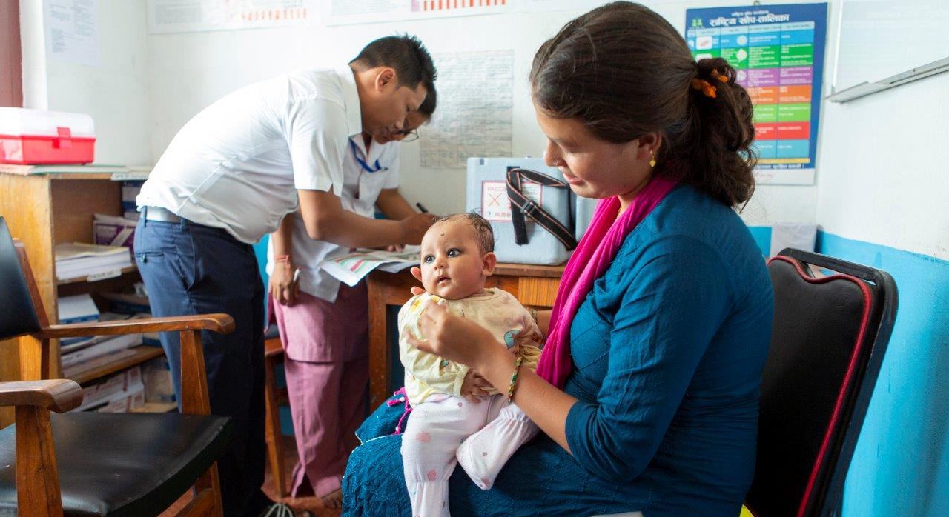
UNICEF assisted the MoHP in preparing a pool of trainers on Child and Adolescent Mental Health. At the regional level, WHO facilitated the South-South Learning exchange on post-Partum family planning (PPFP) and initiated the establishment of a demonstration site for PPFP services at Civil Services Hospital, Bagmati Province. WHO supported the Capacity building of service providers on Facility-based Integrated Management of Neonatal and Childhood Illness atat Gandaki Province for the management of referred cases of new-born and childhood illnesses. With the training for program managers and services providers on maternal and perinatal death surveillance and response and continued monitoring and support, the program has been expanded into 94 hospitals and 27 districts.
The entire National Immunization Programme received ongoing technical support from UNICEF and WHO. In 2022, Nepal became the first country in WHO South-East Asia Region to introduce typhoid conjugate vaccine and the fourth country globally. In the catch-up typhoid campaign, 7.6 million children 15 months to under 15 years were immunized. More than 46,000 children were monitored in the typhoid campaign assessing campaign vaccination status as well as routine measles-rubella vaccination status for children under five years of age. At the community level, more than 60,000 people were being watched for COVID-19 vaccination while more than 7000 children were being watched for regular immunization. 19 UN Volunteers (10 females, 9 males) were recruited as Public Health Officers, Staff Nurses, Health assistants and Lab assistants for UNDP Nepal to support the Federal government (MoHP’s Department of Health Services) in their works to ensure effective vaccination for the people of Nepal against COVID-19 as well as the digitalization of the vaccination. Technical support was also provided by the UN for the completion of
Figure 7: Bipina (three months) and mother Kamala Poudel (20). Bipina is on the road to becoming fully vaccinated- a status shared by all children in this community called Tathali. Bhaktapur, Nepal. August 2019. Photo credit: WHOSEARO

oral cholera vaccination in Kapilvastu for the cholera outbreak.
Through IOM programming gender friendly spaces with breast-feeding corners and safe waiting spaces were constructed at the six-government designated ground crossing points.

Output Area 2.2 – Gender Based Violence (GBV) and Harmful Practices
The UN continued its support to improve national capacity to provide quality, multi-sectoral GBV response services and combating harmful social and gender norms that perpetuate gender inequality, and violence against women and girls (VAWG). In 2022, 21,249 people (male: 7,197; female: 14,052) were engaged in gender-transformative couple discussions, family dialogues, discussions with members of Community Based Organisations, and dialogues with influential leaders in 19 municipalities. Over 16,000 people were sensitized to GBV prevention and risk reduction. UNFPA and UNICEF continued the roll-out of Rupantaran life skills programme empowering a total of 19,403 adolescents (boys: 6,763; girls: 12,640) to make informed decisions about their SRH, education, and marriage through the program. Also, 46,000 adolescents were reached through the radio version of the Rupantaran programme. 11,144 parents
Figure 8 Number of GBV cases reported in Nepal in 2021 and 2022.
(male: 5,301: female: 5,803) of adolescent girls completed the adult component of the Rupantaran programme, creating an enabling environment to ensure the rights and choices of the girls. UN Women completed a National Study on Violence Against Women in Politics in Nepal to explore driving factors to impede women’s political participation and the prevalence of violence among women in politics in Nepal. UN RCO and UN Women advised the National Disaster Risk Reduction and Management Authority (NDRRMA) on integration of prevention of sexual exploitation and abuse (PSEA) in all humanitarian and DRR plans.
UNICEF supported the Nepal Police to strengthen the rollout of a GBV information management system across Nepal. According to police records, 20,945 GBV cases were reported in the Nepali fiscal year 2078-2079 (July 2021-June 2022) which is a 14 per cent increase from the 18,496 cases registered in the previous year (Figure 3). A total of 5,422 women and child GBV survivors and their children were assisted through the safe house and associated services and family-based interventions, such as family counseling and dialogue, teachers’ training on psychosocial support, and on safe referrals of students experiencing GBV. UNICEF capacitated 2,139 (917 female) service providers, including child
rights officers, local government officials, psychosocial counselors, and health service providers to promote age-appropriate and gender-responsive GBV prevention, risk mitigation, and response services from 50 service delivery points.
UNFPA strengthened the capacity of a total of 12 hospital-based one-stop crisis management centres (OCMCs) to provide health and psychosocial support services, and appropriate referrals for GBV survivors. 12 OCMCs served a total of 6,302 GBV survivors (female: 6,063; male: 237; non-binary: 2). Additionally, UNFPA supported the operation of 19 safe houses and shelter homes that provided protection to 1,750 GBV survivors (female: 1,696; male: 54) and their children. In 2022, UNFPA capacitated a total of 1,312 health service providers (female: 1,172; male: 140) from peripheral health facilities and hospitals, including health post personnel, female community health volunteers (FCHVs), psychosocial counselors, staff nurses, and other health workers in hospitals that host OCMCs, on GBV survivor identification, care, and referral. Also, 23 case managers (all female) and 13 psychosocial counselors (male: 2; female: 11 ) received remote or in-person support and supervision.
UNFPA mobilized 121 community psychosocial workers (CPSWs) and 18 CPSW Coordinators to conduct community outreach on GBV within 26 municipalities of four provinces. They provided altogether 9,099 GBV survivors with psychosocial first aid and connected those in need to multi-sectoral GBV services. The CPSWs reached a total of 111,971 people (female: 80,185; male: 28,779; non-binary: 7) from local communities with outreach on GBV, mental health, and psychosocial support. UN Women oriented 4,172 people (female: 2,356; male: 1,2338; non-binary: 478) about the importance of mental health and psycho-social services through awareness programs. Through UNODC programming harm reduction education sessions were delivered to female prisoners in one prison per province covering a total of 611 women. Additionally, HIV testing was provided allowing for 603 women prisoners to be covered.
IOM screened 3,42,770 migrants at six Ground crossing Points including any vulnerabilities and/or GBV protection cases. Through protection screening 245 cases including 152 male and 93 female were identified and further referred. Out of total cases, 81 cases were on fraud, 50 cases on suspected trafficking, 15 were GBV cases, 75 cases of COVID-19 positive, 7 cases of family members missing, 4 cases of mistreated in India, 7 accident cases & 6 other cases. A wallet book consisting of contact details of protection services in emergency has been developed for all GCPs. Through the information sharing on protection including GBV, PSEA, IOM has reached 9,47,246 migrants wherein migrants have received information on relevant rights and entitlement. To enhance the protection services, share and report any cases, a communication system through installation of free internet services at the Ground crossing Points was installed. 924 cases were supported through the Psychosocial First Aid consultation.
In support of Nepal’s commitment to the Convention on the Rights of Persons with Disabilities and further ensured by the Constitution, UN-Habitat supported local governments and educational institutions in promoting disability-inclusive cities and communities including through awareness raising and organizing a municipal-level child art competition in celebration of the International Day of Persons with Disabilities 2022.

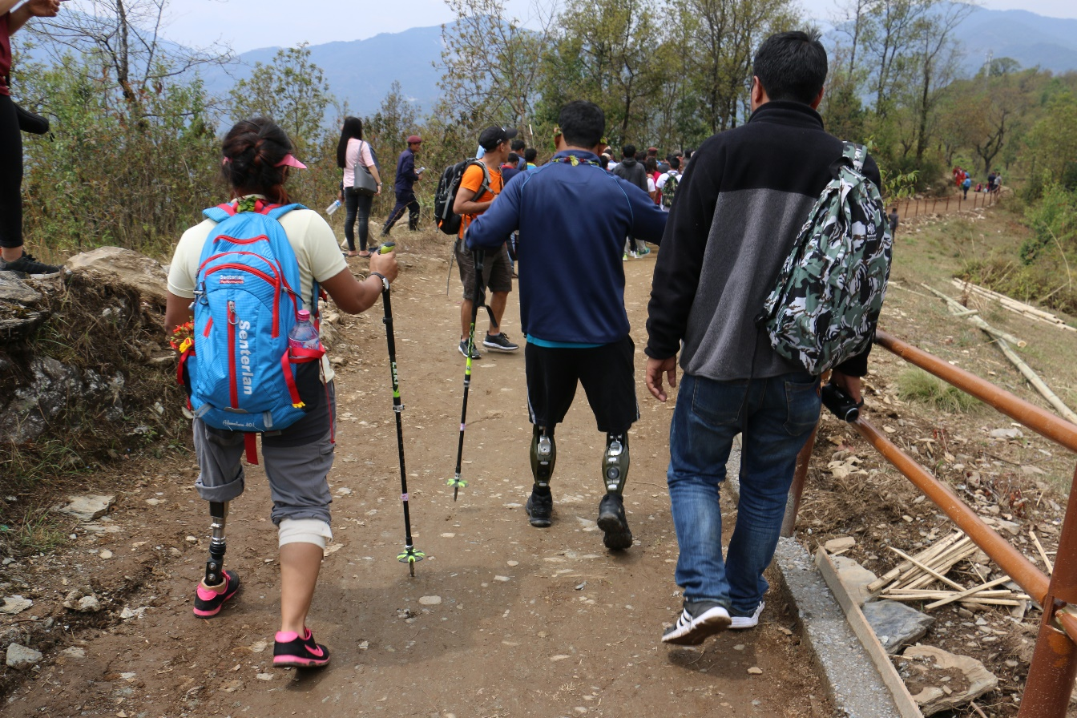
Figure 9:Disabled Friendly trekking trail in Pokhara constructed jointly by UNDP Nepal and Nepal Tourism Board Photo credit: UNDPNepal

Output Area 2.3 – Water, Sanitation and Hygiene (WASH)
During 2022, UNICEF, WHO, WFP and UN-Habitat, and IOM assisted government at federal, provincial, and local levels to further improve the water quality and functionality of water supply services in communities, and WASH services in schools and health care facilities including support to develop policies and plans such as formulation of inclusive WASH policy, climate-sensitive WASH plans, water quality monitoring, and surveillance system, contributing to SDG indicator 6. UNICEF reached over 129,000 people with the provision of safe drinking water, while 51,467 people are living in water-safe communities with 26 municipalities having water quality monitoring mechanisms established. 38,065 students (18,855 girls and 258 children with disability) were supported with access to basic WASH services in 112 schools. Of the total 146 schools where WASH facilities were provided in 2022, 82 received the star rating (15 schools achieved the national standard for three-star, 44 schools of two-star standard, and 23 schools met the criteria for one-star), which includes infrastructure, behaviour change and an enabling environment. WFP supported the construction of group handwashing stations in 270 schools, maintenance of school WASH facilities in 250 schools and construction of waste disposal pits in 649 schools. WFP assisted training on behavior change communication integrated to school health and nutrition to 40 local government education focal person and focal teachers from 1,514 schools with provision of 1 set of SBCC material to each school. 28 healthcare facilities meeting basic WASH services were completed while another 47 healthcare facilities received autoclave and/or laundry machines to improve waste management produced from health facilities. UNICEF and WHO provided technical assistance to MoHP to develop WASH standards for health care facilities. Additionally, WHO supported series of workshops in all provinces for dissemination of the standards. In 2022, WHO provided autoclaves for health care waste management in 30 health institutions including training for operation and maintenance. WFP and UNICEF with the Centre for Human Resource Development, Ministry of Education, Science and Technology (MoEST), continued technical assistance to include the Three Star Approach to promote WASH in schools for basic and advanced indicators in the long term SESP (2022/23-2031/32).Through UNDP support, five local governments developed strategic Green Recovery Plans, prioritizing a holistic approach to municipal waste management along with the establishment of waste collection and segregation/processing units and opportunities for green jobs through composting and commercial organic farming. This resulted in the creation of short-term employment as waste collectors for 190 people (117 women). Skills training on vermi-composting directly benefitted 1,318 households (63% women), with 32 per cent of them starting to make earnings through the sale of compost. With UNICEF help, significant progress was made in scaling up development of localized climate-sensitive costed WASH plans and digitized sector monitoring information management. The WASH plan inventory is in progress in 439 municipalities that have received NWASH data acquisition and processing training from Department of Water Supply and Sewerage Management. Additionally, with WHO’s support water quality component has been integrated in NWASH and 22 district health offices were trained for registration of WQ testing lab/kit and reporting accordingly. The federal government allocated resources to municipalities to update WASH plans they had previously prepared. UNICEF’s collaboration with municipalities also helped leverage some USD 1 million as a contribution from the government and communities (i.e. 28% of the total cost of UNICEF-supported projects). The WASH Investment Summit for developing financial strategies for the provincial-level WASH sector began with private sector engagement.
Under the COVID-19 recovery programme, UNICEF was able to assist 285,817 people (female: 145,767; male: 140,050) in high-density low-capacity communities, schools, points of entry, and health care facilities with infection prevention and control measures. Further at the six Point of Entries, IOM was able to reach 4,35,750 migrants with adequate WASH services and hygiene practices. This included construction of tube well, installation of water filtration and cooling plant, distribution of water purifying drops, child friendly hand washing stations, gender and disability friendly toilets and washroom as well as supplies needed for biohazard waste management and disinfection. These interventions were backup with behavior change communication programs specially focusing on hygiene behaviors for communicable and non-communicable diseases. UNICEF also extended its assistance to respond to the needs arising from small to medium-scale disasters such as flooding, landslides, earthquakes and cholera outbreaks, providing WASH assistance through WASH services and supplies to 78,325 people (female: 39,946; male: 38,379). The UN agencies supported WASH programme results which contributed to national development goals and supported all three tiers of government in formulating WASH policy, setting standards, building capacity and providing safe drinking water. A much-awaited Water and Sanitation Act was enacted, and the WASH Regulation and WASH Policy was finalized. Significant progress was made in scaling up the development of localized climate-sensitive costed WASH plans.

Output Area 2.4 – Nutrition
UNICEF assisted MoHP in establishing the Comprehensive Lactation Management Centre in Paropakar Maternity Hospital to protect, promote, and support breastfeeding, particularly for infants born prematurely, with low birth weight and those born sick. With support from UNICEF, Nepal maintained a high coverage of Vitamin ‘A’ capsule supplementation (97.2%) and deworming (96%) among pre-school children and admitted 12,000 children with SAM in the Outpatient Therapeutic Care centres for treatment nationwide and 26 Nutrition Rehabilitation Homes had an improved capacity for treatment of children aged up to 59 months with SAM. To address the high levels of acute malnutrition in Siraha district of Madhesh province, WFP has been providing technical assistance to MoHP to pilot a moderate acute malnutrition treatment programme with super cereal plus (specialized nutritious foods). 11,000 health workers and 21,000 FCHVs were trained on Comprehensive Nutrition Specific Intervention through UNICEF’s technical support. There was an increase in the coverage of pregnant and lactating women receiving iron folic acid tablets (IFA tablet 180+) from 64 per cent to 69.4 per cent in 2022.
UNICEF, as a co-lead to the nutrition cluster, provided technical assistance and coordination support with a focus on emergency preparedness and minimizing disruptions to regular nutrition programming during disasters. Nutrition in emergency preparedness and response training was provided to 150 health workers who are the members of nutrition clusters at federal and 7 provinces, that resulted in the development of nutrition in emergency preparedness and response plans in all seven provinces and at the federal level.
FAO supported MoALD in organizing food and nutrition thematic group meetings. An emergency project was designed to respond to and recover loss from floods, which is implemented in Kailali and Kanchanpur districts and has assisted 3200 flood victims (cereal and vegetable seeds, shallow tube well (STW) irrigation). Technical support was provided to NPC to prepare a M&E framework to monitor the Action Tracks of Food Systems Transformation. Technical assistance was provided to MoALD in designing and implementing nutrition sensitive interventions benefitting a total of 20710 farmers (100% women) in Madhesh, Bagamati and Gandaki provinces; of which 5,517 women were new beneficiaries covering new areas (Nutrition Field School, homestead nutrition garden, demonstration of food recipes from locally available food). FAO is assisting GoN (MoALD and NSO) in the monitoring of relevant SDG results that include capacity building, data collection, and analysis. WFP strengthened the government’s capacity to provide nutrition services and specialized nutritious foods to 44,701 beneficiaries through the mother and child health and nutrition programmes. Furthermore, WFP provided technical assistance for the development, revision and harmonization of the national nutrition plan, policy, guidelines, and support the implementation, monitoring, and supervision of the national nutrition programme. With WFP support, MoHP Department of Food Technology and Quality Control developed a recipe book that will be endorsed in 2023. The objective of this recipe book is to provide a textual guide for mothers and care takers on preparing and feeding their children aged 6 to 23 months with locally available food. Roll out of the book will be carried out by the local government through cooking demonstration and other platforms.
WFP helped NPC to mobilise USD 40,000 for the establishment and operationalization of fair prices shops in Karnali province. Support was also provided to the Government to translate and print 100 copies of the Fill the Nutrient Gap report, print and disseminate 100 copies of the SUN Business Network (SBN) Strategy and the formation of the SBN advisory group that will lead the engagement of the private sector in nutrition.
Good nutrition is the bedrock of child survival, growth, and development. Well-nourished children are better able to learn, play and participate in their communities. They are also more resilient in the face of illness and crisis. Furthermore, evidence proved that 45% of total death of under five children are due to malnutrition. Hence, the results under nutrition ultimately support the national development goals of reducing neonatal, infant, under five as well as maternal mortality envisioned by 15th Plan.

Output Area 2.5 – Education
UN agencies have continued to support the government to enable children to complete a full course of good quality education in an equitable, inclusive, and safe environment, with a particular focus on children from the most disadvantaged communities. In an effort to support federalization, all three tiers of government have been assisted to develop comprehensive policies and the capacity to support children’s school readiness, improve learning and create safe and child-friendly schools and system.
As chair of the Local Education Development Partner Group, UNICEF has coordinated support to the MoEST in the transition from the previous School Sector Development Plan to the new SESP, including subscriptions to the pooled fund under the education SWAP by donor agencies. UNICEF has supported a range of developments under National Early Childhood Development Strategy (2020-2030). 36 municipalities have developed local integrated Early Childhood Development (ECD) plans. 37 trainers have been trained on a revised parenting education national package. Tools, manuals, and guidelines were developed to support disability-inclusive early childhood education and 216 ECED and Grade 1 teachers were oriented on disability-inclusive early education. 126 trainers were oriented on a new formative assessment package based on the Early Learning Development Standards as set by the MOEST.
WFP supported MoEST to implement a comprehensive early grade reading program in three districts of Sudhurpaschim – namely – Bajura, Bajhang and Darchula, reaching 43,000 children from grade one to three of 949 schools. Teacher’s skills to teach language were enhanced on 873 teacher’s (female -387 male 486) trained on use of teaching learning resources, including promoting mother tongue, and making classroom more inclusive for children with disabilities. Education focal persons from 27 LGs were equipped with knowledge on Early Grade Reading, building their skills to develop a comprehensive education plan and budget at local level. In addition, 251,806 (Female: 51 per cent- 128,368) enjoyed nutritious meals cooked in schools through mid-day meals (to children from ECD to grade six) in 1,602 schools of 4 districts viz Bajura, Bajhang, Darchula and Accham and 35,300 students (17,454 boys and 17,846 girls) in elementary schools benefited from Home Grown school feeding project intervention in Nuwakot.
Following the school closures due to COVID-19, UNICEF continued to help equip children with the foundational skills needed to complete their education, by prioritizing early grades literacy and numeracy, particularly among girls, children with disabilities, children from disadvantaged minorities and migrant families, and those with a different mother tongue. 146,000self-learning packs were provided for children in ECD classes up to Grade 8, 2,378 tole shikshya classes providing 20 hours of extra support were run for 89,431 children from ECED up to Grade 3, and 580 teachers were provided with resources to enable them to teach in children’s mother tongue. Additionally, WFP reached 9,757 students (5,171 were girl and 4,586 boys) of Grades 1, 2, and 3 through 504 Tole Shikshya sessions.
UN agencies have assisted the government to provide alternative pathways in education for children who have dropped out or whose education has been disrupted. A non-formal education equivalency policy, operational guideline and associated learning materials have been put in place. In 2022, 6,636 school children and adolescents were supported to make the transition back to school.
UNFPA supported in strengthening Comprehensive Sexuality Education (CSE) through policy advocacy, capacity and increased investments including through the establishment of multi-purpose model Adolescent Friendly Information Corners (AFICs), a safe learning space for adolescent in school. Of the 86 functional AFICs 16 were upgraded to multi-purpose AFIC equipped with information, communication technology (ICT) and learning materials. A total of 18,067 (girls: 11,604; boys: 6,463) adolescents were able to learn CSE / SRHR related information from these corners. UNFPA assisted the government in developing CSE mentoring and coaching guidelines and updated CSE teachers training manual to make it competency based. A total of 98 (women: 27; men: 71) have been

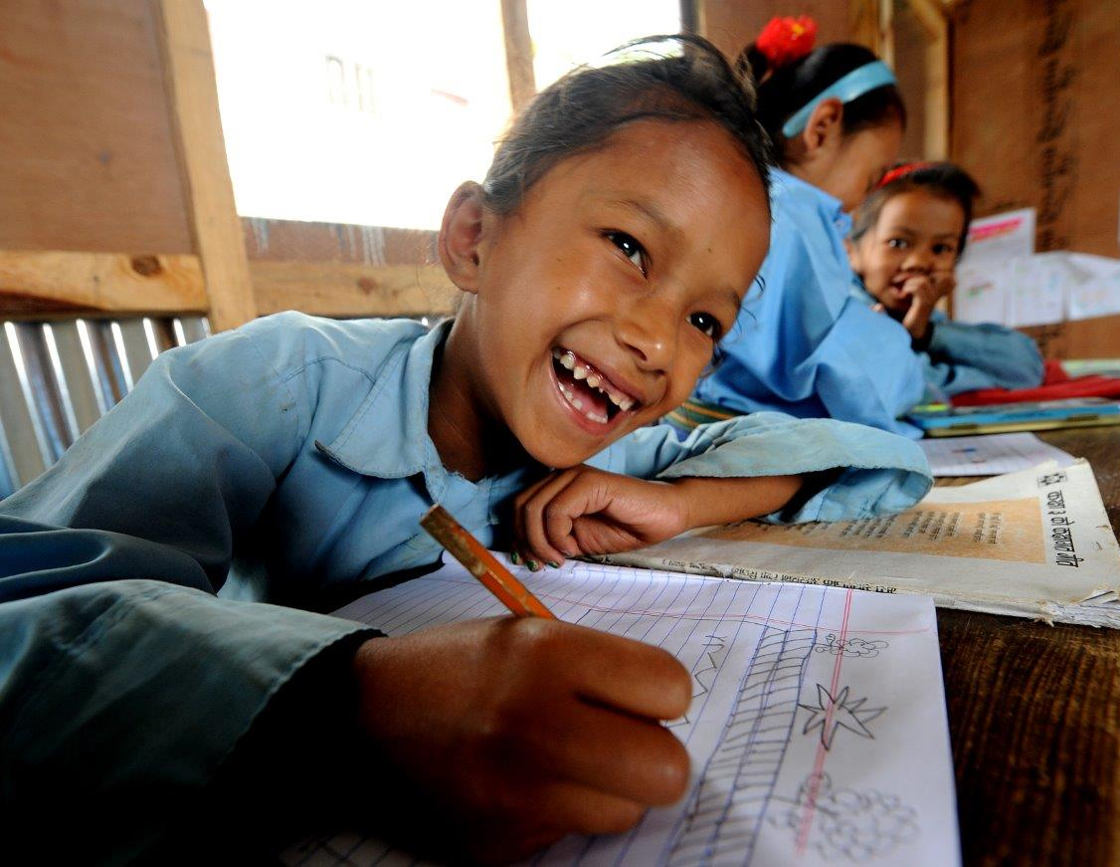
Figure 10: Manjari Tamang, 7, draws in a UNICEF-supported temporary learning centre (TLC) in Dolakha, one of the earthquake-affected districts in Nepal. More than 90 per cent of the district’s school buildings were damaged by the 7.3 magnitude earthquake that struck Nepal on 12 May 2015. Photo credit: CSKarki/UNICEF Nepal

trained on CSE using the revised manual. Likewise, a total of 219 (women: 44, men: 175) local government officials, elected representatives and school authorities have been oriented on the needs and importance of CSE. As co-chair of the Education Cluster, UNICEF has also helped strengthen the mechanisms for responding to emergencies by building reporting capacity at federal and provincial levels. In alignment with the Comprehensive School Safety framework, 75 local governments have developed a Disaster Preparedness Response Plan. Additionally, 878 schools in Karnali, Lumbini and Sudurpaschim have developed Learning Continuity plans.

Outcome 3: Resilience, Disaster Risk Reduction and Climate Change
“At the end of the monsoon season in October last year, massive rains hit our village located within the historically affected Karnali river basin in western Nepal. Unlike previous years, we were well prepared for the floods this time. We got early warning message about a high-probable severe flooding one week before the flood hit us. The early warning message helped us relocate our livestock in a raised embankment and store surplus food in a higher ground saving them from being swept away.  Given we had ample time to prepare, we managed to build a temporary shelter for our own safety.  The post floods response was also very swift this time. I received cash support just two days after the floods.”  - Anticipatory Action | 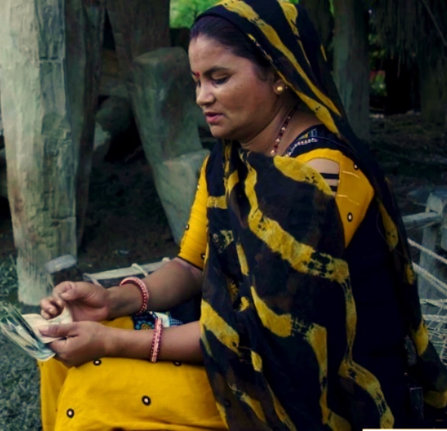  Amrita Kami, Bhada Karnali River Basin, Chisapani. Photo credit: WFP Nepal

Ram Pyari Chaudhari, who is a Community Emergency Response Team (CERT) Volunteer from Dakshinbehidi, Dhangadhi, reflects on the search and rescue training that she received
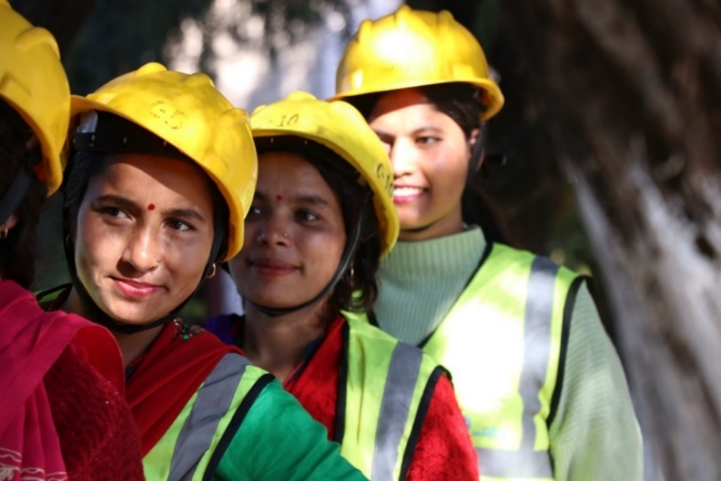 | She says, “In the training, I learned about rescue methods for earthquakes, flood, windstorms. In case an earthquake damages a certain place, we go for search and rescue. While doing so, we ensure our safety first. And accordingly provide first aid as well.”  - SUPER project

Outcome 3 - By 2022, environmental management, sustainable recovery and reconstruction, and resilience to climate change and disaster are strengthened at all levels.

In 2022, Nepal’s environmental management, sustainable recovery and reconstruction, and resilience to climate change and disaster risks continued to be strengthened at all levels. With UN support, progress was made towards goals and targets of the 15th Plan, in particular Goal 7. Healthy and Balanced Environment, and Goal 10. National Unity, Security, and Dignity, and targets 7.3 (Climate change adaptability), and 10.3 (Disaster-resilient society and economy). Building on ongoing work, the federal government continued to enhance its systems and procedures for integrating climate risk management and adaptation measures across sectors. The Ministry of Home Affairs (MoHA), NDRRMA, and the Ministry of Federal Affairs and General Administration (MoFAGA) collaborated for the roll-out and use of the BIPAD portal (https://bipadportal.gov.np/realtime/), an integrated and comprehensive DIMS initiated by the GoN, MoHA and currently owned, and managed by MoHA/NDRRMA. The national government continued to enhance its capacity to establish and operate this national DIMS, working together with the provincial and local governments, and municipalities as well as UN and partners for timely reporting on disaster events and preparation of provincial disaster resilience frameworks. Its development had previously been supported by the UN, who continued to provide technical support to the provincial and local expansion in 2022. Support for scenario-based earthquake impact modelling also assisted to finalize provincial disaster response plans and improve urban risk governance. Further, MoFAGA rolled out the web-based electronic building permit system (e-BPS) in 23 municipalities in partnership with the Town Development Fund to ensure safer construction for private houses.
Provincial and local governments partnering with UN Nepal have significantly increased financing and investment for disaster preparedness and environmental management this year. Sudhurpaschim Province increased its annual budget allocation for disaster preparedness by 71.16 per cent, while two partnering local governments increased their budget allocations by 67.2 per cent and 30.0 per cent respectively. Six other partner local governments also leveraged a combined NPR 25 million across three provinces. Two partner provinces now have an excess of USD 2 million allocated in their respective Disaster Management Funds. These increased allocations were achieved through regular UN advocacy, coupled with implementation of vulnerability capacity assessments and rapid needs assessments.
The MoFE finalized its NDC Implementation Plan and organized a series of events to celebrate the International Year of Sustainable Mountain Development, which culminated in the Mustang Declaration and Nepal’s contribution to the adoption of a UN General Assembly Resolution on Sustainable Mountain Development and shaping the mountain agenda during the UNFCCC COP 27 meeting. The National CCFF was reviewed; Provincial CCFFs drafted in four provinces and finalized in three province; and all seven provinces prepared climate-responsive budgets. Implementation of UNFCCC status was also reviewed.
The MoHP integrated climate risks and adaptation to further enhance climate resilience in Nepal’s health system through improved health sector planning and implementation, in line with international commitments. MoHP further conducted several high-level activities to inform relevant sections of the Nepal Health Sector Strategic Plan 2022 – 2030, with UN support. This included a COVID-19 Intra Action
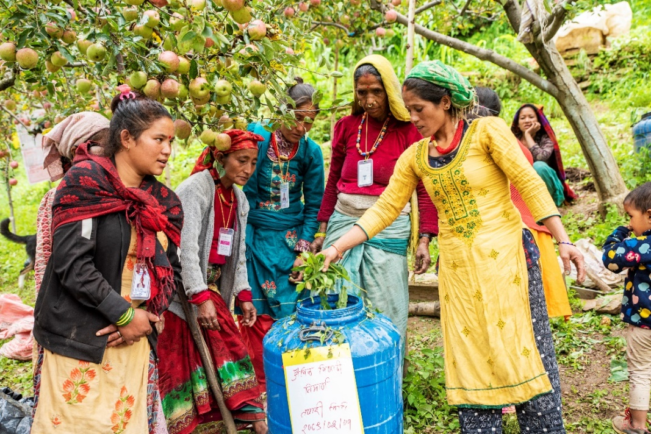
Figure 11:Farmers preparing organic pest in Karnali. Photo Credit: FAONepal
Review, a Health Sector Simulation Exercise to improve coordination for health response during emergencies, and an International Health Regulations Joint External Evaluation measuring status and progress on core health system capacities. Multi-hazard risks were also mainstreamed in local government plans. In 2022, 15 municipalities developed and updated child-sensitive LDCRPs to mainstream multi-hazard risk into local government planning. Additionally, three local governments developed LDRCPs incorporating local plans for disaster preparation and response that took SRH and GBV issues into account.

Output 3.1 - Strengthened capacity of national government to establish and operationalize National Disaster Information Management System (DIMS).
The capacity of MoHA/NDRRMA and MoFAGA was enhanced through training on DIMS of 80 (7 women) local government staff and representatives across 38
local governments in four provinces to strengthen the national DIMS/BIPAD portal, developed by the NDRRMA, with support from UNDP and UNICEF. This contributed to the localization of disaster information collection, timely response, and improved disaster risk governance of local governments. Further, development of daily situation reports was increasingly institutionalized and cluster coordination strengthened through the development of Earthquake Preparation and Response Plans and Provincial Disaster Resilience Framework and by embedding Information Management Officers in Provincial Emergency Operations Centres in two provinces.
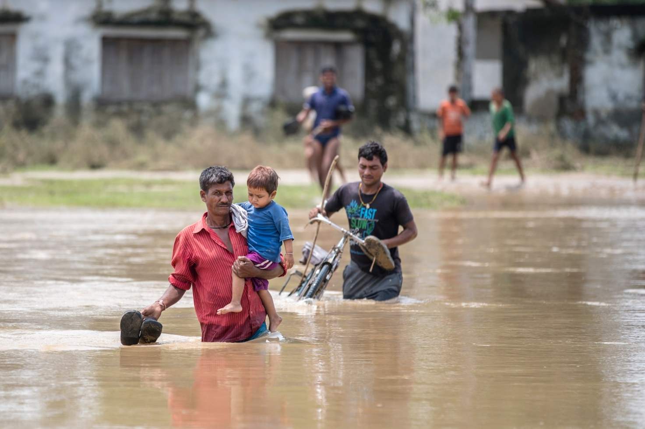
The capacity of MoHP was augmented through development of training manuals on climate change and health and roll-out of training at different levels, with support from WHO. The capacity on information management during all phases of disaster and public health emergencies was strengthened through further support to a network of Health Emergency Operation Centres at national and provincial level. MoHP capacity for early warning and reporting system and laboratory strengthening including implementation of influenza- SARS-CoV-2 integrated sentinel surveillance was also strengthened with WHO support, improving early detection, verification, and response to priority communicable diseases during disasters and public health emergencies. A Climate Resilient Water Safety Plan to ensure supply of safe water from catchment to the consumers level was developed, and a climate sensitive disease surveillance system has been enhanced in four hospitals. The capacity on climate resilience and environmental sustainability of healthcare facilities, and on environmental health, healthcare waste management and WASH in healthcare facilities has also been enhanced with WHO, UNICEF, and UNDP support.
UNODC conducted Open-Source Investigation training and Crime Scene Management training with an aim to strengthen the capacity of police and wildlife and forest officers’ to effectively address trafficking of wildlife and its products through collecting evidence at the crime scene.
With UNESCO support, Government capacity on Disaster Risk Management Planning for Cultural Heritage and the review and integration of Disaster Risk Management (DRM) in the Integrated Management Framework was enhanced through a series of workshops for key stakeholders of the Department of Archeology, Kathmandu, Lalitpur, Bhaktapur, and Changunarayan Municipalities, Nepal Army, Police, and Armed Police Force. A National Guideline on Climate Resilient Villages was drafted and endorsed by NPC with technical and financial support from UNDP.
Figure 12:Families in southern Nepal during the 2017 floods. Photo credit: UNICEF Nepal

Output 3.2 - Strengthened national and provincial institutional mechanisms and actions for climate change, disaster preparedness, response and recovery that are GESI-sensitive and guided by new policies and legislation.
Nepal’s policy and institutional mechanisms for integrating gender-responsive climate change adaptation, DRR and environmental management were significantly strengthened this year, notably through a number of high-level international processes. The commemoration of the International Year of Sustainable Mountain Development in Nepal culminated with the signing of the Mustang Declaration, and Nepal entering the Steering Committee of the Mountain Partnership, representing Asia and the Pacific, as well as acting as a founding member of the Ambition of the Melting Ice Group. A new UN resolution on Sustainable Mountain Development was adopted by the UN General Assembly, with Nepal playing a significant role in its development. The Nepalese delegation to COP27 also played an important role in negotiations to establish the historic Loss and Damage Fund, aimed at supporting countries most vulnerable to climate change to adapt and increase resilience. Altogether, these international roles and commitments, all substantially supported by the UN (FAO, UNDP, UNEP, UNESCO, UNFPA, UNICEF, UN Women, WFP, WHO) are testament to the GoN’s enhanced policy and institutional mechanisms to drive and contribute to the climate change/DRR agenda at global, national, and sub-national levels, providing a strong platform for future raised ambitions and actions in national, sub-national, and sectoral development planning. A Strategy for Enhancing Private Sector Engagement in Climate Change Resilience was also developed, with UNEP support to MoFE Following small-scale localized disasters in the far west, UNICEF, supported the government to reach 61,191 people (female 26,330) including around 22,000 children (11,325 girls) through life-saving humanitarian response in WASH, child protection, health in addition to shelter items such as tarpaulins and blankets in 23 districts. With FAO support 95 Metric Tons of improved variety seeds were provided to 3,200 Flood affected farmers (1,350 women) along with Shallow Tube Well (STW) irrigation support to 209 households, contributing to crop productivity enhancement, increased cropping intensity, ultimately contributing to food and nutrition security. With UN Women support, 250 women from vulnerable and excluded groups from flood-affected households in two municipalities accessed a comprehensive relief package consisting of food, non-food items, and essential supplies and services. Approximately 1,353 family members in these households benefited from this life-saving assistance. 15,324 (129 women with disabilities) women and girls of reproductive age affected by different emergencies benefited from dignity kits that includes essential supplies to address hygiene and protection needs, and 3,822 people (3044 female; 778 male) received psycho-social first aid through 17 CPSW and psycho-social counselors deployed, all supported by UNFPA. Similarly, 59 different sets of inter-agency reproductive health kits supported by UNFPA enabled access to SRH and GBV response services for more than 5,500 women and girls of reproductive age through health facilities in the affected areas. Further, 77 (69 women) received psycho-social and 44 women received legal support. 51,853 people (51% women) directly benefited from ecosystem services through promotion of nature-based solutions facilitating watershed restoration and rehabilitation, plantations and water use and reuse systems that have irrigated 213.73 Ha of agricultural land, supported by UNDP. Over 9,800 families also benefited from improved eco-cookstoves reducing indoor air pollution jointly distributed by UNICEF in partnership with six local governments in Karnali and Sudhurpaschim provinces. This directly reached 29,532 children and 19,688 women of these families, who enhanced their awareness on climate change impacts and adapting clean cooking solutions and now benefit from improved indoor air quality, better health, nutrition, and education for children as well as afforestation. WHO also continued support on addressing health impacts of air pollution and reducing health hazards from haphazard use of chemicals.
With technical support from FAO, MoFE developed 26 Critical Ecosystem Restoration Plans for 26 river systems in the Churia, Dun Valley, Bhavar and Terai regions to enhance the climate resilience of vulnerable communities, potentially reaching a total of population of 3,216,248 residing in these areas, directly or indirectly. The capacity of a total of 302 (158 women) officials was also enhanced on Climate Change and Land Use planning; Ecosystem Mapping and Land monitoring using Geospatial Tools. Similarly, a total of 567 people (296 women) including Indigenous People Organizations were trained on climate change impacts and ecosystem mapping, and gender mainstreaming, all supported by FAO. A One Health Action Plan has been prepared and is in the process of endorsement by the Gandaki Provincial Government, and draft Action Plans are also in the endorsement process in Province 1 and Sudhurpaschim province. A DRRM Policy and Strategy was developed in Province 1, with IOM support. In support of local governments meeting Nepal’s NDC target of net-zero emissions by 2045, Lalitpur Metropolitan City developed a ‘Guidelines for Green Infrastructure Development in Heritage Area, Green Economy through Eco-tourism development Plan and Directive’, with support from UN-Habitat. Four public infrastructures were reconstructed in line with municipal and heritage settlements guidelines in the Kathmandu Valley. Additionally, 136 hectares of degraded forest, 150.98 hectares of rangeland, and 355 hectares of terrace have been restored or improved through
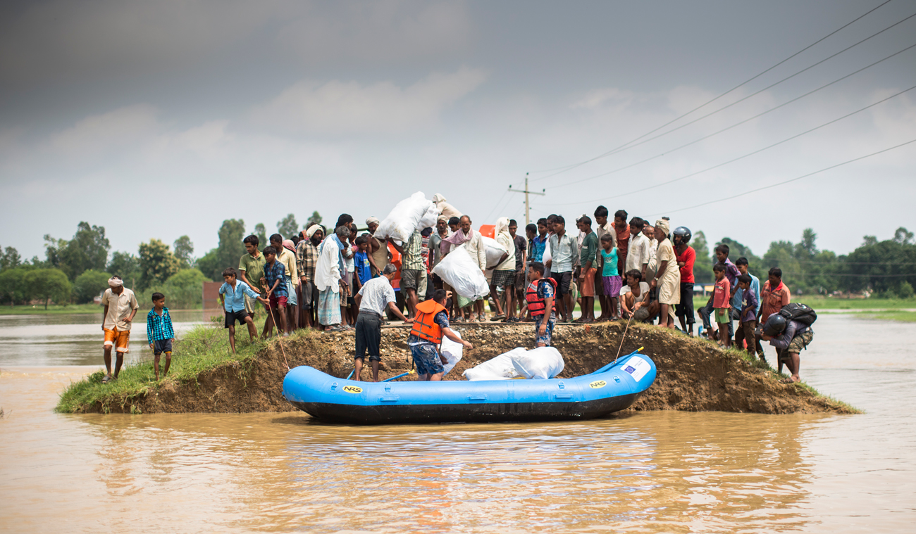
Figure 13: Families affected by the 2017 floods receiving aid in southern Nepal. Photo credit: UNICEF Nepal
planting of more than 455,000 seedlings/rhizomes, and 38 filtering dams and 45 water conservation ponds have been constructed or restored, benefitting more than 1,400 households in three districts, all with support from UNEP.
With support of FAO, a total of 85 (25 women) officials from federal and provincial government were capacitated on animal health data visualization using QGIS (open-source geographic information system) and epidemiological reporting. Capacity of poultry and pig farmers enhanced in strengthening biosecurity measures in their farms and promoting rational use of antibiotics.
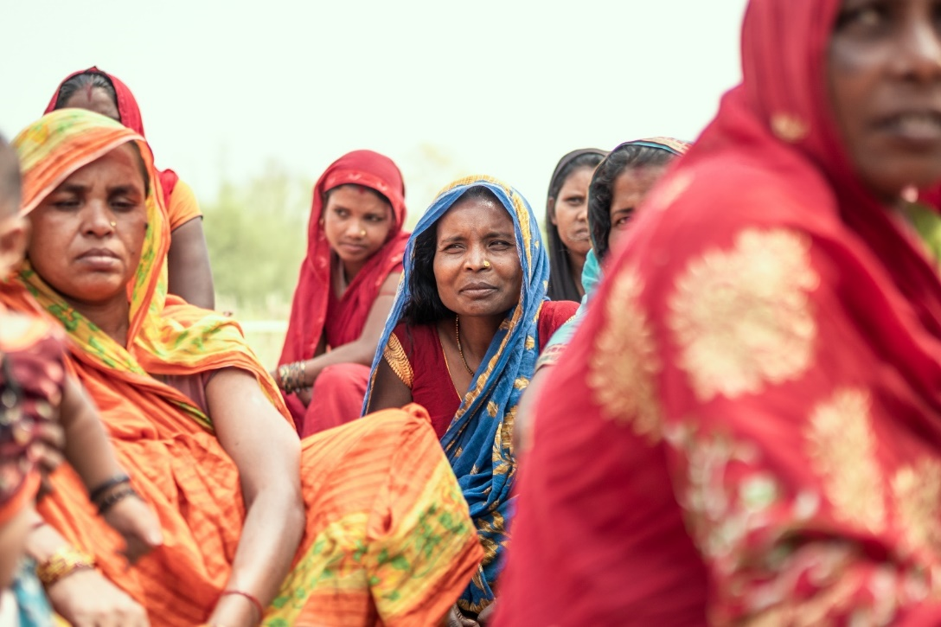
The capacity of 513 (232 women) government SRH officers from the government institutions and GBV service providers, District and Local Disaster Committee Members, and other stakeholders was enhanced through trainings on disaster management, SRH, and prevention and response to GBV in emergencies in seven provinces, with support from UNFPA. The amended Standard Operating Procedure for GBV prevention and response in emergencies was submitted to MoWCSC for approval in compliance with the new post-COVID COVID-19 scenario. Capacity of 165 representatives (60 women, 10 LGBTIQA+) from provincial and local governments, and CSOs in Lumbini and Sudhurpaschim provinces were also enhanced on GESI responsive disaster preparedness, risk mitigation and disaster resilience. This was facilitated through a series of events organized by UN Women, UNICEF, and UNDP as part of the joint SUPER project. Similarly, with support of FAO, a total of 85 federal and provincial government officials were capacitated on animal health data visualization using QGIS and epidemiological reporting.
Two Standard Bidding Documents for Performance Based Road Maintenance and Supply and Delivery of Medicines and Medical Consumables were developed and the capacity of 75 local and provincial government officials through Procurement and Contract Management Clinics was enhanced, with
Figure 14: Members of one of the women’s groups during their monthly gathering in Saptari district. Photo credit: UNRCO Nepal
UNOPS support. Further climate resilient WASH and sports facilities were enhanced in 13 schools, as well as environmental disaster protection, and maintenance of basic infrastructure to ensure child rights in 24 schools across four districts. Additionally, resilience of nine health facilities was enhanced through Health, Safety, Security, and Environment assessments and Operation and Maintenance activities and a Health Quality Assessment audit of Mechi Provincial Hospital. Additionally, 11 local services/infrastructures were reviewed as part of the women’s safety audit. The recommendations generated through this exercise were shared with local and provincial governments to improve public services to ensure safety and security for women and girls. Key guidelines, checklists, and SOPs were also developed to strengthen GESI integration in DRR and climate change adaptation, including A Practitioner’s Guide on Financing for Gender Equality in Humanitarian Action | Publications | UN Women – Asia-Pacific; A Resource Kit for gender equality, disability, and social inclusion mainstreaming in DRR, and a GESI Checklist on Disaster Preparedness and Response.

Output 3.3 - Enhanced capacity of local governments for risk-informed GESI sensitive planning and implementation of CCA and DRR actions.
In 2022, the capacity of more than 19,904 (4,871 women) local government officials and representatives across 702 local governments was enhanced on DRM, utilizing the DRM localization manual developed with support from IOM in collaboration with MoFAGA. This resulted in more than 15 local governments allocating additional budget for DRM activities. Similarly, 149 (63 women) provincial parliamentarians across the seven provinces enhanced their capacity on DRM and management of Provincial Emergency Operation Centres. 104 (20 women) provincial and local government officials also enhanced their capacities on incorporating GESI and protection in policies, institutional mechanisms, and plans of provinces and local governments, following joint support by UNICEF and UN Women. Similarly, capacities of 291 (241 women) representatives from organizations working for the rights of women and vulnerable groups were strengthened to engage with provincial and local governance processes and to advocate for gender-responsive plans and programs, decision making and coordination mechanisms in the DRRM sector.
Capacities of three provincial and four local level Emergency Operation Centres have been further strengthened to ensure effective communication, information management, and coordination related to disaster risks. This comes as a result of UNDP’s and UNICEF’s long-standing support, including through capacity development, provision of necessary IT equipment, pre-positioning of search and rescue equipment, mapping of at-risk wards and critical infrastructure, and community awareness raising.
Provincial and urban disaster preparedness was enhanced in three provinces and four municipalities through conducting earthquake impact modeling. Further, Rapid Vulnerability Assessments, disaster risk mappings, and related capacities and resources were enhanced in six wards through geographic information systems (GIS) mapping exercises, resulting in preparation of 12 maps for wards at high risk of multiple hazards. Comprehensive plans for post-COVID-19 green recovery through Sustainable Integrated Municipal Waste Management were developed for four municipalities, with UNDP support. The capacity of 100 CERT volunteers and 188 people (104 women) on earthquake simulation and of 31 media personnel on humanitarian reporting was enhanced through UNICEF joint UN support (UNDP, UNICEF, UN Women), contributing towards improved shared understanding/anticipation for managing earthquake and urban risks.
With UNFPA's assistance, three local governments created plans for local disaster preparedness and response that included MISP for SRH in emergencies and GBV issues. With UNICEF support, 15 child-sensitive LDCRPs were developed, and multi-hazard disaster risk plans were mainstreamed into local government planning. Similarly, UNICEF capacitated and mobilized over 3,200 child club members (1,500 girls) on raising awareness on DRR actions related to earthquake, flood, and fire preparedness., and supported with non-structural small-scale mitigation actions benefitting over 2,547 children (1,430 girls).

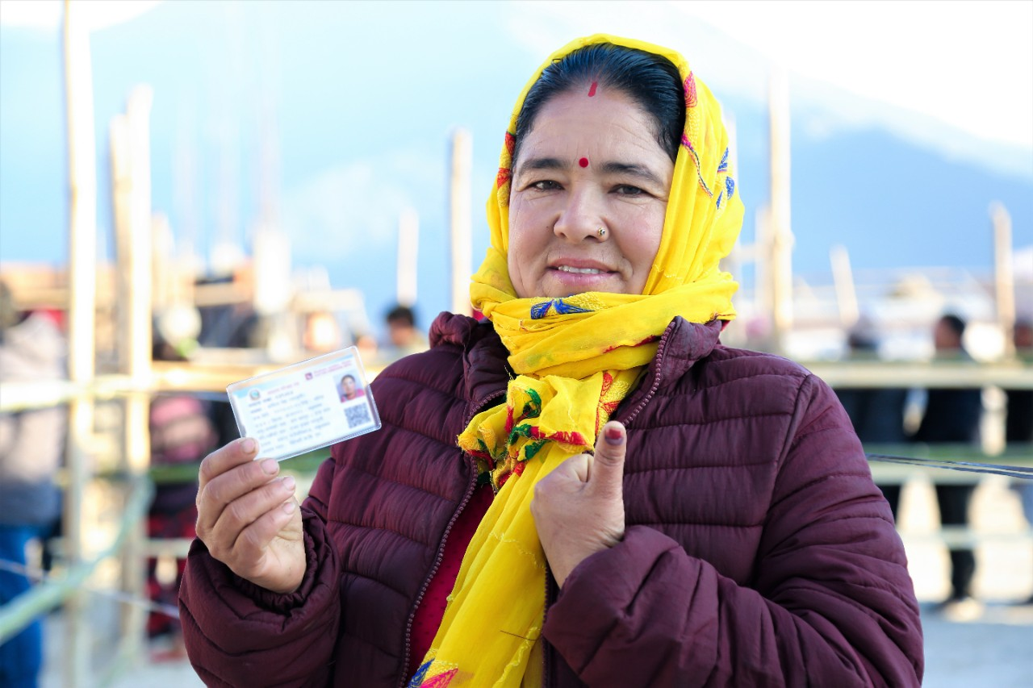
Outcome 4: Governance, Rule of Law and Human Rights
Figure 15:A woman after participating in election in 2017. Photo credit: UNDP Nepal

Outcome 4: Governance, Rule of Law and Human Rights

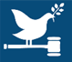
Outcome 4 – By 2022, inclusive, democratic, accountable, and transparent institutions are further strengthened towards ensuring rule of law, social justice and human rights for all, particularly for vulnerable people

Figure 16 Elected representatives by gender (% women, % men) at local, provincial, and federal level.
In 2022, the ECN conducted peaceful, democratic elections, including at the local level in May, and the federal and provincial levels in November, thus demonstrating its increased capacity. Women secured 41.2 per cent of elected positions at the local level, 36.8 per cent at provincial level, and 33.8 per cent at federal level (House of Representatives), marginal improvements compared to the 2017 elections. The peaceful conduct of the second round of democratic elections for all levels of government in the federal structure is a major building piece for the implementation of inclusive, democratic, accountable, and transparent institutions in the federal structure. It also a significant contribution to goals and targets of the 15th Plan, including Goal 9. Comprehensive Democracy, andindicator 9.1.1 (Participation of voters in elections). The UN has provided long-standing capacity development support to ECN since 2008, significantly contributing to its capacity to independently conduct elections, including dedicated support to voter education and outreach, and preparation of relevant guidelines in 2022.
With UN’s continuous advocacy and support, amendments to the law related to sexual violence has been made, increasing the statute of limitation for reporting of rape from one to two years for adults. For minors, a case can be filed within three years after a child turns 18 years. However, complete removal of the statute of limitations in cases of rape is yet to be achieved. The Government endorsed the Children’s Regulation, 2022, paving the way to reduce violence against children by establishing additional minimum criteria for the establishment and operation of childcare and child correction homes, special protection needs, management of children funds, operation of helpline services, and provision of social welfare.
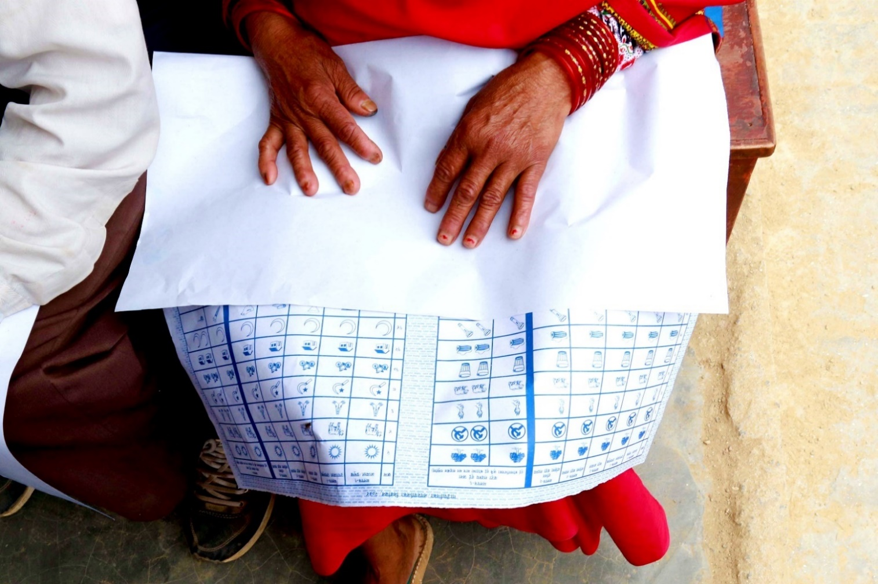
The Government finalized and adopted the post UPR Implementation Strategy to steer the effective implementation of the third cycle of UPR recommendations. The strategy provides guidance in terms of coordination and collaboration, integrated information management, and reporting on implementation. A committee is being formed to monitor, gather and provide oversight. The UN provided technical and logistical support to conduct multiple dialogues and consultations as part of the preparation of the strategy, in close partnership with NHRIs and the Office of the Prime Minister and Council of Ministers.

Figure 17:Communities participating in mock poll before the election in Nepal. Photo credit: UNDPNepal

Output 4.1 - The federal government, national parliament and select national commissions have enhanced capacity and tools to implement national commitments, including the Constitution and support the transition to federalism to advance human rights and inclusive governance.
In 2022, the federal government, parliament, and constitutional commissions gained further increased capacity to support the implementation of federalism, advance human rights and gender-responsive and inclusive governance. In addition to ECN’s enhanced capacity to conduct peaceful, democratic elections (reported above), the federal House of Representatives endorsed the Bill to Amend Some Acts on Criminal Offences and Criminal Procedures, with UNDP contribution to the drafting and review process. Parliamentary Committees furthered the legislative reform process, including by adopting an approach to assess and conduct post-scrutiny of laws related to for example untouchability and domestic violence. Over 50 policies, laws, and strategies relevant for implementation of the Constitution, including on coordination and dispute resolution between provincial and local governments, election conduction and management, sexual violence, criminal offences, and technical education councils, were drafted or reviewed in 2022 with UNDP support, identifying major gaps to be addressed in line with the Constitution. Pending Cabinet endorsement, these laws will significantly impact progress towards inclusive governance, service delivery, and public sector reform. Similarly, a draft amendment to the Women’s Rights Bill to strengthen 42 laws focusing on the implementation of Article 38 of the Constitution on women’s rights was drafted with UN Women support and submitted to the Parliamentary Committee on Women and Social Development. Support was also provided to finalize and adopt an online law-making course and guideline on law drafting for provincial governments.
A consultative assessment on the implementation of federalism was conducted by a National Assembly Special Committee, identifying key issues, challenges, and recommendations for the effective implementation of federalism. 304 (145 women) Members of Parliament enhanced their capacity and confidence to substantially contribute to parliamentary affairs. UNDP contributed to these results through its long-standing capacity development and technical support to the federal and provincial parliaments, and in collaboration with the MoFAGA.
The capacity of the Ministry of Finance (MoF) was strengthened to apply GRB across the public financial management system. This was facilitated through the development and completion of a gender responsive public finance management (GRPFM) report that includes recommendations to strengthen GRPFM practices. MoF expressed a strong commitment to take forward the recommendations of the report. UN Women provided technical and funding support to its partner Nepal Administrative Staff College to conduct the assessment and finalise the report.
Sustained engagement on the need for increased domestic investments towards the national HIV response culminated in government making a commitment to amending the Procurement Act to allow for financing and contracting of CSOs (social contracting) on a multi-year basis. The proposed social contracting mechanism is to come into effect in the course 2023.
The National Women’s Commission (NWC) prepared a report to monitor the implementation status of the Convention on the Elimination of All Forms of Discrimination Against Women (CEDAW) Concluding Observations issued by CEDAW Committee in 2018, with UN Women support. The report identifies gaps and progress made in key areas related to gender equality and women’s empowerment (GEWE). NWC also finalized its internal strategy, as well as an analysis of GESI in the local elections, with UNDP support. Similarly, the MoWCSC prepared a draft report as part of preparation for the seventh CEDAW report from the government based on consultations held at the provincial and federal level with relevant government agencies and CSOs, supported by UN Women and UNFPA. A joint coordination strategy on human rights for all constitutional commissions was also developed with UNDP support, followed by seven joint human rights monitoring visits during the elections.
Significant progress has been made in addressing the Committee on the Rights of the Children (CRC) recommendations on child protection. Based on one of the CRC's concluding observations, the National Child Rights Council has adapted and piloted the Child Protection Information Management System for effective case management of vulnerable children, with support from UNICEF. The Child Rights Information and Monitoring System is finalized and rolled out to consolidate child rights data from various sectors. These initiatives have helped to harmonize and consolidate data on child protection and child rights to provide effective and timely service delivery and referrals to appropriate service providers (social, legal, health, education).

Output 4.2 - Provincial and Local Governments have the systems and capacity to deliver inclusive services in a transparent and accountable manner in line with SDGs.
Provincial and local governments increasingly have systems, procedures, and capacities in place to effectively implement their Constitutional mandates and deliver inclusive services. While much work remains to ensure fully inclusive, transparent, and accountable sub-national governments, progress was made in 2022, including most notably through the successful completion of the second round of provincial and local level elections.
All 753 local governments completed income and expenditure estimations, budget approvals, and treasury operations in the online budgeting and reporting system, developed with UNDP technical assistance to MoFAGA. Fiscal federalism was further advanced through enhanced local government financial management systems, and development of internal audit guidelines. Five local governance guidelines related to fiduciary risk management, community mobilization, Ward Office operationalization, internal control systems and capacity development were developed and rolled out to enhance the institutional capacities at local levels for inclusive and transparent service delivery. Key model laws, guidelines, and strategies were developed to serve as reference for preparation of provincial and local government laws and policies, including related to good governance, senior citizens, persons with disabilities, PSEA, and harassment, and gender equality and social inclusion. Two provinces endorsed codes of conduct against sexual abuse and harassment in 2022. As a result, 20 local governments adopted capacity development guidelines, building on a model plan prepared through UNDP support to the MoFAGA.
A total of 23,347 (4,702 women) newly elected local government representatives enhanced their understanding of planning, programming, procurement, and service delivery through induction trainings developed and conducted with UNDP’s technical assistance. Similarly, 12,360 (4,436 women) local elected representatives enhanced their understanding of key acts and procedures, and 246 Provincial Assembly members (44% women) enhanced their capacity on Parliamentary affairs. As a result, their confidence level increased, and they were able to better contribute during thematic discussion in committees and plenary sessions. 2,472 (895 women) provincial and local government officials and GESI focal persons enhanced their understanding of GESI/GRB across the seven provinces, as a result of joint support by UNDP and UN Women to MoFAGA and the National Administrative Staff College to establish and train a pool of 32 (25 women) master trainers at federal and provincial levels.
With UNICEF's ongoing advocacy and support, 308 municipalities developed child rights’ protection procedures; 222 have formed child rights’ committees; and 219 have appointed child welfare officers as prescribed in the Act Relating to Children 2018. A further 486 stakeholders from local governments enhanced their knowledge on the importance of increased budget allocation for mental health and psychosocial support, with UN Women support, resulting in increased commitments and actions related to mental health.
308 Municipalities  developed child rights Protection Procedure | 222 child rights committees  established | 219 municipalities  appointed child welfare officers

To strengthen accountability, a grievance handling system was developed and launched in two provinces with UNDP support. In the first year of roll-out, 487 grievances were received, with 19 per cent settled. The system has also contributed to enhancing inter-governmental relations between relevant provincial and local governments.
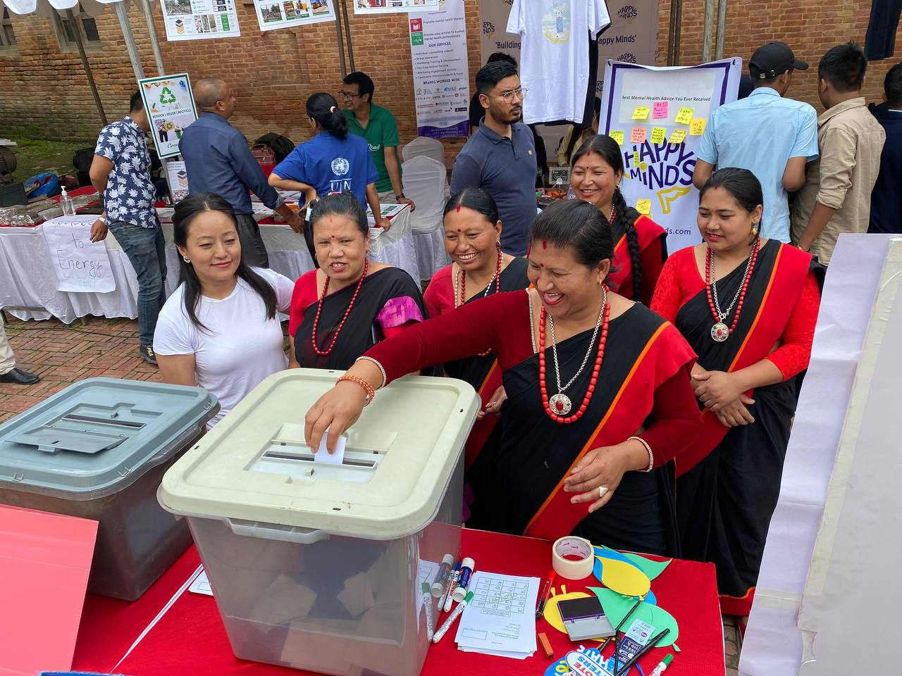
GBV and SRHR issues have been included in the first periodic plan of Sudhurpaschim Province. Madhesh and Lumbini Provinces also received technical support from UNFPA to incorporate similar provisions in their respective plans. Through continuous advocacy, engagement and support to the MoWCSC of Lumbini Province; the ministry has established a fund of NPR 5 million to support survivors of GBV and trafficking. The Protection Monitoring and incident reporting, supported by UNFPA, led to the increased use of data by local governments to inform decision making including

Figure 18:An enumerator interviewing a woman in Simkot Rural Municipality during a socio-economic vulnerability assessment of vulnerable women in Karnali province as part of UNDP Nepal's initiative to address socio economic vulnerability of women through temporary basic income in Nepal. Photo credit: UNDP Nepal.

recognition of GBV risks. Provincial Ministries of Social Development were also supported by UNFPA to expand province-level GBV networks comprising CSOs that can monitor and provide strategic guidance to GBV prevention efforts at the province level. Sudhurpaschim Province endorsed the Dalit Empowerment Act, 2078 which will provide an enabling legal environment to advance Dalit rights, all with UN Women support to conduct consultations and drafting. Karnali Province adopted a Gender Equality and Social Inclusion policy which aims to guide and institutionalize GESI, and the Disability Rights Policy of Sudhurpaschim Province is in the final stage, both developed with technical support from UNDP. Likewise, UNFPA supported the development of eight provincial and local GESI Policies in Province 1, Madhesh, Lumbini and Sudhurpaschim provinces. UNFPA’s support also led
to the endorsement of guidelines for the mobilization of GBV Elimination Funds in 18 municipalities in Province 1 and Sudhurpaschim Province, with approximately USD 40,000 allocated for the current fiscal year.
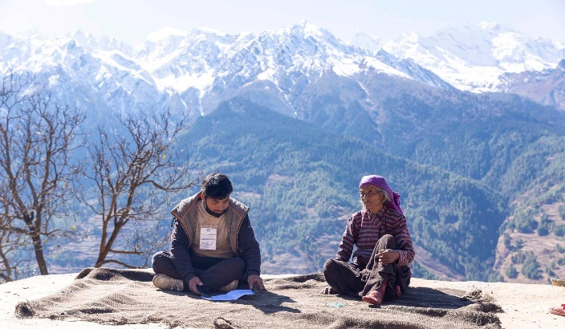
An inter-ministerial coordination committee on migration and sustainable development was established in Province 1, supported by IOM. Similarly, IOM organized provincial level dialogues in all seven provinces with provincial multi-stakeholders from planning commissions, private sector, and provincial governments. Dialogues were also organized to enhance capacity of federal ministries, CSOs, training institutions and migrants on the skills, upskilling and recognizing prior learning of the migrants and their reintegration in Nepal upon return. The outcome of the provincial dialogues will support the provincial and federal policymakers and practitioners in policy planning and program design capacities to better address the needs of the migrants and support reintegration, all supported by IOM. Capacity was also enhanced of 452 (209 women) point of entry officials and frontline workers on risk communication, community engagement (RCCE), health protocols and accountability at six designated ground crossing points, contributing to enhanced operation and sustainability of health desks and provision of water and sanitation, with IOM support.

Output 4.3 - Voice, agency and engagement of civil society strengthened for broadened civic space in line with the principle of leaving no one behind.
More than 3.5 million people were reached with election information and voter education messages supported by UNDP through various medium. Among them, approximately 14,000 people (more than 40% women) from marginalized groups, including youth, Dalits, and persons with disabilities, gained a better understanding of electoral processes and political leadership with support from UNDP and UN Women. UN Women and UNHCR have supported the establishment and strengthening of at least 21 networks and dialogue platforms for women, persons from excluded groups, refugees and host communities. A total of 1,620 women and persons from excluded groups have enhanced their
Figure 19: Women enthusiastically participate in a mock polling organized by UNDP's Electoral Support Project. The project conducted voter education program along with mock poll during elections of Local Level, Provincial Assembly and House of Representatives in 2022 reaching out to more than 28,000 people. Photo credit: Mohammad Shahid Reza/UNDP Nepal.
capacities to form and roll out 21 Community Safety Nets across Nepal, and 41 of the members supported by UN Women were elected to federal, provincial, or local government positions. Similarly, three local governments have institutionalised Youth Friendly Local Governance to promote youth civic engagement in local development processes. Contributing to this, UNDP and UNICEF, jointly with the National Youth Council, strengthened capacities of 238 participants (84 women), including local elected representatives, officials, youth, and CSOs leaders from seven local governments. More than 150,000 youth were engaged in discussions on youth aspirations and political engagement through a theatre show widely shared through social media.
UNV supported UNDP in Nepal to promote voter education during the local and general elections in 2022 through the recruitment of 445 UNV Online Volunteers (45% women and 2.5% with disabilities) as social media campaigners for the voter education campaign My Vote Matters Nepal. 200,000 young people of Nepal were benefitted by this campaign.
Access to information among women and excluded groups about COVID-19 prevention measures, vaccination, and GESI-related issues during pandemic and disasters was enhanced through a communication campaign conducted by UN Women reaching a total of 1,145,000 individuals through radio, social media, and online platforms, as well as 5,440 households through door-to-door visits. Similarly, over 60,000 people were sensitized on parliamentary affairs through outreach supported by UNDP, including radio programs on governance, GBV, and women’s political participation. More than 100 women journalists enhanced their capacity to apply physical and online safety measures during reporting, through UNESCO and UNIC support. An Online Safety Guideline for Nepali Women Journalists was also developed and is pending adoption by the Ministry of Communication and Information Technology and the Press Council Nepal to better account for online threats.
The UN in Nepal together with UNESCO, UNFPA, and Yuwalaya commemorated the first International Day for Countering Hate Speech on 23 June 2022. The first of a kind interaction on understanding contemporary trends and challenges in hate speech brought together over 50 youths to join the discussion on tackling on and offline hate speech together. The speakers shared and offered perspectives on different aspects of the hate speech phenomenon to raise public awareness on the importance of addressing the issue in line with international human rights standards.
A total of 200 cases have been registered with the NHRC through the mobile app to register cases of human rights abuse. The app has also been effective to share human rights related information to CSOs, human rights defenders and communities.

Output 4.4 - Justice sector and law enforcement institutions strengthened to provide greater access to justice, including transitional justice, in accordance with the constitution and human rights standards.
Justice sector and law enforcement institutions are strengthened to provide greater access to justice, including transitional justice, in accordance with the Constitution and human rights standards, and contributing to targets and indicators of the 15th Plan, including related to Goal 8. Good Governance, and targets 8.1 (Rule of law), and 8.2 (Public integrity, transparency, and accountability). The second National Action Plan for the implementation of UN Security Council Resolution 1325, 1820 on Women, Peace, and Security (FY 2022/23 – 2024/25) was endorsed by the cabinet in October 2022 and UN agencies (IOM, UNDP, UNFPA, UNODC, UNRCPD, and UN Women) are jointly working for its implementation. UN agencies provided technical inputs to incorporate victim centric provisions, proposed mechanisms/approaches, and provided recommendations from various studies along with financial support (since 2018) for the drafting and consultation process. Further, the Legal Aid Bill, together with an integrated Legal Aid Policy was finalized this year and is pending Cabinet approval, following consultations with a wide range of stakeholders, with UNDP support. Once endorsed, it will ensure the fundamental right of free legal aid to all.UN agencies (UNDP, UNICEF, UNODC, UN Women) strengthened the institutional capacity of various government institutions and constitutional commissions such as the NHRC, Office of the Attorney General, and Nepal Police’s Women, Children, and Senior Citizens Directorate to deliver their mandate through effective monitoring, investigation, case settlement, development of specialized training manuals, evidence generation and analysis related to cases of VAWG. UNODC undertook a landmark study to analyze how the Nepalese criminal justice system responded to reported cases of rape and sexual assault. The aim was to identify the key legal, procedural and institutional factors that influence the disposition of cases.
Supported by UNDP, UNICEF, and UN Women, a total of 1,519 (610 women) officials of justice and security authorities strengthened their capacity to provide gender-sensitive and child-friendly justice. Similarly, 6,488 people (4,072 women) accessed free remedial legal aid services, and 24,670 people (16,922 women) enhanced their awareness of available legal aid services and procedures, all achieved through UNDP’s collaboration with federal and district legal aid committees and CSOs
Government capacities and mechanisms have also been strengthened for data management, documentation, and implementation of the principle of non-refoulement and other refugee protection principles, with support from UNHCR on the development and implementation of related policies and procedures, including with the National Unit for the Coordination of Refugee Affairs.
Public awareness, media engagement, stakeholder dialogues and platforms supported by the UN in Nepal and its partners have also contributed to encourage the Government to take steps to address gaps in the Citizenship Act and to strengthen civil registration and vital statistics, in line with the 2020 UNCT Guidelines on Legal Identity.

Output 4.5 - High quality disaggregated data available for policy formulation and programme planning, monitoring and implementation.
In 2022, the Nationals Statistics Office (formerly Central Bureau of Statistics) continue its efforts to ensure that the analysis and dissemination phase of the national census (fieldwork in November 2021) is of high quality, to international standards, and the data is widely disseminated and used. UNFPA contributed to this through technical and financial support to statistical capacity gap assessments of data users, technical advice assistance on the selection of appropriate technologies and data processing system, development of tabulation plans and reports, stakeholder consultations, design and implementation of census publicity and communications plan, analysis, and dissemination of census results, census mapping, demographic analysis, population projects, and use of census data. The NSO was further supported during the release and wider dissemination of the Census Preliminary Results Report to a range of stakeholders including all tiers of government, CSOs, academia, development partners, UN agencies, and public users. This was preceded by UNFPA support to conduct a technical review of the preliminary results for quality assurance of the forthcoming final Census results. In addition, support was provided to develop a Census observation report, including lessons learned, challenges and issues encountered related to conducting the Census, as well as a Census risk assessment at various levels which informed designing risk mitigation strategies in the pursuit of thorough preparations for successful and inclusive census data dissemination and effective communications to ensure trust and ownership in the results and use. Support has also been provided to NSO in preparation for conducting a Household Disability Survey in Nepal, using the Census framework.
Further, a baseline study on cross border mobility and a Mapping of Reintegration Services in Nepal was conducted by the MoHP, with support from IOM, aiming to generate evidence for effective reintegration programmes at all tiers of government. Furthermore, to support in evidence generation, IOM together with MoEST, MoLESS and Council for Technical Education and Vocational Training (CTEVT) conducted a “Similarly, the Macro level supply-Level Supply and Demand Analysis of the Skills of Nepalese Migrant Workers” that, conducted by MoEST, MoLESS, and CTEVT with IOM support, provides a more comprehensive picture of supply and demand side of skills in the key destination countries for Nepali migrants including in the domestic market for, as well as for more effective reintegration upon return.

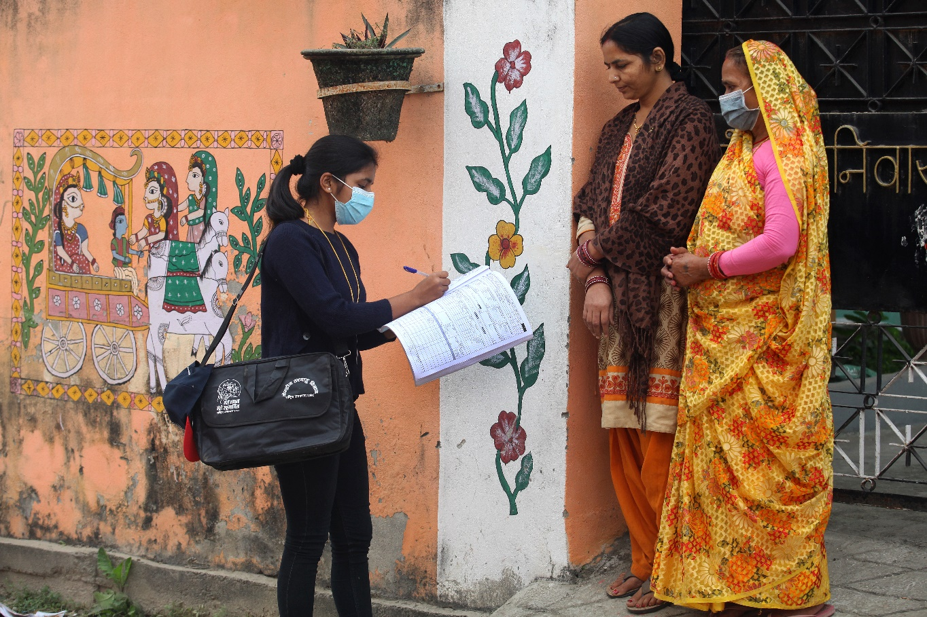
Figure 20: Enumerator collecting data during the latest census in Janakpur. Photo credit: UNFPANepal

2.3. Support to Partnerships and Financing the 2030 Agenda
In 2022, the UNCT deepened the strong partnership with all levels of government to enhance sustainability and resilience in planning, budgeting, and implementation of joint initiatives.
In 2022, the main UNCT initiatives focused on financing the 2030 Agenda have been:
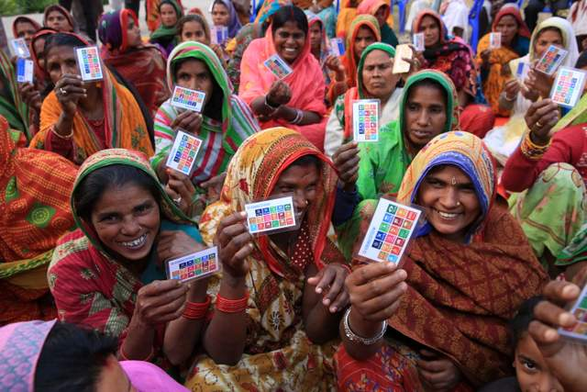
- Federal, provincial, and local governments capacity on SDG financing was significantly strengthened in 2022, as a result of the joint UN support (UNDP, UNCDF, UN Women) funded by the Joint SDG Fund. This included the formulation of SDG resource books, MTEFs, GRB and Revenue Improvement Action Plans to approximately 1,032 local government officials. Going forward, UNDP will continue to provide support to translate the increased capacity for strengthened SDG coding and resource allocations in provincial and local governments budgets.
- The Government submitted its report on SDG Indicator 5.c.1 that measures the proportion of countries with systems to track and make public allocations for GEWE. SDG Indicator 5.c.1 is part of global SDG monitoring framework and measures progress towards Target 5.c, linking national budgets with efforts to implement laws and policies on gender equality and the empowerment of women and girls. UN Women coordinated with the MoF and UNDP for data collection and validation for this indicator.
- IOM liaised with the federal, seven provincial, and 702 local governments to enhance DRRM, through development of guidelines, plans, SOPs, training packages, as well as local acts and policies. The increase in the provincial and local government
Figure 21:Women from Southern Nepal affected by floods showing their cards as a proof of receiving humanitarian aid. Photo credit: UNDPNepal
budgets in DRRM sectors partly was a noticeable impact. For instance, budget allocation in DRRM in Sudhurpaschim Province increased from NPR 10 million in 2077/78 (2019/20) to NPR 40 million in FY 2029/80 (2021/22).
- Through UNICEF’s advocacy and facilitation, six partner municipalities allocated around 50 per cent of cost, (i.e. NPR. 28.32 million, approx. USD 217,906), as budget for procurement of eco-stoves under the Eco Zone project. The project further demonstrated financial innovation by introducing carbon finance and market-led financial products’ development at the local level.
- Contributing to the sustainability of projects, and demonstrating Government commitment, UNDP leveraged government financing to support ongoing interventions on Climate Change Adaptation/DRR. USD 1.78 million was mobilized by the Government to enhance the resilience of ecosystems of vulnerable watersheds of Okhaldhunga and Khotang Districts, and USD 800,000 was leveraged from local governments and local partner organizations for the establishment of waste processing and segregation centres.
Strategic partnerships within the WASH and nutrition sectors were pursued as well. Two concrete examples are:
- Strategic partnerships with the Water Federation of Drinking Water and Sanitation Users Nepal, Municipal Association of Nepal and the National Association of Rural Municipalities in Nepal created enabling conditions for improved WASH sector governance at local level. The partnership remained instrumental in strengthening basic operational knowledge and skills to enhance capacity of municipalities to plan and leverage local resources.
- Continuous partnership with NPC has brought all nutrition partners such as UN agencies, Government sectors, development partners, International Non-Governmental Organisations (INGOs), CSOs, and private sectors together for MSNP interventions in Nepal including planning, implementation support, information management, and M&E and leveraging of the resources at all tiers of government. This wider partnership has enhanced the capacity (knowledge, skills) of government and other partners including leveraging of the financial resource for nutrition programme.
- Under the leadership of the NPC, FAO and WFP are working together to support the national food system transformation and food security management. They supported NPC to draft Food system transformation, including through development of an operational strategy 2022 and M&E framework for implementation and monitoring the action tracks of pathways of food system transformation.
Partnerships around children's development and protection, and reproductive health were scaled up in 2022.
- UNICEF, WHO, WFP, and World Bank along with other I/NGOs are working together forming an ECD Consortium for advocacy and collectively assist government on policy development, planning and implementation of the integrated ECD programmes.
- Through the UNFPA-UNICEF joint global programme to end child marriage, both agencies have been working collaboratively in partnership with other organizations at all levels of the government to support the government to address child marriage.
- In 2022, UNFPA signed a compact agreement for the UNFPA supplies partnership with GoN. The compact agreement is the mutual understanding of working together for ensuring Nepal’s financial contribution to quality Reproductive Health/Family Planning Commodities. As per the compact agreement GoN will contribute, financing one per cent, of the total commodities that will receive from UNFPA in 2023.
In the last year, the main UNCT initiatives to enhance private sector engagement have been:
- The RC and the UN RCO have enhanced the partnership with Global Compact Nepal (GCN) along 2022. The UN RC, as an “ex-officio” member of the GCN Board, has attended some of its Board Meetings and its Annual General Meeting. On 13th December, as a first step of this renewed collaboration, the UN, the Nepal Society of the Disabled and GCN organized a joint dialogue on creating disability inclusive workplaces in Nepal. This dialogue was not only a chance for private sector companies and organisations of persons with disabilities (OPDs) to share experiences and best practices in creating more disability-inclusive workplaces but also to identify joint initiatives to be implemented in 2023. It was agreed, as well, to start the process to establish the “Nepal Business and Disability Network”.
- WFP has been a co-convenor of the SBN since 2019, together with the NPC. The aim of the SBN is to involve and mobilize private sector businesses to act and invest responsibly in improving nutrition at the national level. The SBN developed a strategy to provide an overarching framework and direction to the network and contribute its share in increasing the availability, accessibility, and affordability of nutritious and safe foods for low-income consumers found across the country. In May 2022, the Government with support from WFP successfully held a dissemination workshop for the strategy to mobilize the private sector, who will henceforth lead the SBN and contribute its share in addressing the multiple burdens of malnutrition while also strengthening the SUN Movement in Nepal.
- UNICEF extended its engagement with business and private sector under the new initiative “Business and Community Resilience” in 2022, funded by USAID, working with two local governments/municipalities of Kathmandu Valley.
2022 saw a continuation and strengthening of partnerships with OPDS for UN Nepal, both through entities and their programmes as well collectively as the UNCT. This is exemplified by the consultations with OPDs at both national and provincial level for the UNSDCF; a joint private sector dialogue co-hosted by UN Nepal, GCN and Nepal Society of the Disabled (see above description); a first of its kind consultation with OPDs on accessible and inclusive PSEA mechanisms; as well as continued engagement in relation to the disability inclusion in high-impact common services pilot (more in section on coherence). This will be further strengthened in 2023 particularly in relation to UNSDCF implementation and a study on OPD engagement and disability inclusion in the humanitarian response system in Nepal.
The EU-UN partnership in Nepal has been further strengthened along 2022. Under the leadership of the UN Resident Coordinator and the overall facilitation of the UN Resident Coordinator’s Office, the EU-UN joint programme, “Empowered Women, Prosperous Nepal”, represents a strategic contribution to the achievement of gender equality which is essential for the realization of the national vision of a prosperous and developed Nepal. Its design and development are the fruit of a collaborative process between the EU and four UN agencies (UN Women, UNICEF, ILO and UNFPA). A joint EU-UN technical team has worked together for about 18 months, to identify and plan key interventions that will allow the EU and the UN to leverage a “whole of society” change for the advance of GESI in Nepal. The EU-UN partnership is further reinforced by joint engagement with Government counterparts in a participatory design process.
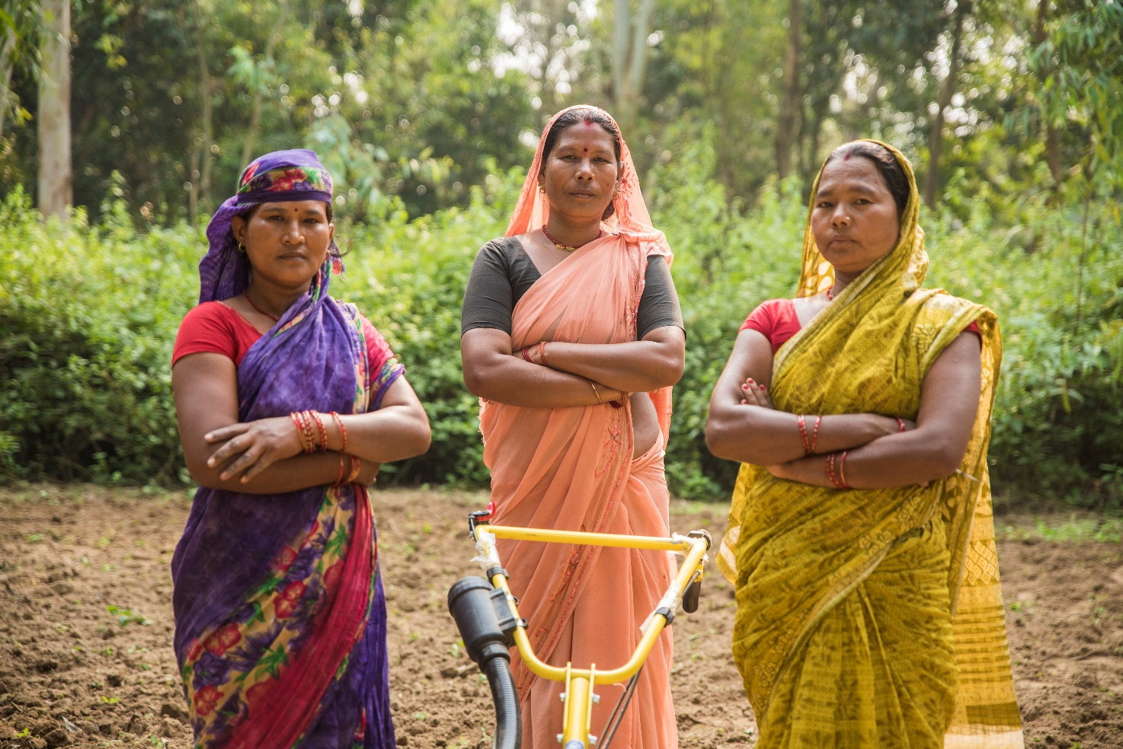
Figure 22:Women farmers from Siraha district. Photo credit: FAONepal
In 2022, the RC and the UNCT have played a key role in leading a diverse range of development coordination platforms. Since July 2021, the EU Ambassador and the UN Resident Coordinator co-chair the IDPG and the UN RCO houses its permanent secretariat. This is a new opportunity for the EU and the UN family in Nepal to strengthen their partnership by promoting effectiveness and harmonization of development assistance in support of national development goals and systems in Nepal. As IDPG co-chairs, the EU Ambassador and the UN Resident Coordinator jointly play a key role in facilitating a stronger common voice for a shared development agenda and supporting the coordination of Development Partners’ joint dialogue with the Government. Additionally, UNDP, UNICEF, UN Women, ILO, IFAD and IOM co-chair different IDPG working groups across a wide set of areas as, for example, federalism, climate change, social protection, migration, education, WASH, health, food security and GESI.

2.4. Results of the UN working more and better together: UN coherence, effectiveness and efficiency
In August 2021, the UNCT in partnership with the GoN, launched the UNSDCF 2023-2027 development process with the signing of the UNSDCF Roadmap by the UN Resident Coordinator and the Secretary of the NPC. Bringing together all agencies and working in close collaboration with key stakeholders the conceptualization, drafting and finalization of the UNSDCF was the priority of the UNCT in 2022. In April, the Visioning and Strategic Prioritization Retreat brought together the GoN, Private Sector, Civil Society and Development Partners in a process to identify the key priorities and entry points for the UN’s partnership with the Government for the coming five years. This was followed up with further in-depth conversations and consultations with the provincial and local governments and a series of consultations with civil society, particularly representatives from historically marginalized groups. Furthermore, the CCA and an innovative mixed-method LNOB Research were utilized as key analyses for the UNSDCF. With this foundation, UN Agencies, utilizing their respective areas of expertise and in line with their mandates, worked collectively to develop outcomes under the priority area identified, around which the UN System in Nepal will coalesce its programming. These four outcomes form the substantive content of this Cooperation Framework and closely align with the priorities and objectives of the 15th plan, the second NDC and the NAP.
Significant progress was made in building the foundations for a stronger, collective, victim-centred approach to PSEA. Nepal has been at the forefront of identifying means to approach PSEA in a development setting and the first UNCT to integrate language on PSEA into the UNSDCF. The integration of PSEA into disaster preparedness and humanitarian response has also been strengthened as exemplified by the increased collaboration with the clusters, the NDRRMA and Provincial Government of Lumbini and Sudhurpaschim.
Under the leadership of the UNCT Nepal, the Delivering as One principles and Standard Operating Procedures have been effectively implemented through joint programmes and enhanced common services for cost effective operations, utilizing the best practices from agencies. Under the overall guidance and oversight of the UNCT and Business Operation Strategy (BOS) task teams, five working groups with representation from 18 UN agencies carried out a series of discussions and analytical exercises to complete the BOS and its 2021 Review. The review found (2022 information only available in March 2023) that with the implementation of the BOS, the Operations Management Team (OMT) in Nepal estimates a benefit of USD 1.161 million and total cost avoidance for all the common services is USD 0.735 million. As part of the Secretary General’s call for efficiency gains, the OMT established and updated the common premises plan on UNINFO, to act as a baseline for the possible establishment of more common premises in the future. UN House Common Services continued to be administered by UNDP, serving the 12 agencies housed inside UN House. As previously there has been a collective effort to ensure a more climate friendly UN House through the continued use of renewable energy (hybrid solar power covering 45 per cent of office electrical consumption) and introducing the use of rainwater harvesting technology.
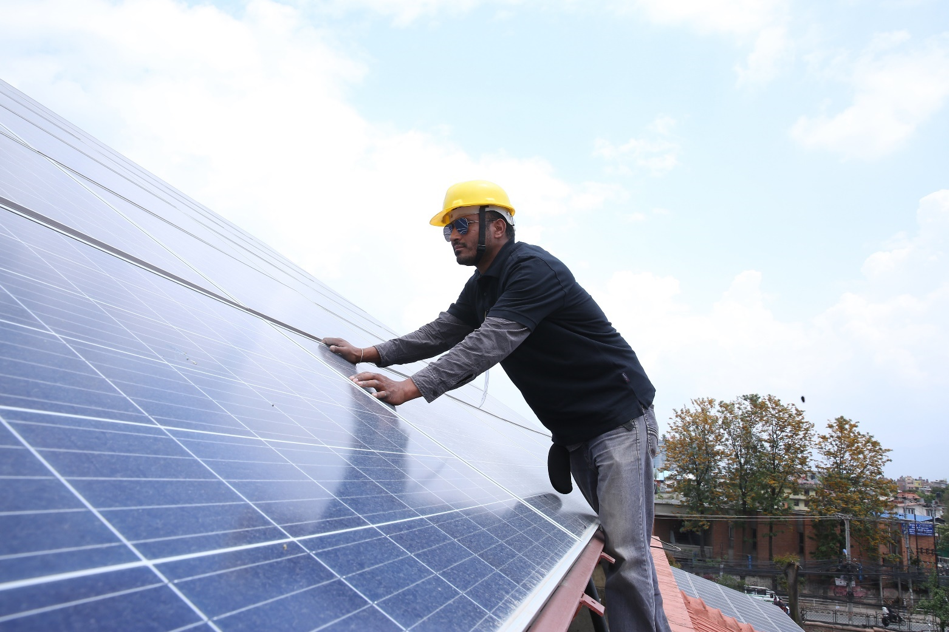
In 2022, recognizing the work done in 2020-2021 on Disability Inclusion, UNCT Nepal received in total USD 68,000 from DCO and the Executive Office of the Secretary General Disability Inclusion teams for the implementation of the UN Disability Inclusion Strategy. The activities implemented through this funding, and in collaboration with the OMT and its task forces, have significantly strengthened awareness and capacity on disability inclusion within the UN Nepal family, particularly in operations under the three components of ICT/Digital Accessibility; Human Resources; Physical Accessibility of Common Premises. A total of 203 (106 female; 97 male) people were trained on disability inclusion including guards, cleaners, HR focal points, administration, and procurement staff. In line with making the UN House inclusive and accessible for all, continuous improvements have been made to the physical accessibility of UN Common Premises since the first audit of 2019, the latest of which include tactile tiles leading from gate to main building, design and construction of an accessible all gender restroom; ramps and railings added to several locations at UN house; three new accessible parking spaces; procurement of emergency wheelchairs; preparation of braille signage and thematic master maps amongst others. UN Nepal has also taken forward its commitments to digital accessibility through capacity development of UN personnel as well as improving the accessibility of the UN Nepal website. The work of UN Nepal in collectively implementing the UN Disability Inclusion Strategy (UNDIS) and its UNCT accountability framework continue to be a priority into 2023.

Figure 23:A worker fitting solar panels. Photo credit: UNDP Nepal
During the COVID-19 pandemic, the UNCG focused on joint communications through the RCCE working group, which was critical to disseminating public health information, combating misinformation, and destigmatizing COVID19 through joint campaigns and events. Recognizing the RCCE’s active engagement and effectiveness, in 2022, the MoHP took over the chairship of the group, a show of ownership of this coordination mechanism by the GoN.
With slowdown of the pandemic and the drafting of the new UNSDCF in 2022, the UN Communications Group (UNCG), under the leadership of UNESCO and WHO (UNIC Secretariat), was reinvigorated and shifted its focus to development of the UN Communication Strategy. The draft strategy was developed to align with the UN Global Communications Strategy and the priorities of the UNSDCF, focusing on more strategic communication and identifying approaches that bring the UN closer to the people and support the realization of our
commitment to LNOB. While a number of joint communications and advocacy campaigns/events were organized in 2022, two innovative campaigns are highlighted here.
Stories of Nepali Women – Patriarchy, Climate Change, Mental Health: Recognizing the unequal and gendered impact of climate change, this storytelling campaign was centred around the social and mental wellbeing of Nepali women living in the most disadvantaged and remote areas of the Himalayan region in the context of the looming climate crisis. Delving into the meeting point of patriarchy and climate change, a dozen immersive stories have been collected which will be published on an interactive webpage within the UN Nepal website.
A Room of One’s Own: This unique writing residency for Lesbian, Gay, Bisexual, Transgender, Intersex, Asexual (LGBTIQA+) persons, the first of its kind in Nepal, urtured a group of LGBTIQA+ writers and poets from across the country. It provided them with a guided, safe and creative space to nurture their writer within and to build community with other LGBTIQA+ led and allied creative spaces. The connected mini social media campaign reached at least 400K+ people. The products created will be curated into a zine in 2023 and feed into the marking of the International Day against Homophobia, Transphobia and Biphobia

2.5. Evaluations and Lessons Learned
The UNDAF 2018 – 2022 endured the impacts of the COVID-19, the global economic slowdown, and the Ukraine war. The pandemic put Nepal’s achievement of several SDGs and national development goals at risk of stagnation or even regression. As such, reorientation of the programmatic activities and resources to the new scenario was key to safeguarding as much as possible of the progress that has been made in Nepal, especially with regards to inclusive economic growth and ensuring basic social services for all. In 2020, UNCT acted quickly and repurposed resources and reoriented programs to address the needs of those left most vulnerable by the pandemic and to take the measures necessary to mitigate the spread of the virus. As a flexible programmatic framework, the UNDAF served as a basis for both designing additional targeted interventions and reproposing of the existing resources. As a result, the UNCT contributed to a coordinated, effective, and multi-sectoral response to the global pandemic such as COVID-19 while protecting development gains and the continued delivery of and access to basic services. The pandemic showed that UNDAF provided sufficient space for flexibility and adaptation. This lesson will be carried forward in the new UNSDCF period, keeping space for adaptative programmatic approach based on regular assessment of development context applying developmental evaluation.
The UNDAF 2018 – 2022 was formulated before provincial plans were developed; and hence, the UNDAF was not adequately aligned with the provincial plans. When there were provincial plans, and it was time for the UNDAF to adapt to those plans, the development context changed requiring UNCT to repurpose and reorient the programmatic activities to respond and recover from the impact of COVID-19. As a result, an opportunity to readjust the UNDAF to adapt to the provincial plans was missed. This is a lesson on how the agencies can align backwards to the new plans by their counterparts. Drawing lessons from how the UNDAF missed the opportunity to align with provincial plans and how it was adjusted to the pandemic, the cycles of the framework both create enough space for flexibility as well as align with both national and subnational plans. To ensure alignment with provincial plans, UNCT needs to engage with both federal and provincial governments.
Differences in mandates, process, procedures, and reduced funding limit coherence across agencies, impacting initiation of additional joint programming. This can be reduced by ensuring that agency staff have adequate incentives to collaborate across agencies. A lesson from the UNDAF was to have a UN-wide plan for how the impacts of UN interventions will be monitored with the Theory of Change for the UNSDCF in order to demonstrate the effectiveness of the UNDAF. The UNCT should also develop ways to hold the individual UN agencies accountable for providing timely and reliable data, so that programmatic adjustments can be made. Furthermore, it was suggested to analyse the barriers and create incentives for agencies at national and provincial level to pursue more joint programmes and programming.

2.6. Financial Overview and Resource Mobilization

2.6.1. Financial Overview
In 2022, as shown in figure the total budget and expenditure for UNDAF were USD 112.72 million and USD 97.43 million respectively. The total expenditure for the different Outcomes were approximately USD 21 million (Outcome 1), USD 38 million (Outcome 2), USD 30 million (Outcome 3) and USD 11 million (Outcome 4).

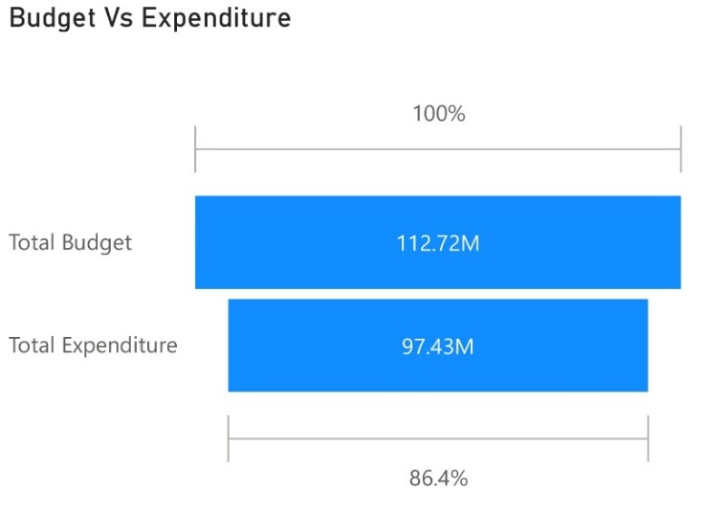  Figure 24 Total budget and total expenditure for 2022 | 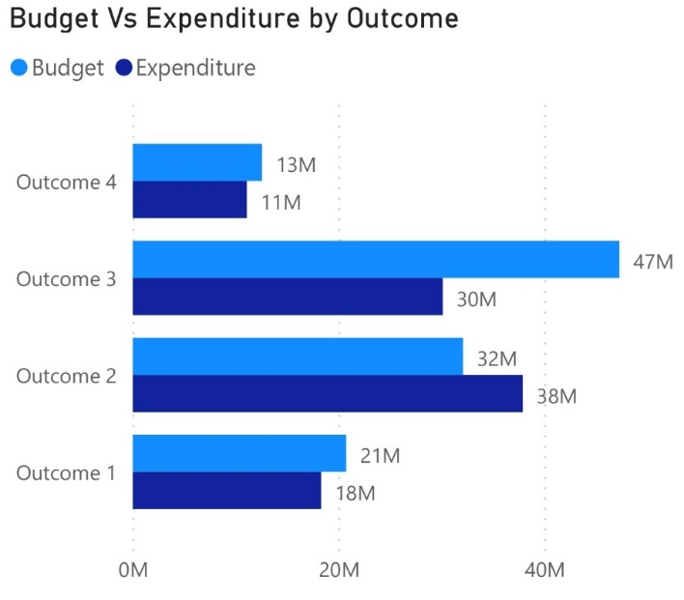  Figure 25 Total budget compared to total expenditure per outcome for 2022.
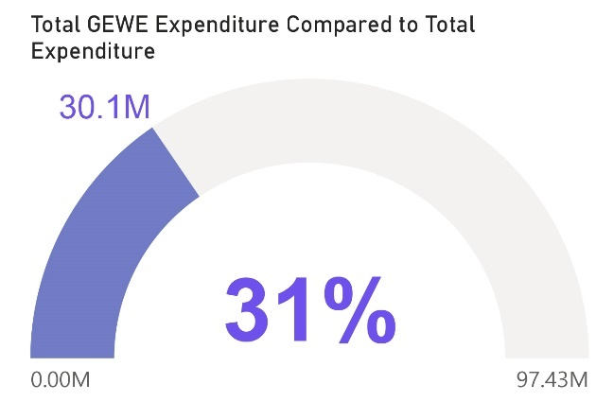
Gender Equality and Women’s Empowerment
The UNCT is committed to track budgeting and expenditure for GEWE since the roll-out of the Gender Equality Marker Coding tool in 2020. In 2022, 31 per cent of the total expenditure went towards GEWE (Figure 8).
GEWE expenditure varies across the outcomes. Outcome 2, Social Development, has outputs whose primary concern is GEWE, such as programmes on GBV and child marriage thus explaining a higher proportion of budgets and expenditures going towards GEWE. Figure 9 and Figure 10 below demonstrate the proportion of GEWE expenditures for each outcome in absolute amount and percentage.
Figure 26 Percentage of total expenditure and absolute amount spent on GEWE for 2022.
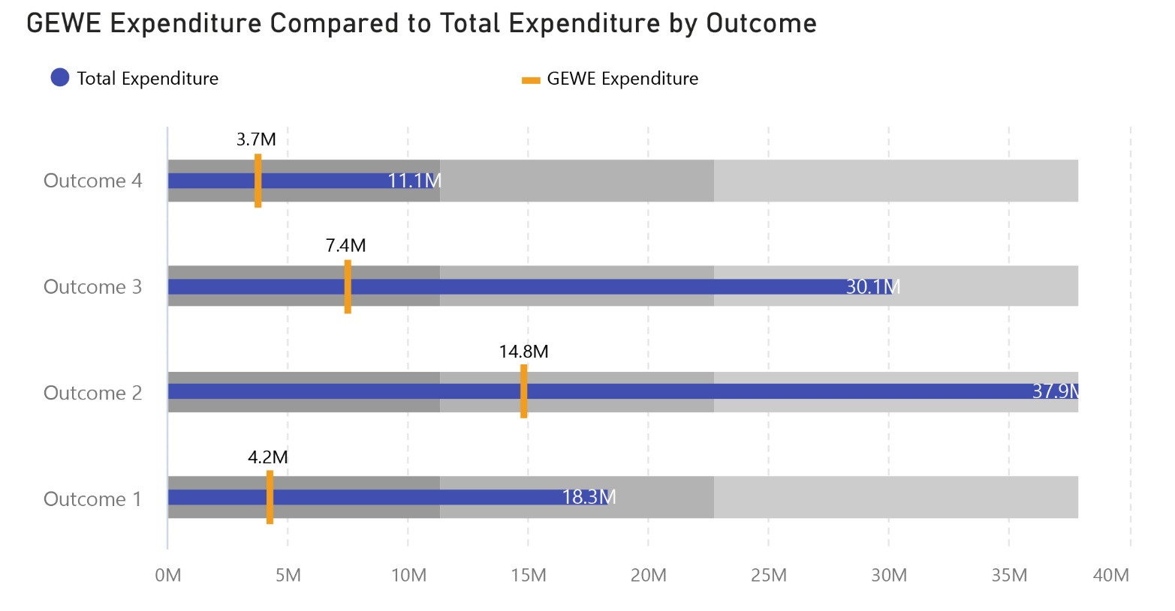
Figure 27 Absolute amount spent on GEWE per outcome compared to total expenditure per outcome.

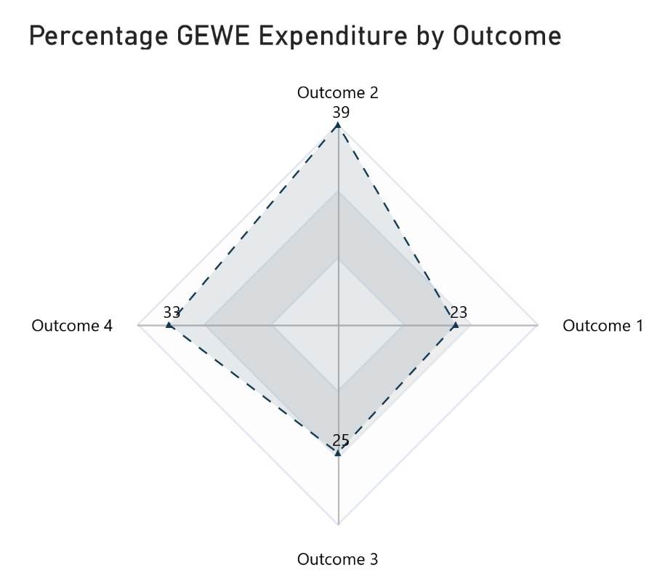
Figure 28 Percentage of total expenditure spent on GEWE per outcome.

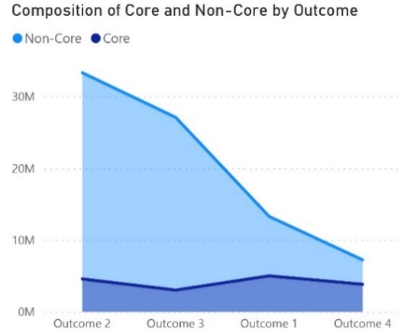
Composition of expenditure coming from core and non-core funding

The first two figures below show an overview of the allocation of total core and non-core funding as well as for each outcome (Figure 11 and Figure 12). The diagrams that follow show the sources of non-core funding for each outcome (Figure 13; Figure 14; Figure 15; Figure 16).
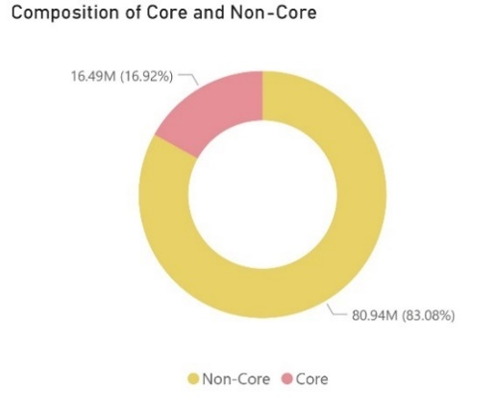
Figure 29 Composition of tot expenditure by core and non-core Figure 30 Composition of core and non-core funding by outcome. funding.
Figure 30 Composition of core and non-core funding by outcome.
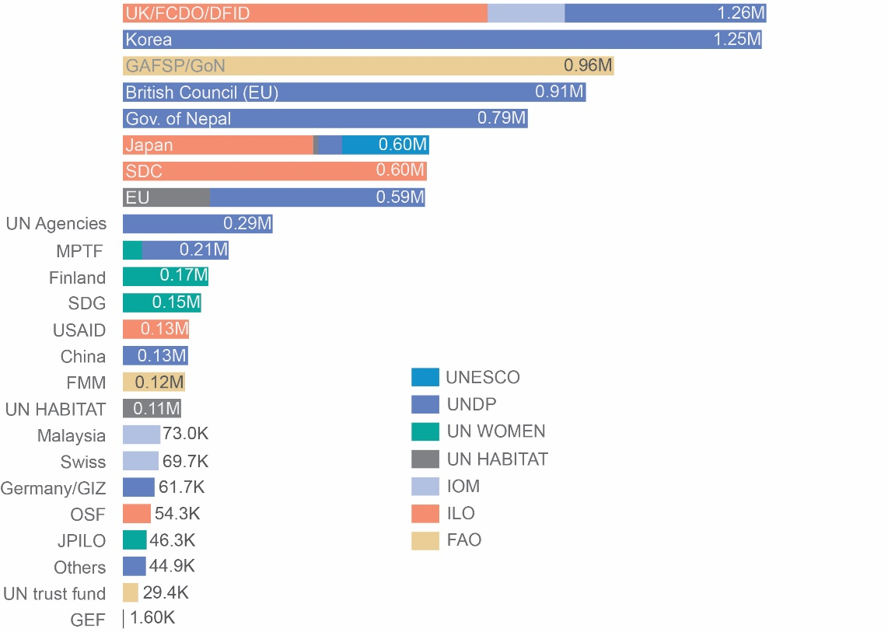
Outcome 1: Non-Core Contributors

Figure 31 Sources of non-core funding for outcome 1
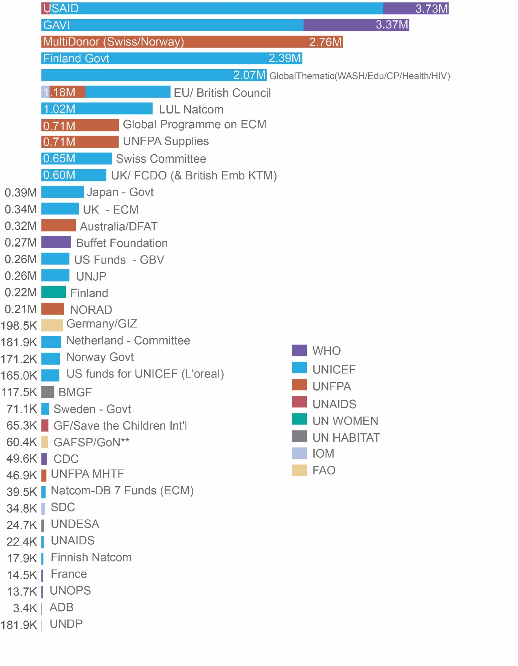
Outcome 2: Non-Core Contributors
Figure 32 Sources of non-core funding for outcome 2.

Outcome 3: Non-Core Contributors
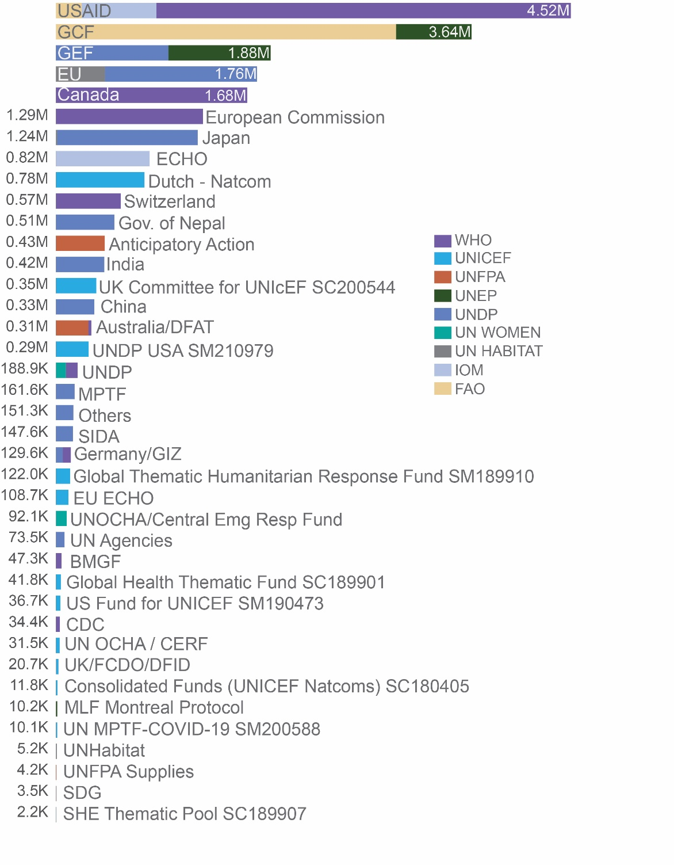
Figure 33 Sources of non-core funding for outcome 3.

Outcome 4: Non-Core Contributors
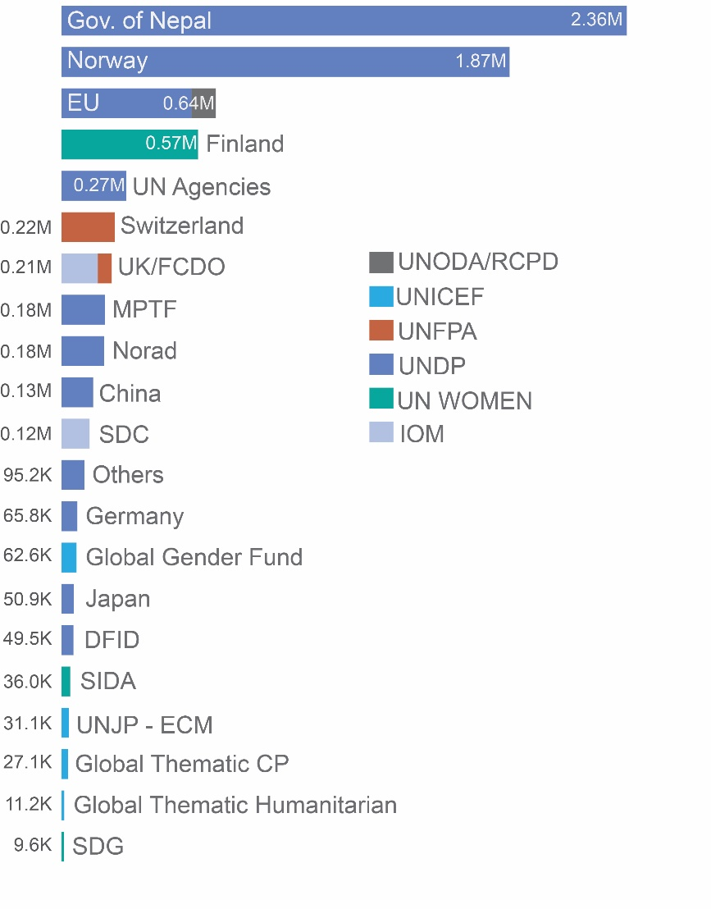
Figure 34 Sources of non-core funding for outcome 4.

2.6.2. Resource mobilization and quality of funding
During 2022 opportunities were identified for optimizing resource mobilization, funding was secured to extend key projects and support upcoming projects and key development partners continued to underpin programmes contributing to a more prosperous and equitable Nepal.
In 2022, key opportunities were identified for optimizing resource mobilization. IOM Nepal’s activities related to DRRM were funded by USAID/BHA. Synergy with other USAID-funded projects helped optimize resources (sharing of training manual and master trainers) and avoid duplication. Of the initially planned 753 local level trainings, 20 were covered by other IOM projects and 31 were covered by USAID funded projects implemented by different organizations hence ensuring the coverage of all 753 local authorities in Nepal. Some local governments also extended their resources both in cash (e.g., payment of lunch, accommodation for government training participants from remote areas) and in kind (e.g., vehicle service to transport trainees, training venue). Going forward, opportunities for mobilizing resources from climate finance instruments exist, for which UN agencies need to come together and collaborate on defining the way forward by engaging the government for the development of financing strategy and resource mobilization plans. Similarly, during 2022, major focus was given to COVID-19 and other probable pandemic response, preparedness, and recovery. For the same, and to support the GoN’s effort in COVID-19 response and preparedness, IOM Nepal was supported by Directorate-General for European Civil Protection and Humanitarian Aid Operations (DG-ECHO) for its intervention on effective case management by strengthening isolation centres and management at six ground crossing points.
During 2022 resources were also mobilized to continue key projects and support upcoming projects related to governance, rule of law and human rights. In late 2022, UNDP’s Parliament Support Project was extended, now continuing during the new UNSDCF cycle with support from the Government of Norway. Similarly, UNDP’s Access to Justice Project has also been extended until 2026 with support from the Government of Norway. Going forward, UN Women, UNICEF, UNFPA and ILO have designed a four-year joint programme entitled ‘Empowered Women, Prosperous Nepal’. The new programme is funded by the EU Delegation. One of the key objectives is to enhance women’s leadership, voice, and agency by strengthening national women machineries, building capacity of key duty bearers to design, implement, and monitor gender-responsive programming, and engaging rights holder in evidence-based civic dialogue to demand social accountability and transparency for gender equality and women’s rights. In 2022, resources were also mobilized for upcoming projects on reproductive health. UNFPA collaborated with the Norwegian Embassy for a project entitled Reproductive Health Efforts for Accelerating Impact. The project will run for three years with the aim to contribute to the reduction of unmet needs for family planning with a particular focus on adolescents and youth in priority provinces in Nepal.
In 2022, key development partners continued to support programmes contributing to improved, equitable access, availability, and utilization of basic social services for people in Nepal. The EU, Foreign, Commonwealth and Development Office (FCDO), the Government of Japan and other partners have been supporting UN nutrition programmes for many years. Additionally, the GoN has been allocating enough financial resources through the government’s Redbook/Annual Work Plan and Budget at federal, provincial, and local levels for the implementation of the MSNP. FCDO and the Government of Finland have been long-supporting partners to the WASH sector in Nepal. Further, the Bill & Melinda Gates Foundation and other development partners including multilateral banks are collaborating on the agenda set by the government for the WASH sector. During 2022, the EU, USAID, the government of Finland, Norway, and the German NetCom have supported UNICEF Education interventions. As the focal point of the local education development partner group, UNICEF also works closely with the seven joint financing partners including both the World Bank and the Asian Development Bank.

CHAPTER 3 UNCT KEY FOCUS FOR NEXT YEAR
The Population and Housing Census 2021: The NSO is preparing for the release of the main census results during the first quarter of 2023. The census data will provide inputs for SDGs, national indicators and monitoring of the results and resources framework of the UNSDCF and UN agencies’ programming work. Census population size and distribution may be used to review delineation of electoral constituencies, and will be used by federal government for allocation of resources to provincial and local governments and review of GESI policies relating to social protection and allocation of Civil Service quotas. The thematic reports will be drafted by national authors. UN agencies have shown interest in supporting thematic analysis on topics of relevance to their respective mandates. Across 2023, NSO will undertake data dissemination at all administrative levels, thematic analysis and development of other products. To ensure that the census results are used for planning by governments across all levels, sensitization and capacity building on use of the results will be undertaken by the NSO. Census population size and distribution will be used to produce a dataset for humanitarian preparedness, response and monitoring which will be updated through annual projections. Agencies engaged in humanitarian activities can use this dataset to align respective interventions.
Implementation of the UNSDCF: In 2023, the UNCT Nepal will focus on the planning and implementation of the UNSDCF. For this, it will develop Joint Workplans, including methodological note to the result framework for monitoring progress on the implementation of the UNSDCF from the LNOB lens. Similarly, the UNCT Nepal will develop resource mobilization and communication frameworks for coordinated and coherent implementation of the UNSDCF.
The South-South Cooperation and LDC Graduation: In 2022, working with UNCTs in Bangladesh and Lao PDR, UNCT Nepal supported the GoN to engage in south-south cooperation for exchange of ideas on preparing smooth transition strategy for Nepal’s irreversible and sustainable graduation from LDC status. In 2023, the UNCT Nepal will continue to support the GoN to prepare and implement smooth transition strategy and its participation in international forum, including the joint organization of the side event by the Governments of Nepal, Bangladesh and Lao PDR on the margin of the Fifth United Nations Conference on the LDCs (LDC5). In addition, the UNCT Nepal will mobilize the United Nations’ global and regional expertise on development finance, international trade, and macroeconomic analyses to provide technical support to Nepal for the smooth transition.
Strengthening Federal System of Governance: In 2022, the elections of the three tiers of the government were successfully held for the second time as directed by the 2015 Constitution of Nepal, continuously demonstrating a strong commitment to the federal system of governance. In addition to the decentralization of delivery of basic services and devolution of power, the federal system of governance is expected to promote inclusive governance in Nepal. Hence, in 2023, the UNCT Nepal will continue to work with the three tiers of governments to enhance their capacities and strengthen inclusive governance practices, ensuring participation of women and marginalized groups and delivery of basic services.
The Sixteenth Plan: The 15th Plan will come to an end in the fiscal year 2023/24. Therefore, the NPC has initiated to develop the approach paper for the formulation of the sixteenth five-year plan (the 16th Plan). In 2023, the NPC will develop the 16th Plan; and the UNCT Nepal will work with the NPC to support the formulation of the 16th Plan as and when there is request from the NPC. At the same time, the UN will continue to support the 15th Plan objective of inclusive and green growth, improved productivity, decent work and sustainable livelihoods, inclusive of the provision of a comprehensive system of social security, enabling a further shift to the formal economy and supporting a smooth graduation from LDC status.
Transitional Justice: With the tabling of the transitional justice bill, the UN Nepal will work with the different stakeholders to ensure a Nepali led and owned victim centric approach to the transitional justice process in line with international human rights standards.
Socioeconomic Recovery from the Impact of COVID-19 and Global Economic Slowdown: There is an urgent need for policy and programmatic intervention for the socioeconomic recovery from the impact of the COVID-19 pandemic and the global economic slowdown. Hence, the UN Nepal will continue to provide both technical and programmatic support to the GoN and communities to reach out the people who have been hit hardest first.
Safeguarding against environmental degradation and climate change: Climate change is going to be a big issue for Nepal in the coming years, as it is vulnerable to external shocks including climate change. Climate impacts are significant, and vulnerabilities are very high in Nepal. The country may see an increasing trend of frequent extreme climatic events, such as cloud bursts and severe floods, increased drought, high temperatures and rapid glacial retreat. Melting of the snow shifts the permanent snowline upward and significantly increases the risk of flash flooding downstream, while rising temperatures and precipitation can increase the occurrence of Glacial Lake Outburst Floods and landslides over moraine-dammed lakes. All the aforementioned climate change impacts will pose challenges for water supply, energy production, ecosystem integrity, agricultural and forestry production, disaster preparedness, and ecotourism. These are all areas, which the UN will be looking at supporting the Government.
PSEA: For the past few years, UNCT Nepal has been at the forefront of identifying means to approach PSEA in a development setting and the first country team to integrate language on PSEA into its new UNSDCF 2023-2027. This work will deepen with the implementation of the new UNSDCF and joint work planning processes, as the PSEA WG will work in close collaboration with results groups to identify means to integrate PSEA across the UN’s joint work as a means of ensuring accountability to the people we serve.
Disability Inclusion: In 2022, the UN Agencies in Nepal have strengthened their work on disability inclusion across all pillars of work. Dedicated consultations with OPDs, as well as OPD representation in federal and provincial level consultations, were incorporated into the formulation process of the UNSDCF. Further, the implementation of the Disability Inclusion Pilot in Nepal has significantly strengthened the awareness and capacity on disability inclusion within the UN Nepal family. In 2023 the work will continue in supporting the implementation of the UNDIS in Nepal including through strengthening disability inclusion in humanitarian preparedness and response, meaningful engagement and consultation with OPDs, and continued capacity development of UN personnel on UNDIS.
The European Union and United Nations Collaboration: Building on the excellent relationship that has been established by the UNCT with the EU over the years, the EU-UN joint programme “Empowered Women, Prosperous Nepal”, has scaled up the EU-UN partnership in 2022. EU Ambassador and UN RC leadership and strategic direction in combination with UN agencies technical expertise and comparative advantage and, moving from individual projects to holistic joint initiatives that bring transformative change are at the core of this new joint programme. The UNCT will work together to jointly implement this initiative along 2023 and, as well, will explore similar collaboration opportunities in areas such as Climate Change, Food Security and support to Nepal’s LDC Graduation Process.

The census reference to urban populations refers to those living in urban municipalities.
Situation_of_women_and_marginalized_groups_representation_in_the_elected_institutions_in_Nepal_Analysis_ of_Federal_and_Provincial_Election_2022.pdf
Mustang Mountain Declaration 2022
WFP Nepal's Annual Country Report 2022
SAMRIDDHI Project Annual Progress Report 2022
Nepal country profile on technology in public employment services for youth
Nepal Labour Migration Report_2022
SAMRIDDHI Project Annual Progress Report 2022
WFP Nepal's Annual Country Report 2022
Literacy rate Nepal
Education Review Office, Nepal (ero.gov.np)
Flash Report CEHRD
NMICS Survey Findings Report
Drinking Water, Sanitation & Hygiene: Nepal 2019
HMIS System
DoHS-Annual-Report-FY-2077-78-date-5-July-2022-2022_FINAL.pdf
Mustang Declaration on Sustainable Mountain Solutions Call for Action
“Improving Access To Eco-Cookstoves and Establishing Green Zones at Schools and Health Facilities in Nepal to Address Deforestation and Air Pollution’ titled as Eco-Zone project in short.
Building a Resilient Churia Region in Nepal 2019
Building a Resilient Churia Region in Nepal 2019
One Health Action Plan Gandaki Province 2022 – 2026
UNDAF funding is divided into core resources, which are non-earmarked and can be spent to finance any programme within an agency's strategic plan and non-core funding which are resources that have restrictions on where and how they can be spent determined by the donor. For most UN agencies core funding would be received from headquarters for core functions while non-core funding would be received from donors for specific programmes.

