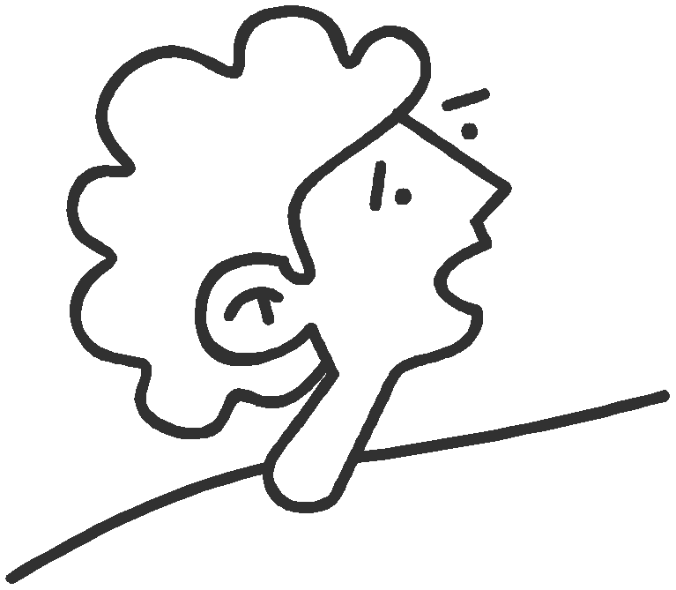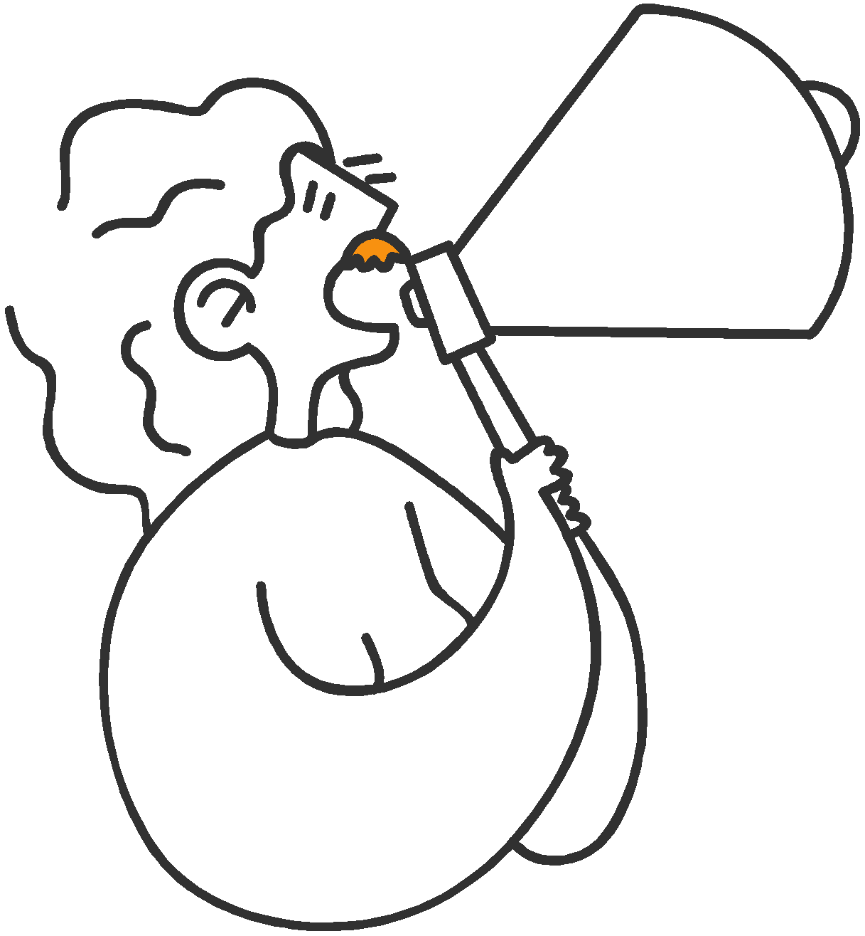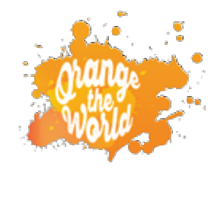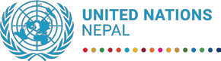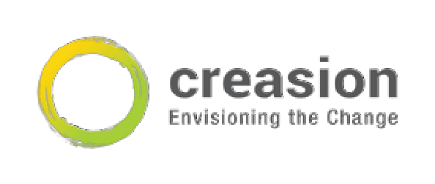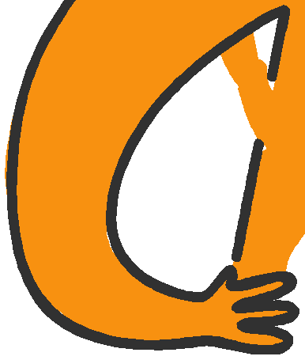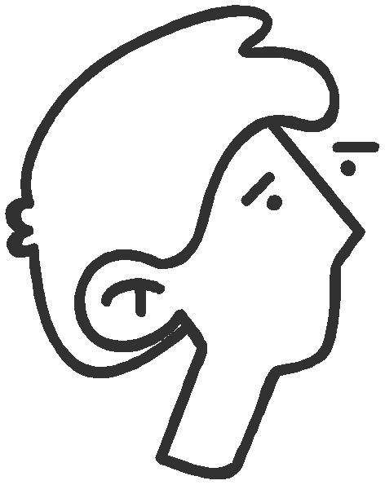

Intergenerational dialogue
between youth and decision-makers on addressing Gender Based Violence in Nepal
30 November - 6 December, 2021
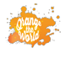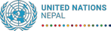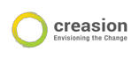ABBREVIATIONS

CSOs: Civil Society Organizations

GBV: Gender Based Violence

H.E.: Her Excellency

LGBTQIA+: Lesbian, Gay, Bisexual, Transgender, Queer, Intersex, and Asexual

SH: Sexual Harassment

SOGIESC (Sexual Orientation Gender Identity Expression and Sex Characteristic) SRH: Sexual Reproductive Health
UN: United Nations

UNICEF: United Nations Children Fund

VAW: Violence Against Women
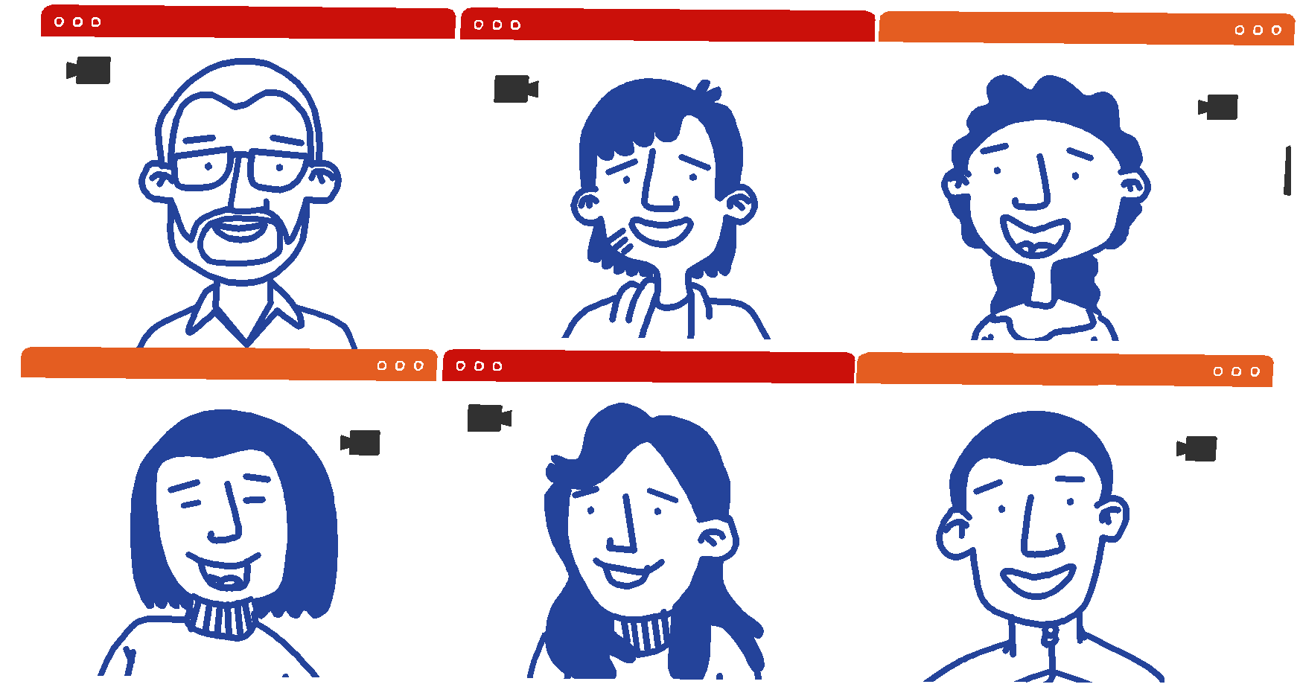Consulted with young people in Nepal on violence against women, girls, sexual minority and untouchability groups, in order to identify various approaches in addressing GBV issues in their community and country. Young participants were asked to come up with
1) Roles of youth in preventing Gender Based Violence issues, and
2) Key call-to-action for decision-makers for the changes they want to see in Nepal on the issue.

25 youths
Age 18-29
Particpants selected
via application process Applications from 7 provinces, Youth with Disabilities and LGBTQIA+

1) Provided a platform to connect young people’s voices and ideas to decision-makers and facilitate a dialogue between them
2) Mobilized accountability and leveraged support for youth-inclusive comprehensive policies to design safe spaces for young people.
3) Empowering spaces for young people with a youth-led call to action.
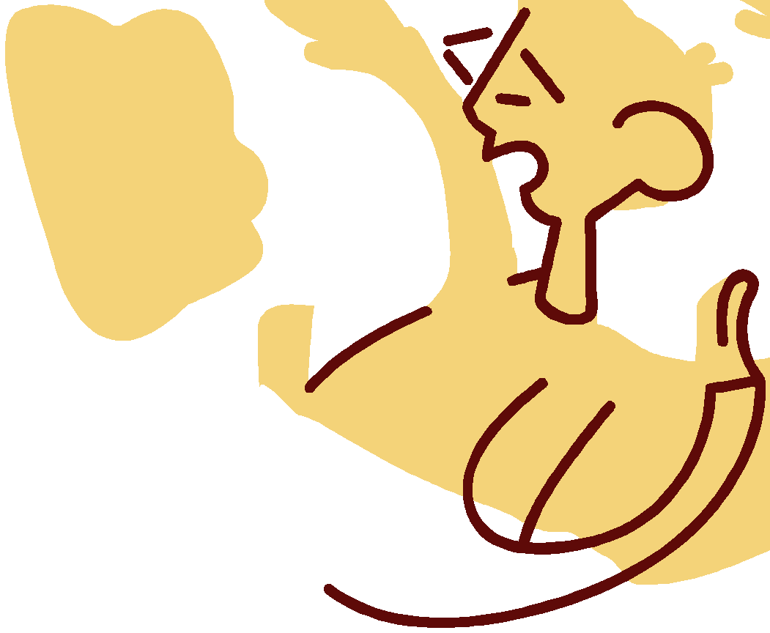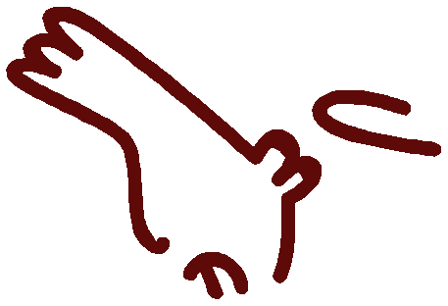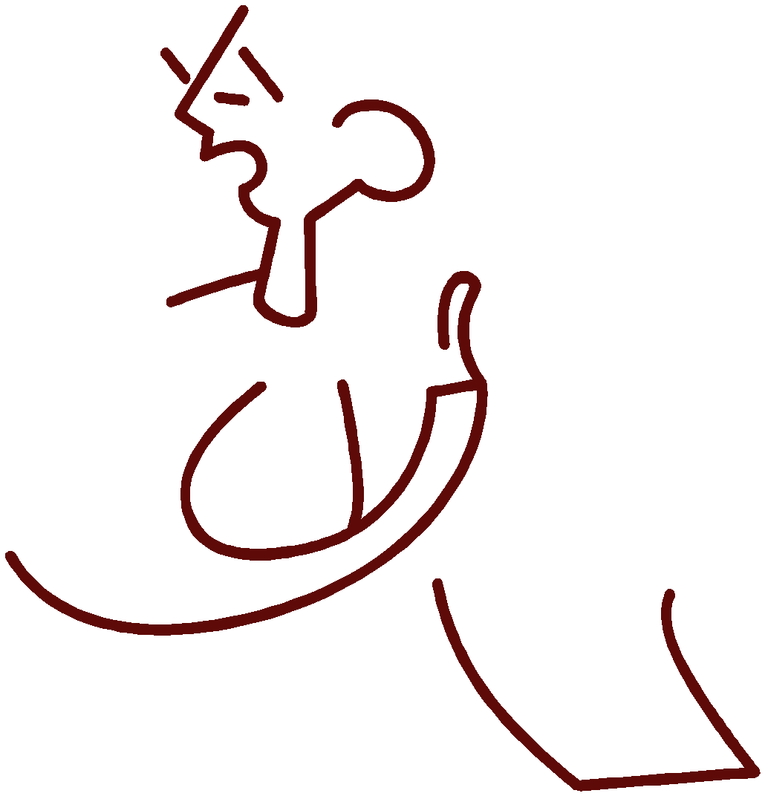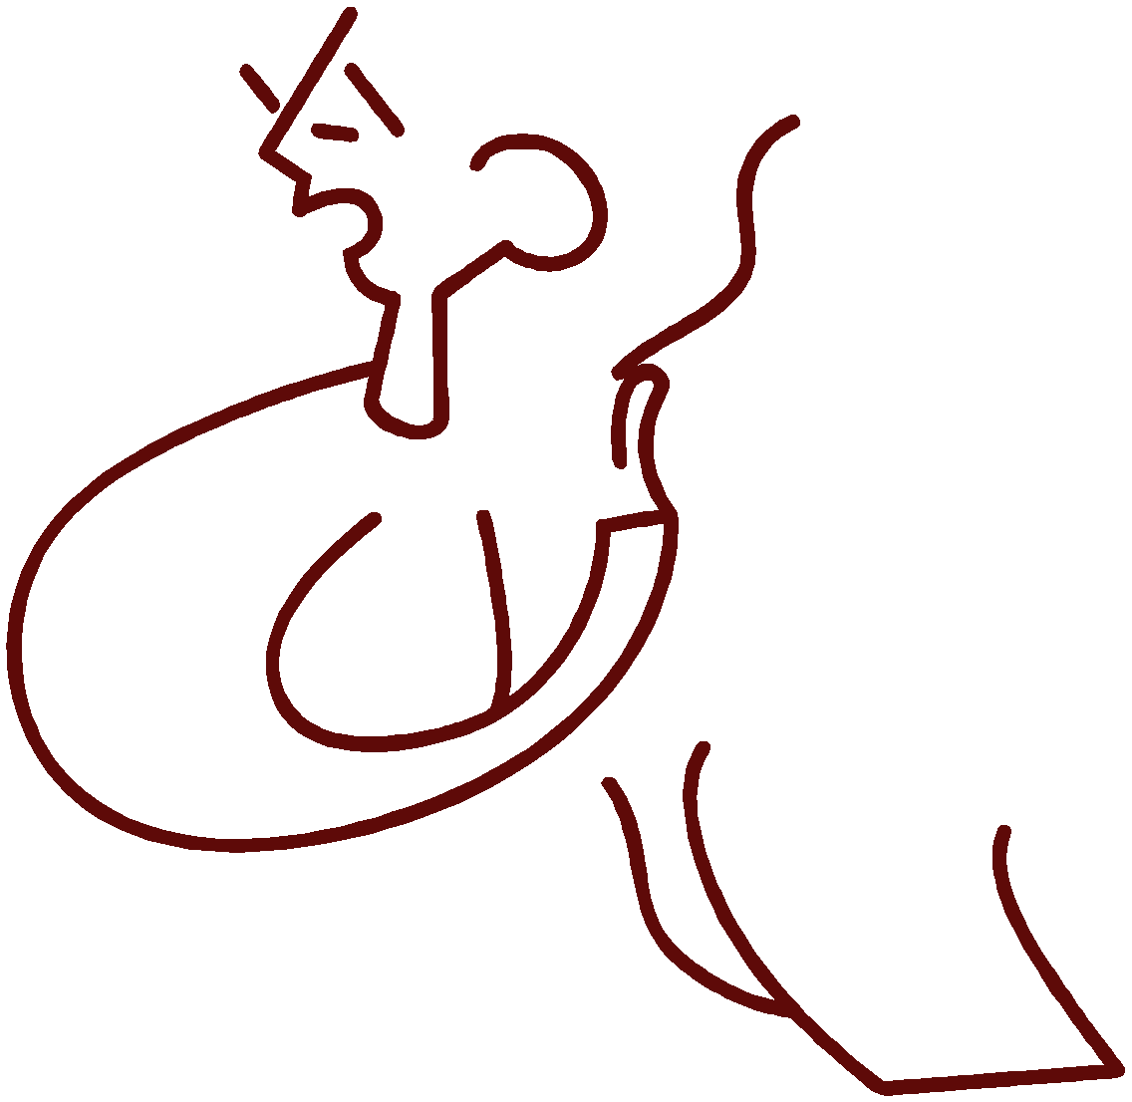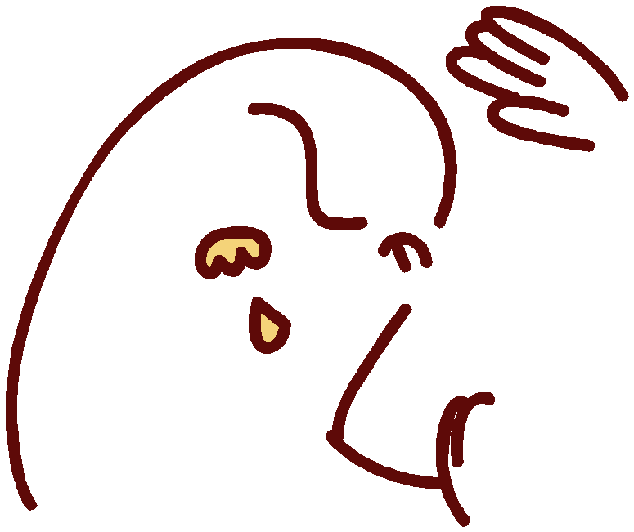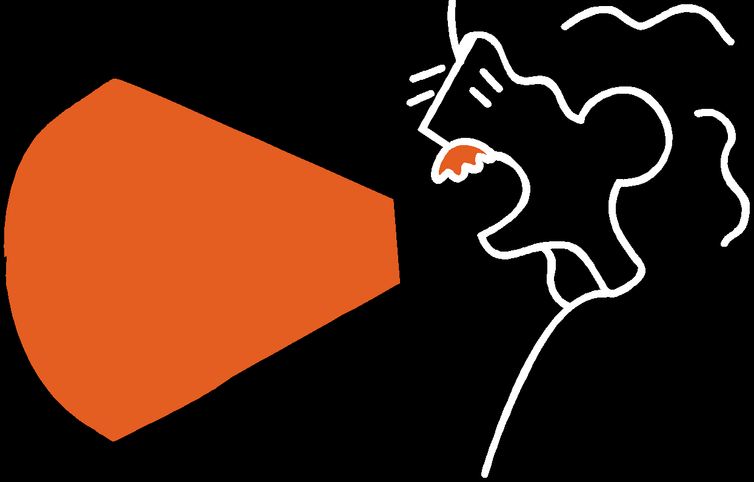

Gender Based Violence occurs due to systemic inequalities between sexuality. The session covered the discussions on what measures and mechanisms are in place to address GBV and interventions on masculinities and social norms.
Sensitize communities on GBV, SRH, Sexuality, disability

Be the rst-respodent/
quick-respondent on behalf of GBV survivors who need access to support

What youth can and want to do to help
Help disseminate information & improve existing services to be more accessible including
youth preferred technology

Work together to help develop, push out, and scale key messages and campaigns that will interest youth
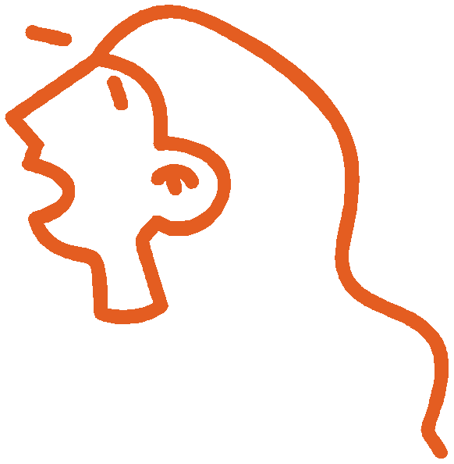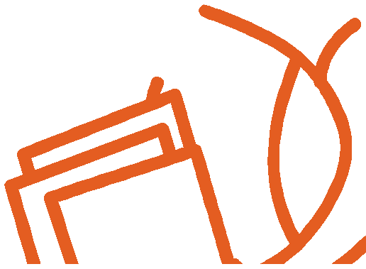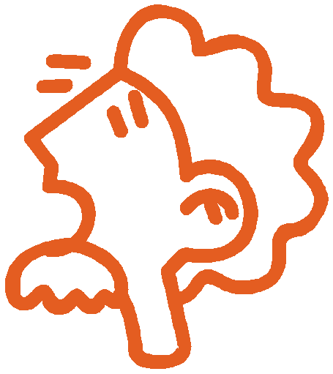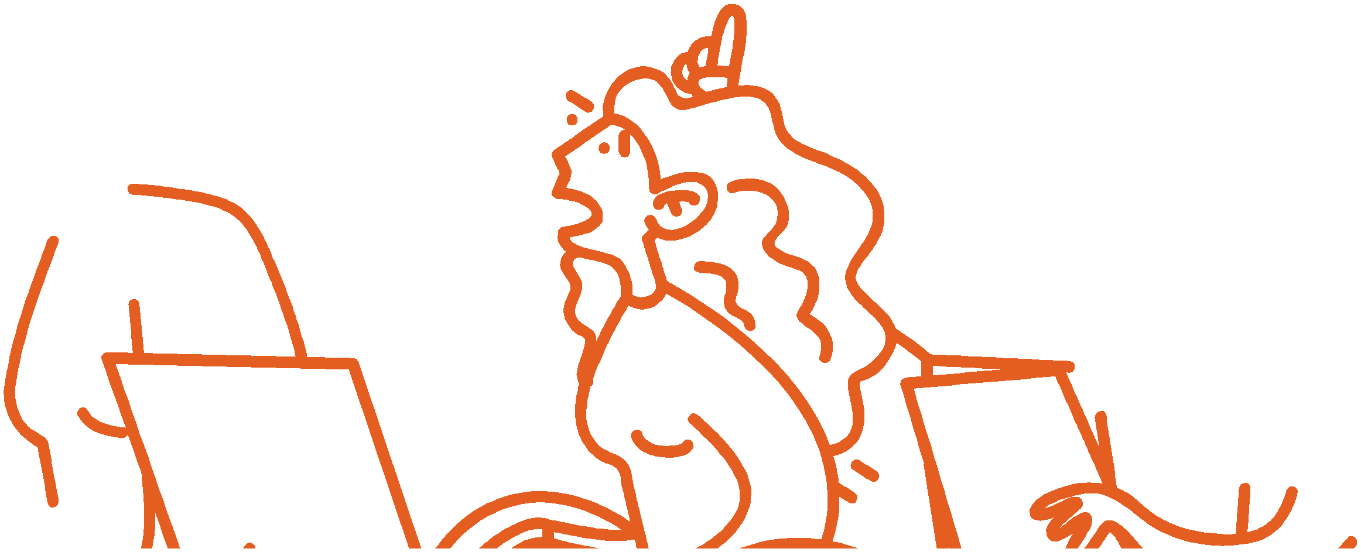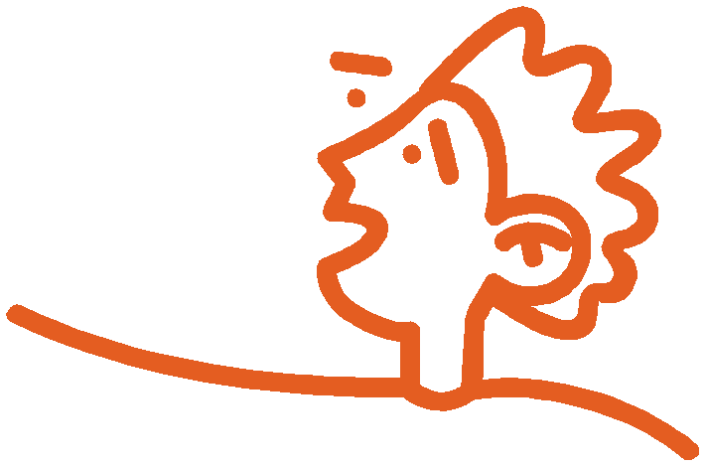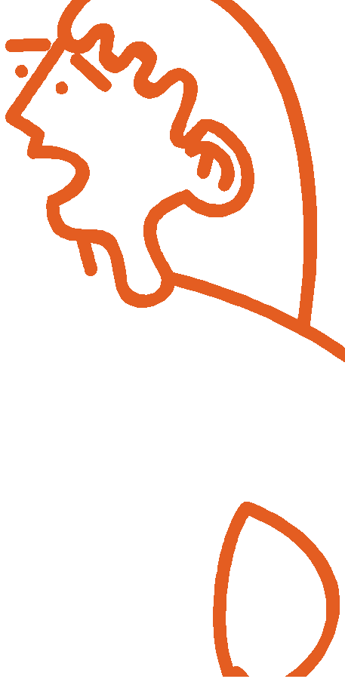Support real-time monitoring,
reporting, and gap identi cation including usage of digital

Call To Action
ACCESSIBILITY & AWARENESS
•Improve access to essential services (age and gender appropriate)
•Regularly disseminate information ( jingle/video) including for youth/parents
•Reporting mechanisms that works for all ages, genders, and disabilities

FUNDING
• Invest in accessible, inclusive, and transparent
data collection and monitoring (age, disability, and gender disaggregated)
• Funding support to CSOs working on GBV;
build a network of young people.

INSTITUTIONAL CAPACITY
•Dedicated committee with GBV experts on central &
local level
•Systematic public structure for smooth case handling
& monitoring
•Fast track of GBV judiciary cases; child bench, separate
GBV court
•Citizenship from mother’s side/LGBTQIA+
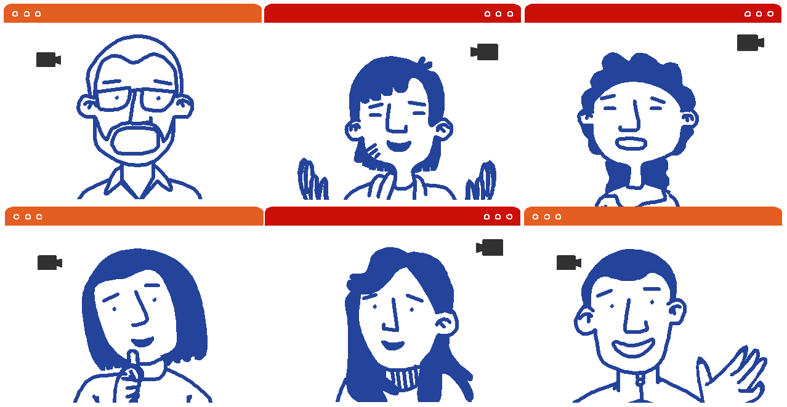

EDUCATION/SCHOOL
•Better curriculum on GBV/SH,
LGBTQIA+/disability
•Educate youth on GBV cybercrimes
•Expertise of teachers on GBV
•Mandatory psychosocial counselling
Youth Representatives

I work as a youth advocate for women’s political literacy. I am leading a couple of movements against GBV - including rape cases such as street flash mops across Nepal. I have been working with the government and development partners on youth’s political engagement. Youth’s role is very important in addressing GBV issues and advocating for women’s citizenship.

I am a burn victim since I was 18. A male friend threw kerosene out of his ego for rejecting him as a potential suiter. It has been a painful, difficult and depressing journey. I want to voice against this type of violence and advocate for other survivors in a similar situation. I am advocating for forming strict laws even for acid attackers.
I am a disabled LGBTQIA+ activist and a burn survivor. I faced sexual and mental harassment in the orphanage. It is difficult for the LGBTQIA+ community to accept me because of my disability and they are not sensitized about disability of LGBTQIA+. My scholarship was revoked when I first came out in the media identifying myself as a gay man with a disability. I'm now a program officer in the Blue Diamond Society. I want to help people with the disability LGBTQIA+ and get their Human rights.

Prakriti Bhattarai Chairperson, Political Literacy for Women UNICEF Youth advocate for GBV
Puja Karki
Astitwa Nepal
GBV survivor & activist
Aaditya Rai Blue Diamond Society LGBTQIA+ activist

With the great number of youth net- works in our country, how can we utilize them to advocate and prevent GBV in the coming days?
There is a lack of laws, reforms, and support for Burn Survivors in com- parison to Acid attack Survivors in our country. Are your organizations advocating anything for the Burn Victims?
Do your organizations have a GBV policy of diverse SOGIESC to respond to workplace discrimination and violence? Are there any LGBTQIA+ and disability representatives in the National Youth Council?
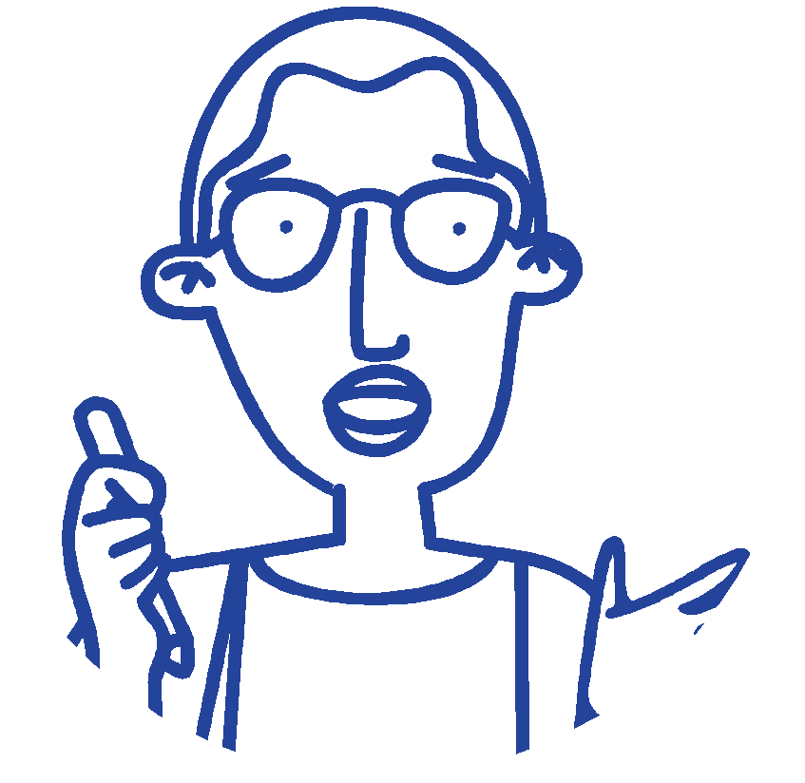

In response to Aaditya’s question on gender-inclusive policy we do have a workforce on diversity policy in our o ce which ensures people from marginalized groups including persons with disability and gender minorities to engage as personnel and perform their tasks with dignity.

Elisabeth von Capeller
H.E. of the Embassy of Switzerland
The movement against gender-based violence has been going on for years, yet women still su er. But with evolving times, we are also continuously developing and updating our acts and policies to incorporate all the needs of the people. Addressing Puja and Aaditya’s question, the government has drafted acts for burn survivors and is planning the inclusion of quotas for people with disability and LQBTIQIA+ in the National Youth Council. Let's be hopeful and wait as the government amends all these changes. I would also like to emphasize that we need to push the government for action but at the same time the youths also need to address the issues as soon as we see them in the community and raise more awareness.

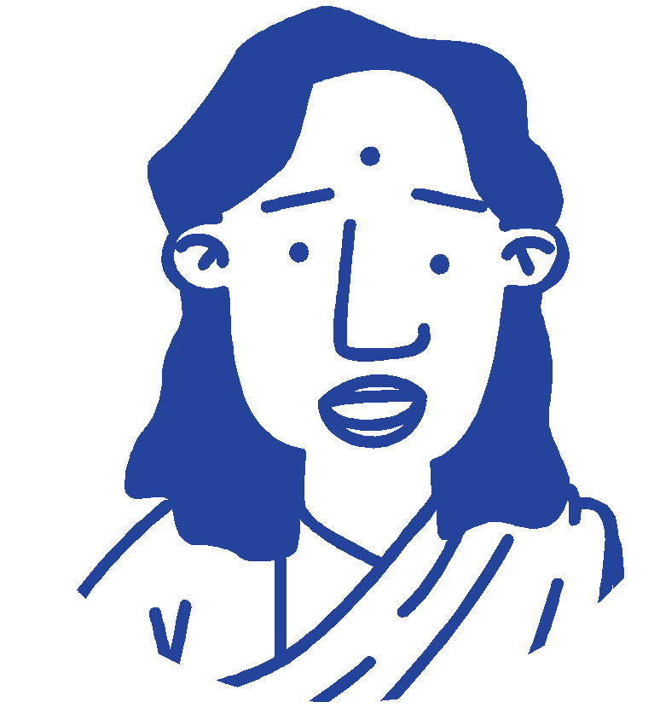Chandra Thapa, Under Secretary, National Youth Council,
Ministry of Youth and Sports

Addressing the question posed by Aaditya on gender-inclusive strategies and policies within the UN system there exists of the United Nations-wide Strategy on Gender Parity and shared that it has speci c targets and indicators that ensure gender parity in the UN.

Richard Howard,
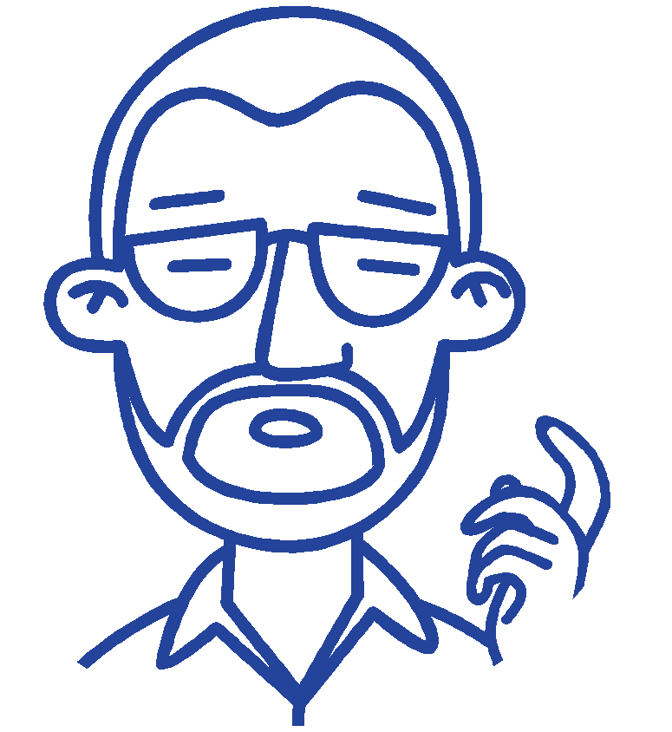Resident Coordinator ad. interim Country
Director at ILO Nepal
We recognize the UN Youth Group Task Force which is working for youth-centric programming in the UN system and acknowledge this youth dialogue coordinated by the UN Youth Task Force Team. The COVID-19 pandemic has brought more vulnerability for women and girls about Gender Based Violence and is often a multidimensional concern with intersectionality around it. I want to emphasize the importance of strengthening institutional capacities to address GBV, including in the education sector. There is a new sectoral plan for education in Nepal which could serve as a good opportunity. It is important to protect social security along with the need for behavioral change to address GBV issues. I urge the need of today’s young people to be the change-makers for the coming future in addressing the VAW and GBV issues.

Elke Wisch
UNICEF Representative for Nepal
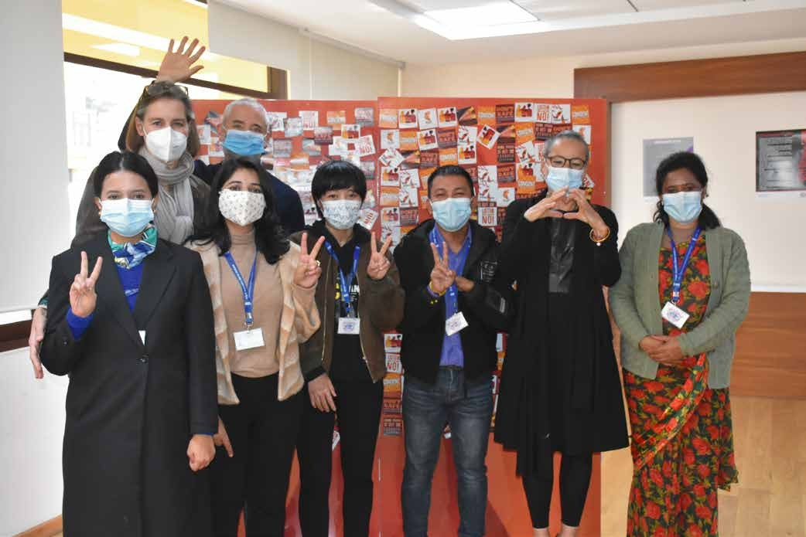

Elke Wisch, Richard Howard
Prakriti Bhattarai, Sujata Koirala, Puja Karki, Aaditya Rai, Elisabeth von Capeller, Chandra Thapa

